Additional file 2
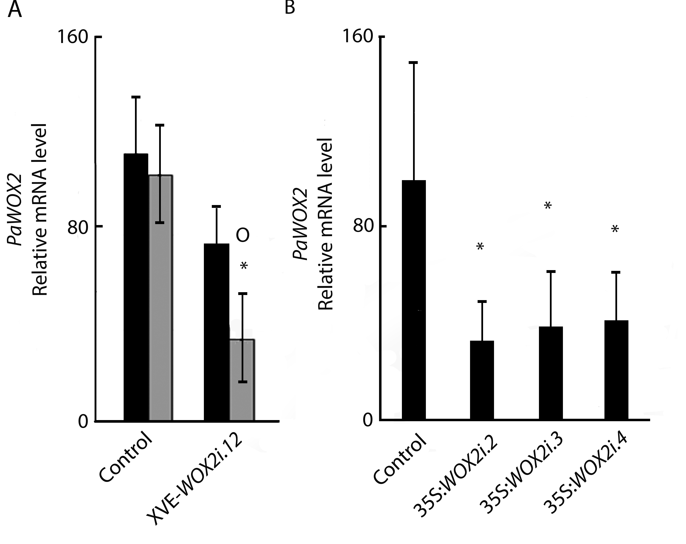
Figure S2. Quantitative RT-PCR analysis of the relative mRNA level of PaWOX2 in early late embryos (LE1s). LE1s were sampled after two weeks on maturation medium from the control, 35S:WOX2i and XVE-WOX2i lines. The mRNA level of PaWOX2 was normalized against three reference genes: CELL DIVISION CONTROL2 (PaCDC2), ELONGATION FACTOR 1 (PaEF1) and PHOSPHOGLUCOMUTASE (PaPHOS). The presented data are means ± SE of three biological replicates. A) Relative mRNA level of PaWOX2 in line XVE-WOX2i.12. Relative mRNA level of PaWOX2 in control and line XVE-WOX2i.12, non-induced (black bars) or induced for 48h with β-estradiol (grey bars). Asterisks indicate significant differences between the control and the line XVE-PaWOX2i.12 (ANOVA , p<0.05); circles indicate significant difference between the non-induced and induced cultures (ANOVA, p<0.05). B) Relative mRNA level of PaWOX2 in 35S:WOX2i (2-4). Asterisks indicate significant differences between the control and the 35S:PaWOX2i lines (two tail t-test, p<0.05).

