Additional file 1
Supplemental information contains 4 Supplemental Figures and 8 Supplemental Tables

Supplementary Figures

ZD958 (F1)
Picking up haploids identified by color
Selfing
Induced by Cau5
Doubling and selfing
.........
.........
.........
Induced by CAU5

Figure S1 Route used to develop DH population and the corresponding haploidpopulations.

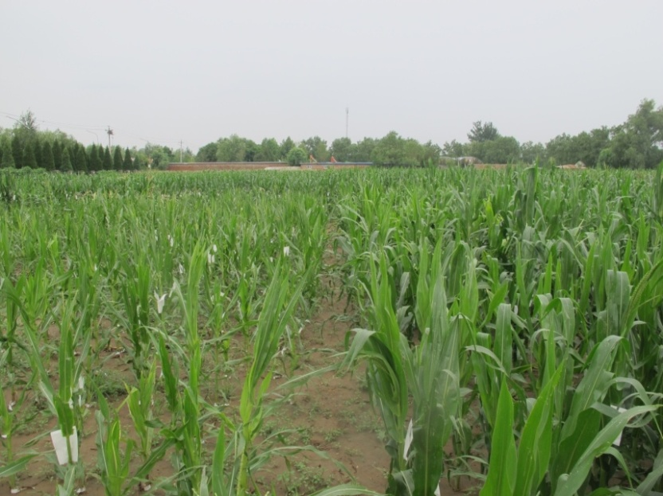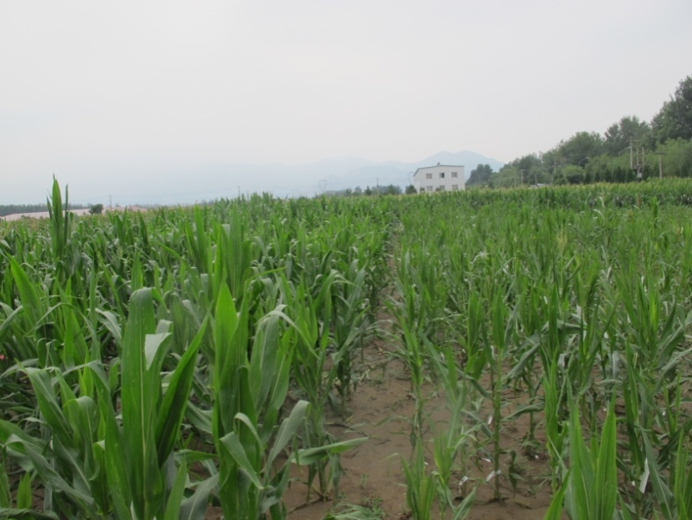
DH population
DH population
haploid population
haploid population

Figure S2 Presentation of DH and haploid populations planted in field.

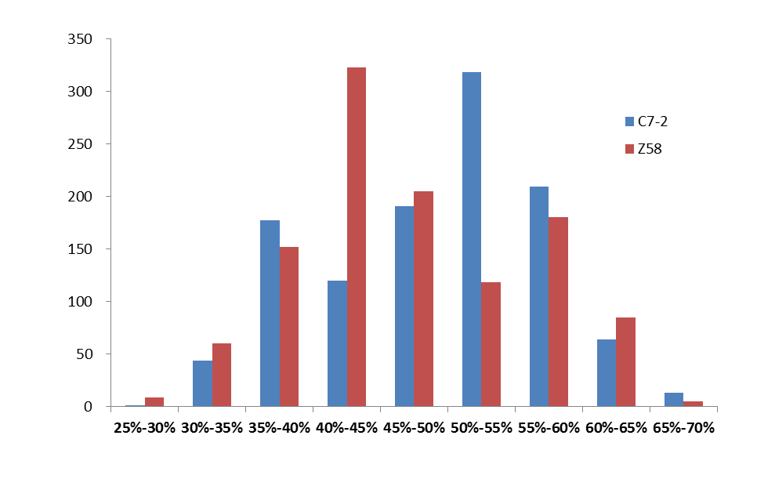
Number of SNP markers

Figure S3 Histogram for genotypic percentage in DH population.

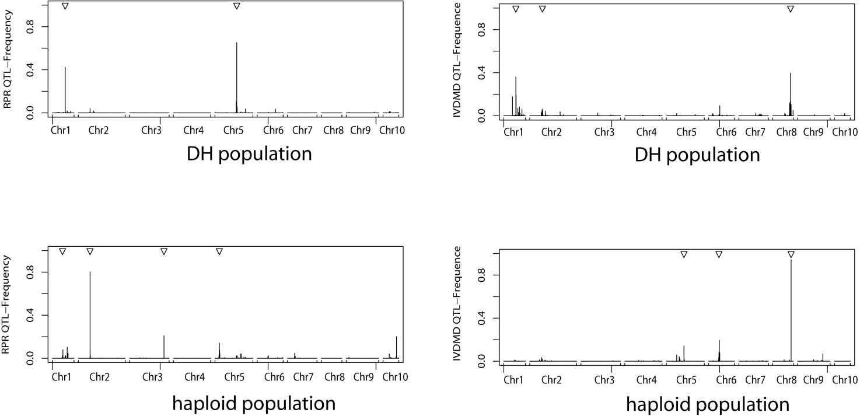

Figure S4 QTL detectedfrequency for RPR and IVDMD in DH and haploid populations with five-split cross validation for 1000 times.
For RPR, the QTL at bin 2.02 and 5.05 were detected in DH and haploidpopulation with high frequencies in the 1,000 cross-validation, respectively. For IVDMD, the QTL at bin 8.04 and 8.05 were detected in DH and haploid population with high frequencies in the 1,000 cross-validation, respectively.

Supplemental Tables

Table S1 Primer sequences of genes involved in lignin and cellulose synthesis for RT-PCR.
Name | Accession numbers | Forward primer | Reverse primer
PAL | L77912 | CACGGACCACCTGACCCACAA | GCGTACCTGTCCTGCTTGGGC
COMT | M73235 | ACTCTTGCCCTGTCTGTTCCTTGTA | CACCGCGTCCTTGAGATAGTACCT
ccoAOMT | AJ242981 | ACATCAACCGCGAGAACTACGAGCT | CGCTCGTGGTAGTTGAGGTAGTTGT
CCR | NM_001112018 | GGCACCGTCAGGAACCCAGAT | AGATGGCGTCGTAGTCCAGCAGA
CAD | AJ005702 | TCGGGGCTTCAAAGTATCCTAT | TATGACCAGATCTTCTTGTTGCAGT
CesA11 | AY372245 | TGGAGTGGCATCGGGATCG | CACCGTCGTCCACTTGAACAG
CesA12 | AY372246 | ATCTATCGGACCGTCTCAACCAGG | GCCACTTGAGGTTGCCGTTCTT
ACTIN | DQ492681 | TCACTACGACTGCTGAGCGAGAAAT | AATAGAACCTCAGGGCACCTAAACC

Table S2 Summary of SNP characteristics in DH population.

 |  | Mean±SD |  | Range
High-quality SNP number |  | 2956
MAF(%) |  | 0.42±0.06 |  | 0.00 | 0.50
SNP heterozygosity in each line(%) |  | 2.06±4.24 |  | 0.00 | 25.81
SNP missing rate in each line (%) |  | 1.50±2.51 |  | 0.03 | 15.36
SNP missing rate (%) |  | 1.50±2.47 |  | 0.00 | 20.00
SNP heterozygosity (%) |  | 2.06±1.95 |  | 0.00 | 14.21

Table S3 Summary of the linkage map characteristics DH population.

Chromosome |  | Number of markers |  | Length (cM) |  | Minimum interval (cM) |  | Maximum interval (cM) |  | Average interval (cM)
1 |  | 144 |  | 100.34 |  | 0.002 |  | 5.80 |  | 0.70
2 |  | 132 |  | 217.19 |  | 0.001 |  | 19.60 |  | 1.65
3 |  | 90 |  | 183.46 |  | 0.007 |  | 12.56 |  | 2.04
4 |  | 171 |  | 172.55 |  | 0.002 |  | 16.13 |  | 1.01
5 |  | 111 |  | 175.74 |  | 0.001 |  | 16.69 |  | 1.58
6 |  | 73 |  | 120.41 |  | 0.002 |  | 15.22 |  | 1.65
7 |  | 89 |  | 136.62 |  | 0.008 |  | 12.76 |  | 1.54
8 |  | 172 |  | 95.61 |  | 0.001 |  | 7.63 |  | 0.56
9 |  | 86 |  | 150.59 |  | 0.029 |  | 20.16 |  | 1.75
10 |  | 69 |  | 74.32 |  | 0.014 |  | 13.59 |  | 1.08

Table S4 QTL detected for other stalk traits in DH and haploid populations.

Traits | Bin | Position(cM)ª | Support interval (cM) | Flanking markers ^{b} |  | LOD | A^{c} | P_{G} (%)
WC^{haploid} | 1.09 | 70.69 | 70.11-70.98 | PZE_101087901 | PZE_101215138 | 4.67 | -0.79 | 14.70
WC^{DH} | 1.09 | 73.48 | 73.07-73.86 | PZE_101092737 | SYN15084 | 5.79 | -1.06 | 25.50
WC^{haploid} | 1.05 | 80.18 | 80.01-80.37 | PZE_101101518 | PZE_101117162 | 5.6 | -0.88 | 17.80
WC^{DH} | 2.07 | 143.1 | 141.12-144.92 | PZE_102147840 | PZE_102151093 | 3.85 | -0.88 | 14.40
WC^{DH} | 4.06 | 70.59 | 70.39-70.70 | PZE_104075114 | PZE_104079202 | 3.91 | -0.72 | 11.40
ADF^{DH} | 1.07 | 39.91 | 39.28-40.10 | PZE_101066291 | SYN29479 | 5.02 | -1.56 | 11.50
ADF^{haploid} | 1.09 | 48.62 | 48.35-48.67 | PZE_101165770 | PZE_101205714 | 6.39 | -1.71 | 15.90
ADF^{haploid} | 2.02 | 54.19 | 53.64-58.11 | PZE_102030524 | PZE_102039914 | 6.00 | 1.63 | 14.80
ADF^{DH} | 2.02/2.03 | 57.55 | 53.64-61.47 | PZE_102030524 | PZE_102039914 | 5.73 | 1.73 | 12.30
ADF^{DH} | 5.01 | 40.18 | 38.65-45.16 | SYN37537 | PZE_105026200 | 3.73 | -1.34 | 7.40
ADF^{DH} | 8.04 | 82.67 | 82.42-83.23 | PZE_108068741 | PZE_108069615 | 6.12 | -1.79 | 14.90
NDF^{DH} | 1.07 | 39.91 | 39.28-40.10 | PZE_101066291 | SYN29479 | 6.80 | -1.09 | 1.60
NDF^{haploid} | 1.09 | 48.62 | 48.35-48.67 | PZE_101165770 | PZE_101205714 | 6.77 | -2.17 | 16.20
NDF^{DH} | 1.04/1.07 | 55.86 | 55.29-56.42 | PZE_101179982 | SYN3987 | 3.51 | -2.88 | 6.80
NDF^{haploid} | 2.02 | 54.19 | 53.64-58.11 | PZE_102030524 | PZE_102039914 | 4.09 | 1.71 | 10.10
NDF^{DH} | 2.02/2.03 | 58.67 | 53.64-62.59 | PZE_102030524 | PZE_102039914 | 3.65 | 2.18 | 9.90
NDF^{haploid} | 4.10 | 159.53 | 155.99-160.02 | SYN24017 | SYN7819 | 3.13 | 1.48 | 7.30
NDF^{DH} | 8.04 | 81.66 | 81.45-81.92 | PZE_108068136 | PZE_108068741 | 5.03 | -2.37 | 13.60
NDF^{haploid} | 9.02/9.03 | 59.14 | 57.28-60.67 | SYN29878 | PZE_109037900 | 3.69 | -1.6 | 8.40
Lig^{haploid} | 3.05 | 99.62 | 99.24-100.43 | PZE_103089927 | SYN28295 | 3.60 | -0.4 | 11.00
Lig^{DH} | 3.05 | 103.91 | 102.06-105.48 | SYN28295 | PZE_103098628 | 5.63 | -0.37 | 19.40
Lig^{DH} | 6.03 | 49.81 | 43.22-50.73 | PZE_106041753 | PZE_106051230 | 6.26 | -0.39 | 23.50
Lig^{haploid} | 6.04 | 69.62 | 65.63-71.16 | PZE_106064885 | PZE_106065229 | 4.20 | -0.44 | 12.90
Cel^{haploid} | 1.08 | 54.19 | 54.1-54.20 | PZE_101177728 | PZE_101241459 | 12.08 | -1.53 | 24.10
Cel^{haploid} | 2.02 | 43.60 | 37.97-44.03 | SYN2695 | PZE_102019300 | 3.47 | 0.82 | 6.60
Cel^{DH} | 2.02 | 55.31 | 53.64-60.35 | PZE_102030524 | PZE_102039914 | 5.74 | 1.13 | 12.90
Cel^{haploid} | 3.06 | 147.65 | 146.98-149.31 | PZE_103151399 | PZE_103165581 | 4.12 | 0.92 | 8.30
Cel^{DH} | 5.06 | 133.84 | 133.61-134.33 | PZE_105149244 | PZE_105142633 | 4.87 | -1.14 | 12.40
Cel^{haploid} | 7.04 | 102.81 | 97.86-106.65 | PZE_107105855 | SYN3390 | 5.59 | -1.13 | 10.60
Cel^{DH} | 8.04 | 78.11 | 77.75-78.48 | PZE_108060911 | SYN37439 | 3.58 | -1.10 | 13.30
Cel^{haploid} | 9.06 | 109.97 | 108.29-115.21 | SYN25121 | PZE_109104633 | 3.33 | -0.78 | 5.70
WSC^{DH} | 1.04 | 56.99 | 56.42-57.53 | PZE_101179982 | SYN36407 | 5.69 | 1.79 | 14.50
WSC^{DH} | 6.03 | 51.65 | 50.73-53.40 | PZE_106049961 | PZE_106052536 | 3.85 | -1.46 | 9.50
WSC^{haploid} | 8.05 | 85.38 | 84.79-85.70 | PZE_108069355 | PZE_108074750 | 4.88 | 1.74 | 14.60
WSC^{DH} | 8.05 | 94.79 | 94.47-95.20 | PZE_108077037 | PZE_108076067 | 7.93 | 2.23 | 20.80

ªThe peak position with the highest LOD of each QTL.
^{b}The Flanking markers of the identified QTL according to B73 reference sequence Version 5.60.
^{c}Estimate of allele effect.
^{DH} QTL detected in DH population.
^{haploid}QTL detected in Haploid population.
QTL shown in one frame represented that the genetic distance between them was less than 20cM.

Table S5 Annotation of the 45 predicted genes located within putative RPR QTL interval in DH population.

Gene ID | Start Positionª | Description
GRMZM5G814057 | 176271377 | Transmembrane 9 superfamily member, putative, expressed
GRMZM2G056505 | 176326899 | CPuORF19 - conserved peptide uORF-containing transcript, expressed
GRMZM2G056629 | 176347442 | Aldose 1-epimerase, putative, expressed
GRMZM2G075637 | 176387128 | SET, putative, expressed
GRMZM2G081589 | 176487861 | Sucrose transporter BoSUT1, putative, expressed
GRMZM2G138365 | 176549610 | Unknown
GRMZM2G156734 | 176587988 | Znc finger, C3HC4 type, putative, expressed
GRMZM2G132706 | 176610086 | Cytokinin-O-glucosyltransferase 2, putative, expressed
AC201791.3_FG005 | 176788138 | Unknown
GRMZM5G870219 | 176799407 | Oxygen evolving enhancer protein 3, identical, putative, expressed
GRMZM2G457262 | 176828886 | Unknown
GRMZM5G827556 | 176828886 | Unknown
GRMZM2G129929 | 176866260 | Unknown
GRMZM2G325683 | 176870667 | Unknown
GRMZM2G325693 | 176876092 | Unknown
GRMZM2G027193 | 176895071 | Unknown
GRMZM2G146380 | 176939481 | No apical meristem protein, putative, expressed
GRMZM2G001223 | 176991826 | MYB family transcription factor, putative, expressed
AC190990.2_FG005 | 177016937 | DNA replication
GRMZM2G099989 | 177123526 | Unknown
GRMZM2G316366 | 177222141 | OsMADS27 - MADS-box family gene with MIKCc type-box, expressed
GRMZM2G492156 | 177229409 | OsMADS27 - MADS-box family gene with MIKCc type-box, expressed
GRMZM2G016707 | 177233625 | Unknown
AC210598.3_FG003 | 177239242 | Unknown
GRMZM2G103152 | 177442845 | Unknown
GRMZM2G454702 | 177485913 | Unknown
GRMZM5G801651 | 177662568 | Choline transporter-related, putative, expressed
GRMZM5G896337 | 177663621 | Choline transporter-related, putative, expressed
GRMZM2G459166 | 177668908 | OsFBX77 - F-box domain containing protein, expressed
GRMZM2G086246 | 177739535 | Unknown
GRMZM5G861269 | 177745636 | Dynein light chain type 1 family protein, putative, expressed
GRMZM2G410710 | 177824670 | Mitochondrial prohibitin complex protein 1, putative, expressed
GRMZM2G176382 | 177830186 | Unknown
GRMZM2G176253 | 177840203 | Peptide transporter PTR2, putative, expressed
AC212286.3_FG007 | 177973750 | Unknown
GRMZM2G095861 | 177975509 | Potassium channel AKT1, putative, expressed
GRMZM2G095782 | 178036903 | tRNApseudouridine synthase family protein, putative, expressed
GRMZM5G884270 | 178073884 | Phosphatidylinositolglycan class N family protein, expressed
GRMZM2G377168 | 178086882 | Photosystem II 5 kDa protein, chloroplast precursor, putative, expressed
GRMZM2G077612 | 178090178 | Unknown
GRMZM2G444643 | 178116669 | ASC1, putative, expressed
GRMZM2G433002 | 178235052 | Hydrolase, alpha/beta fold family domain containing protein, expressed
GRMZM2G131746 | 178240933 | Unknown
GRMZM2G131727 | 178243013 | N-terminal protein myristoylation;
GRMZM2G060355 | 178263018 | Unknown
ªNucleotide position in the B73 reference sequence (version 5b.60; MaizeSequence, http://www.maizesequence.org/)

Table S6 Annotation of the 191 predicted genes located within putative RPR QTL interval in haploid population.

Gene ID | Start Positionª | Description
GRMZM2G032554 | 13879463 | Expressed protein
GRMZM2G032583 | 13884934 | Unknown
GRMZM2G100732 | 13986968 | DNA-binding protein, putative, expressed
GRMZM2G169553 | 14106651 | Purine permease, putative, expressed
GRMZM2G162447 | 14178945 | Invertase/pectin methylesterase inhibitor family protein, putative
GRMZM2G024312 | 14205645 | Zinc finger, C3HC4 type domain containing protein, expressed
GRMZM2G322817 | 14222092 | Unknown
GRMZM2G024517 | 14229619 | Unknown
GRMZM2G163067 | 14266571 | Unknown
GRMZM2G098099 | 14293505 | Unknown
GRMZM2G014005 | 14322542 | Unknown
GRMZM2G014009 | 14331192 | Unknown
GRMZM2G014187 | 14335492 | Regulatory protein, putative, expressed
GRMZM2G066489 | 14397636 | Glutamate receptor, putative, expressed
GRMZM2G405064 | 14433162 | CAPIP1, putative, expressed
GRMZM2G010011 | 14438836 | Zinc finger family protein, putative, expressed
GRMZM2G146847 | 14462634 | RING-H2 finger protein ATL2A, putative, expressed
GRMZM2G146866 | 14466612 | Protein kinase domain containing protein, expressed
GRMZM2G016705 | 14526287 | Expressed protein
GRMZM2G314386 | 14530124 | Expressed protein
GRMZM2G017197 | 14534118 | Unknown
GRMZM2G314396 | 14534118 | CAMK_CAMK_like.27 - CAMK includes calcium/calmodulindepedent protein kinases
GRMZM2G314412 | 14545405 | U-box domain-containing protein, putative, expressed
GRMZM2G479665 | 14613507 | Protein phosphatase 2C,
GRMZM2G479684 | 14620170 | Core histone H2A/H2B/H3/H4 domain containing protein, putative
GRMZM2G054130 | 14660441 | Oral cancer overexpressed protein 1, putative, expressed
GRMZM2G318527 | 14679417 | ZR1 protein, putative, expressed
GRMZM2G421256 | 14714775 | MYB family transcription factor
GRMZM2G421279 | 14720962 | Core histone H2A/H2B/H3/H4 domain containing protein
GRMZM2G120717 | 14722000 | Oral cancer overexpressed protein
GRMZM2G120724 | 14728687 | Expansin precursor
GRMZM2G356273 | 14755031 | Expansin precursor
GRMZM2G076844 | 14798721 | Expressed protein
GRMZM2G076771 | 14804053 | PPR repeat domain containing protein, putative, expressed
GRMZM2G303147 | 14822431 | Unknown
GRMZM2G303118 | 14825894 | tRNA-splicing endonuclease positive effector-related
AC191961.3_FG009 | 14869123 | tRNA-splicing endonuclease positive effector-related
GRMZM2G129386 | 14882783 | SIT4 phosphatase-associated protein domain containing protein
GRMZM2G430500 | 14891652 | Unknown
GRMZM2G129399 | 14892972 | Heavy metal-associated domain containing protein
GRMZM2G129450 | 14896479 | Unknown
GRMZM2G402837 | 15000058 | OsMADS18 - MADS-box family gene with MIKCc type-box
GRMZM2G102059 | 15022549 | B3 DNA binding domain containing protein
AC186904.4_FG007 | 15114411 | Unknown
GRMZM2G050262 | 15123576 | Unknown
GRMZM2G050234 | 15127944 | Naringenin,2-oxoglutarate 3-dioxygenase
GRMZM2G050216 | 15132700 | Zinc finger, C3HC4 type domain containing protein
GRMZM2G045398 | 15140829 | Zinc finger, C3HC4 type domain containing protein
GRMZM2G464772 | 15192689 | Cytokinin inducible protein, putative
GRMZM2G038835 | 15243138 | Unknown
GRMZM2G038851 | 15245261 | Ubiquitin-conjugating enzyme
GRMZM2G341089 | 15266020 | Ubiquitin-conjugating enzyme
GRMZM2G109869 | 15340482 | GRAS family transcription factor domain containing protein
GRMZM2G702945 | 15355908 | Unknown
GRMZM2G702948 | 15478269 | Unknown
GRMZM2G318408 | 15481802 | Zinc finger, C3HC4 type domain containing protein
GRMZM2G426067 | 15567011 | Unknown
GRMZM2G125494 | 15570785 | Uncharacterized mscS family protein,
AC217385.3_FG009 | 15582700 | Unknown
GRMZM2G153378 | 15682289 | Unknown
GRMZM2G164318 | 15865938 | Fatty acid hydroxylase
GRMZM2G164340 | 15872003 | Unknown
GRMZM2G164378 | 15881088 | Unknown
GRMZM2G164405 | 15889503 | Aminotransferase, classes I and II, domain containing protein
GRMZM2G164413 | 15895715 | Unknown
GRMZM2G164428 | 15908515 | Unknown
GRMZM2G114131 | 15967914 | DeoxyribonucleasetatD
GRMZM2G114186 | 15973106 | Unknown
GRMZM2G114192 | 15976524 | RhoGAP domain containing protein
GRMZM2G114220 | 15984741 | Ubiquitin fusion degradation protein
GRMZM2G114276 | 15993945 | Leucine-rich repeat family protein
GRMZM2G076766 | 16010167 | Unknown
GRMZM2G080156 | 16023592 | 3-oxo-5-alpha-steroid 4-dehydrogenase
GRMZM2G080274 | 16036480 | Histone H1
GRMZM2G556131 | 16107968 | Dihydrodipicolinate synthase, chloroplast precursor
GRMZM2G106921 | 16123074 | C4-dicarboxylate transporter/malic acid transport protein domain containing protein
GRMZM2G106881 | 16125764 | ZOS4-12 - C2H2 zinc finger protein
GRMZM2G003752 | 16219232 | Fasciclin-like arabinogalactan protein membrane
GRMZM2G303135 | 16233441 | Exostosin family domain containing protein
GRMZM2G476597 | 16293302 | Cytochrome P450, putative
GRMZM2G175728 | 16302477 | Copper chaperone for superoxide dismutase
GRMZM2G086210 | 16342319 | HOTHEAD precursor, putative
GRMZM2G086430 | 16348456 | Uncharacterized membrane protein
AC191654.3_FG004 | 16355785 | Unknown
GRMZM2G086484 | 16361016 | Unknown
GRMZM2G161902 | 16398790 | Unknown
GRMZM2G161913 | 16450273 | Tetratricopeptide repeat domain containing protein
GRMZM2G042756 | 16532570 | Dehydration-responsive element-binding protein, putative
GRMZM2G368838 | 16539933 | AP2 domain containing protein
GRMZM2G068128 | 16546854 | RING-H2 finger protein
GRMZM2G080992 | 16638278 | MATE efflux family protein
GRMZM2G081032 | 16654256 | OsFBX148 - F-box domain containing protein
GRMZM2G081060 | 16658315 | Zinc RING finger protein
GRMZM2G128179 | 16675700 | Dehydration response related protein
GRMZM2G318956 | 16769117 | Unknown
GRMZM2G069525 | 16870336 | MYB family transcription factor
GRMZM2G039455 | 16938974 | PINHEAD
GRMZM2G129261 | 17094412 | ZOS4-11 - C2H2 zinc finger protein
GRMZM2G117060 | 17250064 | SNF2 family N-terminal domain containing protein
AC210678.3_FG004 | 17259392 | Unknown
GRMZM2G176647 | 17334303 | Transducin/WD40 repeat-like superfamily protein
GRMZM2G145968 | 17348097 | HMG1/2
GRMZM2G057131 | 17430807 | RWP-RK domain-containing protein
GRMZM2G138886 | 17476257 | Cyclin
GRMZM2G082181 | 17543996 | Unknown
GRMZM2G384126 | 17555876 | Unknown
GRMZM2G142672 | 17560385 | Unknown
GRMZM2G142664 | 17580338 | Growth regulator related protein
GRMZM2G041506 | 17607193 | Unknown
GRMZM2G410728 | 17676008 | Unknown
GRMZM2G109865 | 17689071 | Transmembrane amino acid transporter protein
GRMZM2G101333 | 17788654 | GDSL-like lipase/acylhydrolase,
GRMZM2G101383 | 17791589 | Pseudouridine synthase family protein
GRMZM2G101408 | 17796828 | Coiled-coil domain-containing protein 124 putative expressed
GRMZM5G834171 | 17857003 | Unknown
GRMZM2G322819 | 17861166 | OsPOP9 - Putative Prolyl Oligopeptidase homologue
GRMZM2G027891 | 17867648 | Mechanosensitive channel of small conductance-like 5
GRMZM2G088601 | 17901565 | Unknown
GRMZM2G019783 | 17986668 | ATFUC1
GRMZM2G019863 | 17999113 | Amine oxidase
GRMZM2G019876 | 18003198 | Unknown
GRMZM2G020500 | 18073161 | Cytochrome P450
GRMZM2G175504 | 18113572 | STE_MEKK_ste11_MAP3K.17 - STE kinases include homologs to sterile 7, sterile 11 and sterile 20 from
GRMZM2G174807 | 18133344 | Aquaporin protein, putative
GRMZM2G047347 | 18202741 | Unknown
GRMZM2G349344 | 18203836 | Protein kinase
GRMZM2G388585 | 18241594 | Expressed protein
GRMZM2G087678 | 18247490 | ATROPGEF7/ROPGEF7
GRMZM2G163110 | 18308012 | OsSub44 - Putative Subtilisin homologue
GRMZM2G462986 | 18316891 | OsSub44 - Putative Subtilisin homologue
GRMZM2G036996 | 18350561 | Unknown
GRMZM2G172795 | 18417370 | Anthocyanin regulatory Lc protein
GRMZM2G168474 | 18460858 | Cis-zeatin O-glucosyltransferase
GRMZM2G168516 | 18466456 | Unknown
GRMZM2G399862 | 18507575 | Unknown
GRMZM2G099130 | 18509782 | Unknown
GRMZM2G144153 | 18615568 | Glutathione peroxidase domain containing protein
GRMZM2G144083 | 18620426 | Copper-transporting ATPase 3
GRMZM2G120016 | 18644060 | Cis-zeatin O-glucosyltransferase
GRMZM2G143512 | 18705084 | Copper-transporting ATPase 3
GRMZM2G171556 | 18762222 | Serine racemase
GRMZM2G469313 | 18766156 | Receptor-like protein kinase 5 precursor
GRMZM2G071253 | 18811363 | Zinc knuckle domain containing protein
GRMZM2G071327 | 18815692 | Actin-depolymerizing factor
AC214523.3_FG002 | 18984281 | Unknown
GRMZM2G044143 | 18987884 | Beige/BEACH domain containing protein
GRMZM2G003307 | 19037250 | Pre-mRNA-processing factor 31
GRMZM5G825321 | 19145889 | Scarecrow, putative
GRMZM2G162271 | 19195367 | Unknown
GRMZM2G162276 | 19199595 | LTPL122 - Protease inhibitor/seed storage/LTP family protein precursor
GRMZM2G162319 | 19251973 | Unknown
GRMZM2G462258 | 19253013 | Beta-amylase
GRMZM2G462261 | 19257350 | Glycosyl transferase 8 domain containing protein
GRMZM2G162333 | 19264742 | Pectinesterase
GRMZM2G077811 | 19281986 | Thioesterase family protein
GRMZM2G170509 | 19319916 | Thioesterase family protein
GRMZM2G170516 | 19323633 | Unknown
GRMZM2G170520 | 19359170 | ZOS4-10 - C2H2 zinc finger protein
GRMZM2G170522 | 19365673 | Unknown
GRMZM2G132756 | 19431051 | ZOS4-10 - C2H2 zinc finger protein
GRMZM2G132774 | 19438615 | Cyclin
GRMZM2G132777 | 19443026 | Amino acid kinase
GRMZM2G458974 | 19451472 | 40S ribosomal protein S7
GRMZM2G158657 | 19458968 | Carotenoid cleavage dioxygenase 7, chloroplast precursor
GRMZM2G084062 | 19602388 | Eukaryotic translation initiation factor 3 subunit C
GRMZM2G129300 | 19713890 | Unknown
GRMZM2G129298 | 19721489 | Unknown
GRMZM2G121275 | 19828184 | Aquaporin protein
GRMZM2G121223 | 19832065 | START domain containing protein putative expressed
GRMZM2G702954 | 19909592 | Unknown
GRMZM2G101290 | 19914845 | Lactate/malate dehydrogenase
GRMZM2G101181 | 19917630 | Growth regulator related protein
GRMZM2G078648 | 19989571 | Unknown
GRMZM2G172936 | 20008480 | AP2 domain containing protein
GRMZM2G411639 | 20046124 | Peptide chain release factor protein
GRMZM2G028969 | 20096078 | AP2 domain containing protein
GRMZM2G325513 | 20102238 | DREB subfamily A-4 of ERF/AP2 transcription factor family
AC207188.3_FG002 | 20119937 | Unknown
GRMZM2G105137 | 20122023 | MYB family transcription factor
GRMZM2G139458 | 20192163 | Unknown
GRMZM2G139463 | 20195602 | L-asparaginase precursor protein
GRMZM2G429035 | 20362638 | Unknown
GRMZM2G044884 | 20393500 | Cytokinin-N-glucosyltransferase 1
GRMZM2G044752 | 20400706 | Homeobox associated leucine zipper
GRMZM2G347027 | 20407553 | Rhodanese-like domain containing protein
GRMZM2G346982 | 20418891 | Unknown
GRMZM2G328781 | 20522957 | Inactive receptor kinase At2g26730 precursor
GRMZM2G026050 | 20529696 | Ethylene-responsive element-binding
GRMZM2G175816 | 20536334 | Hydrolase, NUDIX family, domain containing protein
GRMZM2G475678 | 20563651 | AP2 domain containing protein
GRMZM5G805505 | 20607306 | AP2 domain containing protein
ªNucleotide position in the B73 reference sequence (version 5b.60; MaizeSequence, http://www.maizesequence.org/)

Table S7 Annotation of the 24 predicted genes located within the putative IVDMD QTL interval in DH population.

Gene ID | Start Positionª | Description
AC199217.3_FG004 | 120316735 | Unknown
GRMZM2G436864 | 120363477 | Unknown
GRMZM2G088336 | 120458694 | Unknown
AC187099.5_FG005 | 120576304 | Zinc finger RING-type putative expressed
GRMZM2G332410 | 120592109 | Unknown
GRMZM2G033230 | 120608901 | (bZIP19) Basic-leucine zipper (bZIP) transcription factor family protein
GRMZM2G173195 | 120753225 | (GPDHC1) 6-phosphogluconate dehydrogenase family protein
GRMZM2G380561 | 120768105 | (BG1) Beta-1 3-glucanase 1
GRMZM2G083016 | 120773908 | (AMC6, ATMC5, ATMCP2B, MC5) Metacaspase 5
GRMZM2G066041 | 120870569 | (AMC6, ATMC5, ATMCP2B, MC5) Metacaspase 5
GRMZM2G066158 | 120874781 | (ATERF12, ERF12) ERF domain protein 12
GRMZM2G066204 | 120877364 | Unknown
GRMZM2G174347 | 120960110 | (ATERF-9, ATERF9, ERF9) Erf domain protein 9
GRMZM2G473111 | 120963905 | Unknown
GRMZM2G089355 | 121130629 | Zinc finger C3HC4 type family protein putative expressed
GRMZM2G388371 | 121158301 | Ribosomal protein L11 methyltransferase-related
GRMZM2G179444 | 121177893 | Pectin lyase-like superfamily protein
GRMZM2G479869 | 121206618 | Nucleotide/sugar transporter family protein
GRMZM2G410318 | 121283721 | (ATMSH5, MSH5) MUTS-homologue 5
GRMZM2G043069 | 121418738 | Protein kinase superfamily protein
GRMZM2G042865 | 121435529 | (DOGT1, UGT73C5) Don-glucosyltransferase 1
GRMZM2G074631 | 121484561 | (UGT73B3) UDP-glucosyl transferase 73B3
GRMZM2G027530 | 121579977 | Unknown
GRMZM2G010927 | 121669230 | HSP20-like chaperones superfamily protein
ªNucleotide position in the B73 reference sequence (version 5b.60; MaizeSequence, http://www.maizesequence.org/)

Table S8 Annotation of the 191 predicted genes located within putative IVDMD QTL interval in haploid population.

Gene ID | Start Positionª | Description
GRMZM2G043069 | 121418738 | Protein kinase superfamily protein
GRMZM2G042865 | 121435529 | (DOGT1, UGT73C5) Don-glucosyltransferase 1
GRMZM2G074631 | 121484561 | (UGT73B3) UDP-glucosyl transferase 73B3
GRMZM2G027530 | 121579977 | Unknown
GRMZM2G010927 | 121669230 | HSP20-like chaperones superfamily protein
GRMZM2G366873 | 121797016 | Auxin-responsive GH3 family protein
GRMZM2G082792 | 121883080 | (FQR1) Flavodoxin-like quinone reductase 1
GRMZM2G384755 | 121889087 | Serine/threonine-protein kinase receptor precursor putative expressed
GRMZM2G082894 | 121901413 | Unknown
GRMZM2G026452 | 122003962 | Unknown
GRMZM2G100809 | 122031317 | (SC3) Secretory carrier 3
GRMZM2G402137 | 122040827 | NAF1 domain containing protein expressed
GRMZM2G157631 | 122060823 | OsFBX169 - F-box domain containing protein expressed
GRMZM2G087426 | 122110472 | Unknown
GRMZM2G060327 | 122141815 | Ubiquitin-specific protease 25
GRMZM2G060284 | 122146888 | Transcription initiation factor IIF beta subunit
GRMZM2G096600 | 122221082 | Tesmin/TSO1-like CXC domain containing protein, expressed
GRMZM2G096553 | 122225283 | Pseudouridylate synthase, putative, expressed
GRMZM2G173198 | 122238600 | Tesmin/TSO1-like CXC domain containing protein expressed
GRMZM2G173137 | 122240358 | Pseudouridylate synthase, putative, expressed
GRMZM2G060213 | 122408765 | Unknown
GRMZM2G527250 | 122422960 | Unknown
GRMZM2G074648 | 122426675 | Calreticulin precursor protein, putative, expressed
GRMZM2G375222 | 122458204 | Transcription elongation factor SPT5 homolog 1, putative, expressed
GRMZM2G154936 | 122751582 | Glucan endo-1,3-beta-glucosidase-like protein 3 precursor, putative, expressed
GRMZM2G035944 | 122903771 | TCP family transcription factor, putative, expressed
GRMZM2G035651 | 122928857 | NLI interacting factor-like phosphatase, putative, expressed
AC209819.3_FG012 | 122948949 | Ras-related protein, putative, expressed
GRMZM5G811797 | 122951333 | Ras-related protein, putative, expressed
AC209819.3_FG010 | 122954415 | Unknown
AC209819.3_FG003 | 123004028 | Heat- and acid-stable phosphoprotein, putative, expressed
AC209819.3_FG005 | 123041911 | O-methyltransferase, putative, expressed
AC209819.3_FG006 | 123055027 | Myosin heavy chain-related, putative, expressed
AC209819.3_FG007 | 123057720 | Unknown
AC209819.3_FG009 | 123061033 | Dof zinc finger domain containing protein, putative, expressed
AC209819.3_FG008 | 123063066 | Unknown
GRMZM2G096115 | 123145419 | Encodes CBL-interacting protein kinase 12 (CIPK12).
GRMZM2G095955 | 123149285 | Unknown
GRMZM2G091592 | 123168303 | Unknown
GRMZM5G850924 | 123253292 | Unknown
AC234149.1_FG002 | 123322670 | Unknown
AC234149.1_FG001 | 123324138 | Unknown
GRMZM2G073044 | 123469338 | Unknown
GRMZM2G179264 | 123501085 | FT, together with LFY
GRMZM2G179274 | 123507161 | Unknown
GRMZM2G479987 | 123509007 | Unknown
GRMZM2G068943 | 123601206 | Trehalose-6-phosphate synthase, putative, expressed
AC187243.3_FG005 | 123614699 | Unknown
GRMZM2G180668 | 123810520 | VQ motif-containing protein
GRMZM2G104283 | 123844264 | Protein serine/threonine/tyrosine kinase activity
GRMZM2G350023 | 123899080 | Unknown
GRMZM2G136369 | 123906214 | Homeobox domain containing protein, expressed
GRMZM2G122727 | 123928358 | Unknown
GRMZM5G891056 | 123944098 | Unknown
AC233864.1_FG002 | 124013979 | Unknown
GRMZM5G892365 | 124033198 | Unknown
AC233864.1_FG009 | 124042906 | Unknown
AC233864.1_FG014 | 124086876 | Unknown
GRMZM2G115346 | 124144400 | Unknown
GRMZM2G415891 | 124164647 | Unknown
GRMZM2G115364 | 124165959 | Unknown
GRMZM2G169236 | 124188697 | Unknown
GRMZM2G162884 | 124208874 | Unknown
GRMZM2G084477 | 124223433 | Unknown
GRMZM2G127844 | 124282351 | Peptidyl-tRNA hydrolase, putative, expressed
GRMZM2G135381 | 124357134 | GATA zinc finger domain containing protein, expressed
GRMZM2G038082 | 124433434 | Unknown
GRMZM2G330693 | 124434479 | Unknown
GRMZM5G802899 | 124437928 | Unknown
GRMZM2G173700 | 124457224 | Kinesin motor protein-related, putative, expressed
GRMZM2G173710 | 124485354 | Histidine-containing phosphotransfer protein, putative, expressed
GRMZM2G071223 | 124583741 | Unknown
GRMZM2G071339 | 124587539 | Pectinesterase, putative, expressed
GRMZM2G163546 | 124622026 | Unknown
GRMZM2G058690 | 124645482 | IQ calmodulin-binding motif family protein, putative, expressed
GRMZM2G058745 | 124652438 | Hexokinase, putative, expressed
GRMZM2G109842 | 124707856 | Profilin domain containing protein, expressed
GRMZM2G106819 | 124796660 | Tolerance to heavy metals and oxidative stress
GRMZM2G106917 | 124799105 | Unknown
GRMZM2G093418 | 124839636 | Unknown
GRMZM2G093404 | 124841672 | Zinc finger/CCCH transcription factor, putative, expressed
GRMZM2G095807 | 124847602 | Anthocyanidin 5,3-O-glucosyltransferase, putative, expressed
GRMZM2G082707 | 124930000 | 50S ribosomal protein L20, putative, expressed
GRMZM2G319747 | 124936785 | Unknown
GRMZM2G015433 | 124950950 | WRKY23, expressed
GRMZM2G353822 | 125007017 | Unknown
GRMZM5G855375 | 125007024 | Unknown
GRMZM2G052200 | 125008668 | Unknown
GRMZM2G408989 | 125111092 | ER lumen protein retaining receptor, putative, expressed
AC205471.4_FG003 | 125180331 | HSF-type DNA-binding domain containing protein, expressed
AC205471.4_FG008 | 125196525 | TOO MANY MOUTHS precursor, putative, expressed
AC205471.4_FG007 | 125225855 | Unknown
GRMZM5G861659 | 125261081 | INVOLVED IN: positive regulation of flower development; LOCATED IN: nucleus;
GRMZM2G044866 | 125294565 | Unknown
GRMZM2G044797 | 125299768 | Unknown
GRMZM2G044771 | 125305205 | Unknown
GRMZM2G044744 | 125308562 | Starch synthase, putative, expressed
GRMZM2G420684 | 125392109 | Unknown
GRMZM2G121117 | 125417802 | Unknown
GRMZM2G048117 | 125466267 | Unknown
GRMZM2G048200 | 125469959 | GDSL-like lipase/acylhydrolase, putative, expressed
AC187826.3_FG007 | 125522018 | Unknown
GRMZM2G017142 | 125536101 | PHD finger protein, putative, expressed
GRMZM2G029027 | 125589568 | Arginyl-tRNAsynthetase, putative, expressed
GRMZM2G034551 | 125741136 | Metal cation transporter, putative, expressed
GRMZM2G059693 | 125902255 | Lipase, putative, expressed
GRMZM5G855411 | 125974327 | Unknown
GRMZM2G380515 | 126076746 | Unknown
AC210792.5_FG003 | 126142833 | Unknown
GRMZM2G163542 | 126206978 | Unknown
GRMZM2G118834 | 126280300 | Unknown
GRMZM5G804181 | 126296004 | Unknown
AC210413.3_FG005 | 126400002 | Unknown
GRMZM5G873249 | 126441194 | Unknown
GRMZM5G871000 | 126443109 | Unknown
AC208327.4_FG002 | 126449851 | OsGrx_S15.1 - glutaredoxin subgroup II, expressed
AC208327.4_FG003 | 126490922 | Unknown
AC208327.4_FG006 | 126549890 | N-acetylglucosaminyltransferase, putative, expressed
GRMZM2G389118 | 126595171 | An integral membrane GTPase
GRMZM2G389015 | 126599841 | Unknown
AC197021.3_FG004 | 126620838 | Unknown
GRMZM2G088020 | 126626745 | Unknown
GRMZM2G150367 | 126699195 | Stress-related protein, putative, expressed Rubber elongation factor protein (REF)
GRMZM2G150434 | 126701828 | Peripheral-type benzodiazepine receptor, putative, expressed
GRMZM2G150453 | 126726262 | Unknown
GRMZM2G166089 | 126868440 | Cullin, putative, expressed
GRMZM2G467497 | 126880182 | Prolinesynthetase co-transcribed bacterial homolog protein putative expressed
GRMZM2G141066 | 126901418 | Unknown
GRMZM2G381129 | 126953822 | Prolinesynthetase co-transcribed bacterial homolog protein putative expressed
GRMZM2G050800 | 126999827 | Serine/threonine-protein phosphatase 2A regulatory subunit B subunitgamma
GRMZM2G120178 | 127072692 | Serine/threonine-protein phosphatase 2A regulatory subunit B subunitgamma
GRMZM2G135978 | 127112957 | OsFBL21 - F-box domain and LRR containing protein, expressed
GRMZM2G090963 | 127335528 | Unknown
GRMZM2G150485 | 127487910 | Bifunctional protein folD, putative, expressed
GRMZM2G135320 | 127621662 | Unknown
GRMZM2G135366 | 127625737 | Unknown
GRMZM2G150474 | 127719984 | Glutathione S-transferase, putative, expressed
GRMZM2G025954 | 127775718 | Unknown
GRMZM2G443340 | 127853411 | Unknown
GRMZM2G139434 | 127881302 | Unknown
GRMZM2G372200 | 127959986 | BRCT domain-containing DNA repair protein
AC200884.4_FG002 | 128124567 | Unknown
GRMZM2G011491 | 128128073 | PPR repeat domain containing protein, putative, expressed
GRMZM2G053952 | 128203219 | Unknown
GRMZM2G355389 | 128206303 | Unknown
GRMZM2G054040 | 128246413 | CRS1/YhbY domain containing protein, putative, expressed
AC225346.3_FG001 | 128343673 | Unknown
GRMZM2G170798 | 128348231 | Serine/threonine protein phosphatase, putative, expressed
GRMZM2G111306 | 128427935 | Myb-like DNA-binding domain, SHAQKYF class family protein, expressed
GRMZM5G816304 | 128433773 | Methyltransferase domain containing protein, putative, expressed
GRMZM2G037350 | 128481827 | WD domain, G-beta repeat domain containing protein, expressed
GRMZM5G876434 | 128486678 | WD domain, G-beta repeat domain containing protein, expressed
GRMZM2G700655 | 128542778 | Unknown
GRMZM2G165930 | 128552327 | DNA binding protein putative expressed
GRMZM5G834260 | 128602397 | Unknown
GRMZM5G817255 | 128698509 | RNA recognition motif containing protein, putative, expressed
AC202915.3_FG002 | 128751312 | Phosphoglycerate mutase, putative, expressed
GRMZM2G399541 | 128811372 | Unknown
GRMZM2G073842 | 128916712 | Unknown
GRMZM2G171781 | 129072528 | MYB family transcription factor, putative, expressed
GRMZM2G013450 | 129119355 | Mitochondrial carrier protein, putative, expressed
GRMZM2G121510 | 129290690 | Unknown
GRMZM2G083292 | 129341989 | Unknown
GRMZM2G323415 | 129386628 | Unknown
GRMZM2G002361 | 129409767 | Unknown
GRMZM2G002427 | 129414617 | Unknown
GRMZM2G042593 | 129496306 | IF, putative, expressed
GRMZM2G343024 | 129500966 | Protein kinase, putative, expressed
GRMZM2G117198 | 129620163 | S-adenosylmethioninesynthetase, putative, expressed
GRMZM2G383215 | 129651033 | Cyclin-dependent kinase B2-1, putative, expressed
GRMZM2G084369 | 129692395 | Unknown
GRMZM5G826666 | 129696124 | Unknown
ªNucleotide position in the B73 reference sequence (version 5b.60; MaizeSequence, http://www.maizesequence.org/)

