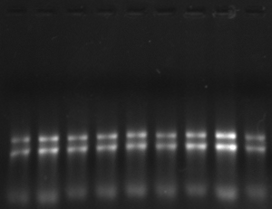
D1 D2 D3 B1 B2 B3 A1 A2 A3
Figure S2 A: Electrophoresis of total RNA from seedlings of Brassica rapa turnip under dark, blue light and UV-A treatment (D1-3, Dark treatment; B1-3, Blue light treatment; A1-3, UV-A treatment)
M 3 4
M 5 6
M 1 2
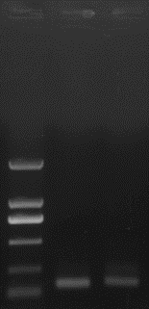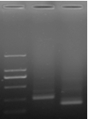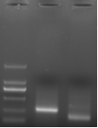

2000bp

1000bp
750bp

500bp

250bp
100bp

2000bp

1000bp
750bp
500bp

250bp
100bp

2000bp

1000bp
750bp
500bp

250bp
100bp

Figure S2 B: Fragments of RLM-5’ RACE (RNA Ligase Mediated 5’-RACE) (M, marker DL2000; 1, Bra016891 (SPL9); 2, Bra014599 (SPL15); 3, Bra003305 (SPL15), product of 2nd nest-PCR; 4, Bra003305 (SPL15), product of 3rd nest-PCR; 5, Bra004674 (SPL9), product of 2nd nest-PCR; 6, Bra004674 (SPL9), product of 3rd nest-PCR)
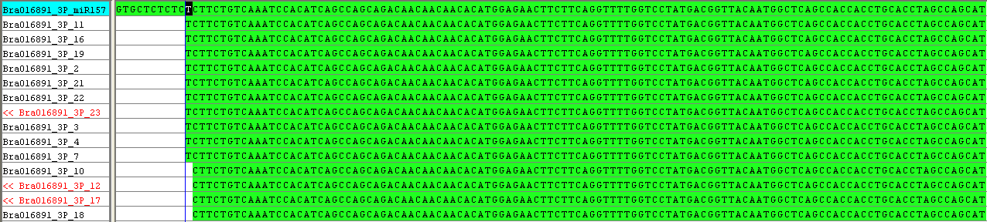
Figure S2 C: Blast analysis of sequencing results with target Bra016891 (SPL9) sequence
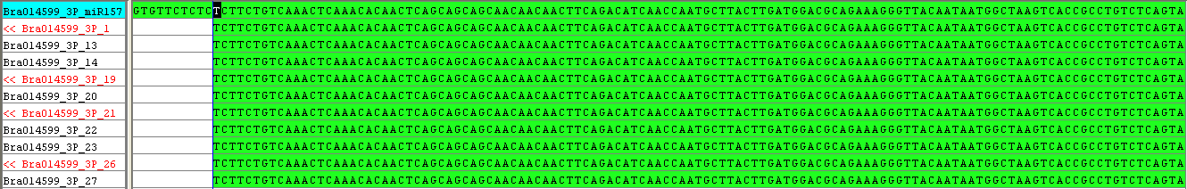
Figure S2 D: Blast analysis of sequencing results with target Bra014599 (SPL15) sequence
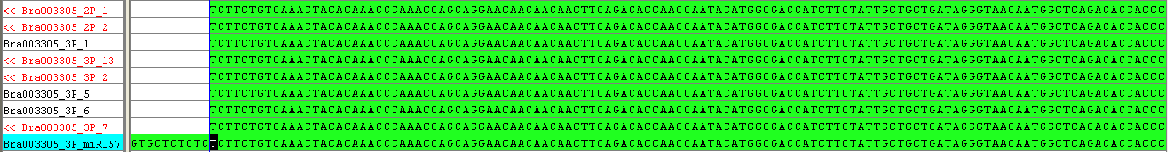
Figure S2 E: Blast analysis of sequencing results with target Bra003305 (SPL15) sequence
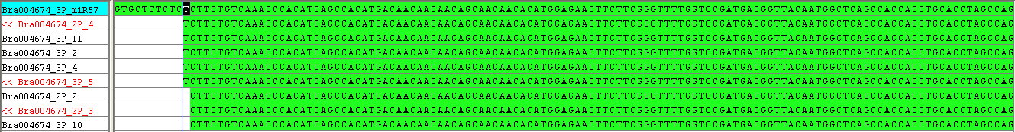
Figure S2 F: Blast analysis of sequencing results with target Bra004674 (SPL9) sequence

