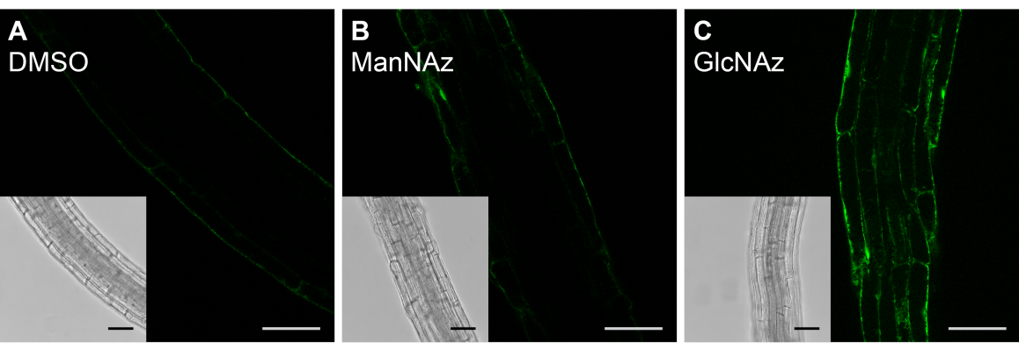
Additional File 5. DMSO-incubated control for the corresponding ManNAz experiment. Optical sections of 4 day old Arabidopsis seedling roots incubated for 24 hours with 0.01 % DMSO as a control (a), 25 µM ManNAz (b), or 25 µM GlcNAz (c), followed by labelling through a copper-catalysed click-reaction with Alexa Fluor® 488 alkyne. Scale bars = 50 μm.

