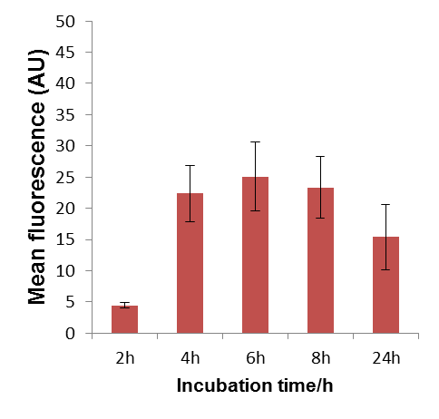
Additional File 7. Mean fluorescence intensity of the epidermal cells of 4 day old Arabidopsis seedling roots illustrating the time-dependent uptake of 25 μM Ac₄GlcNAz. The error bars represent the S.D. in the fluorescent intensity throughout the cells of seedlings . Data of those cells were collected from 3-4 seedlings per treatment.

