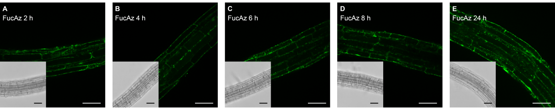Additional File 8A. Optical sections of 4 day old Arabidopsis seedling roots incubated for 2 (a), 4 (b), 6 (c), 8 (d) and 24 hours (e) with 25 µM Ac₄FucAz, followed by labelling through a copper-catalysed click-reaction with Alexa Fluor® 488 alkyne. Scale bars = 50 μm.

Additional File 8B. Mean fluorescence intensity of the epidermal cells of 4 day old Arabidopsis seedling roots illustrating the time-dependent uptake of 25 μM Ac₄FucAz. The error bars represent the S.D. in the fluorescent intensity throughout the cells of seedlings. Data of those cells were collected from 3-4 seedlings per treatment.

