a. actin gene
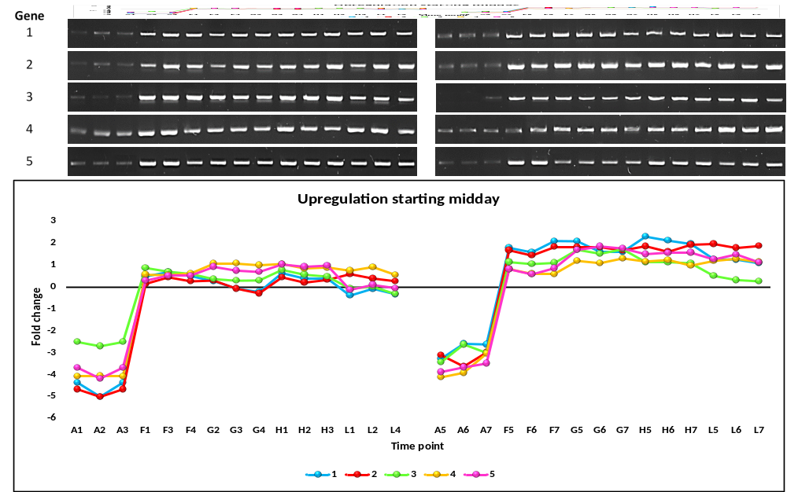
b. Selected upregulated genes starting midday
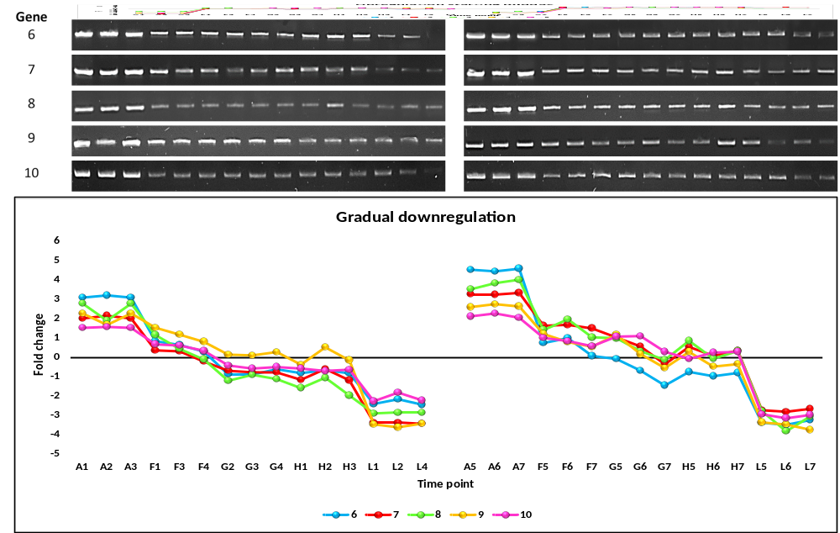
c. Selected gradually downregulated genes
Figure S3.

