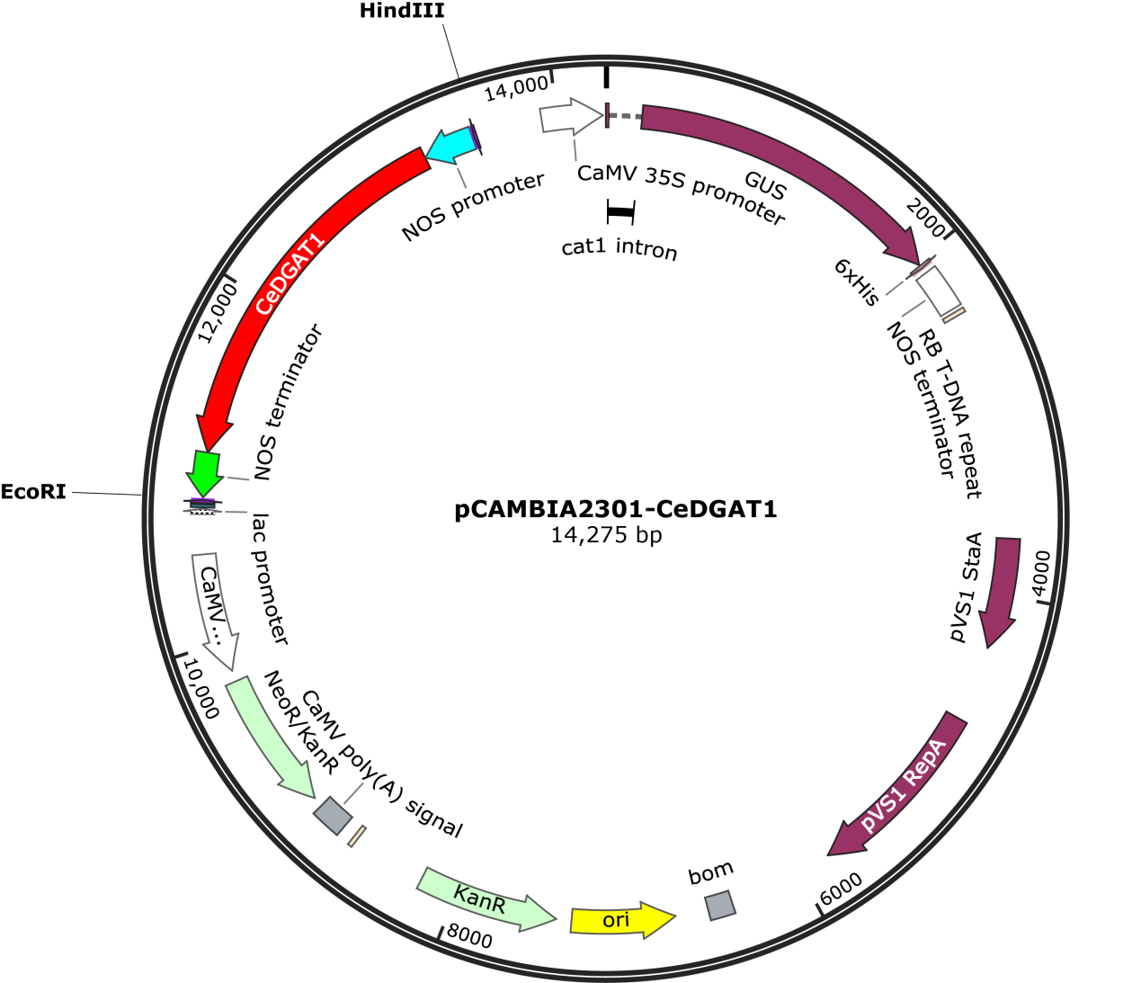
Figure S2. A schematic map of the pCAMBIA2301-NOS-CeDGAT1-nos plasmid. The pCAMBIA2301-NOS-CeDGAT1-nos vector contained: an expression box of the CeDGAT1 gene from Chlorella ellipsoidea under the control of NOS promoter and nos terminator; an expression box of the GUS gene, controlled by the CaMV35S promoter and nos terminator; and an expression box of the kanamycin resistant gene, which conferred resistance to kanamycin.

