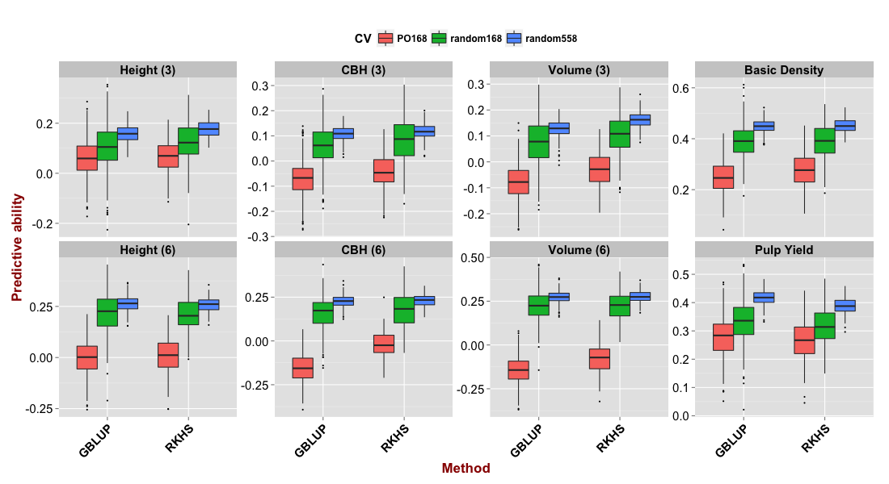
Additional file 13 Predictive abilities by training in pure species eucalypt parents and predicting in their F₁ hybrids. Predictive ability estimated under three training/validation sets (TS/VS) scenarios with two methods (GBLUP and RKHS) for each trait. PO168 (red boxes): all 168 E. grandis and E. urophylla pure species G0 parents used for training and 168 G1 random selected hybrid progeny for validation; random168 (green): randomly selected 168 individuals from all 1,117 for TS and 168 randomly also for VS; random558 (blue): randomly divided all 1,117 individuals into TS and VS of same size (558/558). Outlier estimates are indicated by black dots.

