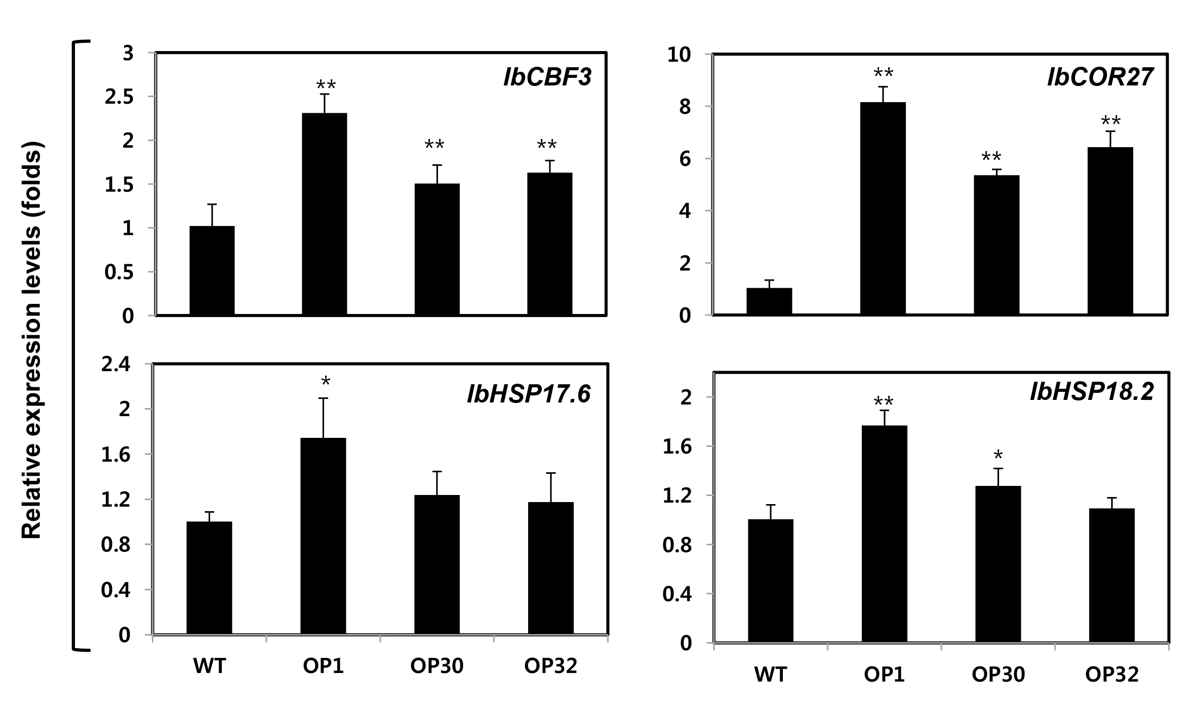

Figure S1. Transcript levels of IbHSP, IbCBF, and IbCOR genes in WT and OP plants. qRT-PCR analysis of IbHSP, IbCBF, and IbCOR genes including IbHSP17.6, IbHSP18.2, IbCBF3 and IbCOR27 was performed using mRNA isolated from sweetpotato leaves. Under normal growth conditions (25°C), WT and OP plant samples were taken, and the transcript levels of these genes were normalized to tubulin gene (TUB) expression. The error bars represent the mean ± SD of three biological replicates. Asterisks indicate significant differences between WT and OP plants by ANOVA at * p < 0.05 and ** p < 0.01.

Table S1. Primers used for PCR analysis.
Primer | Sequence (5'-3') | Application
IbCBF3-F | TTCGCCACTGTCTTCTTC | Real-time PCR
IbCBF3-R | CATATCCTGGACTTCTTGTTG | Real-time PCR
IbCOR27-F | CCAATCTCAGCTTCCTTTGC | Real-time PCR
IbCOR27-R | CATGAACCTCAGCATTGTCG | Real-time PCR
IbHSP17.6-F | CACCACATCATGGACTACGC | Real-time PCR
IbHSP17.6-R | TCGATCTGCACCTTGATGTC | Real-time PCR
IbHSP18.2-F | GAGCGGAGCAAAGAGAAAGA | Real-time PCR
IbHSP18.2-R | TCAATGGCCTTAACCTCTGG | Real-time PCR
TUB-F | CAACTACCAGCCACCAACTGT | Real-time PCR
TUB-R | CAAGATCCTCACGAGCTTCAC | Real-time PCR

