Table S1. Primer sequences used for reverse transcriptase (RT)-PCR analysis of C-repeat binding factors (CBFs), ABA biosynthesis, and certain tomato invertase and invertase inhibitor genes.

Name | Sequenceª
CBF1 | F: 5'-TCTTCTTCATCGTCATCGTCGT-3'
 | R: 5'-GTAGGCATCAGTTTCCACACAAT-3'
CBF2 | F: 5'-ACTAATAATCTCAATCACTACTCCCC-3'
 | R: 5'-GCGTGCACATCAGCTAATTCA-3'
CBF3 | F: 5'-GGACCCACGTATAGAATCTTGTT-3'
 | R: 5'-ACCACTGATTCTTCTTCCTCCG-3'
NCED1 | F: 5'-GTATGACACCACCAGACTCCA-3'
 | R: 5'-AAGCTTCACAGTTGCCTCCA-3'
LIN6 | F: 5'-GTAGATGTAGATTTAGCAGA-3'
 | R: 5'-CTATGGTTTCTTTGTGACGT-3'
LIN8 | F: 5'-CTGGATATGTAGATGTAGAT-3'
 | R: 5'-ACGTCTGCTCAAATATCATG-3'

ª:F: forward primer; R: reverse primer.

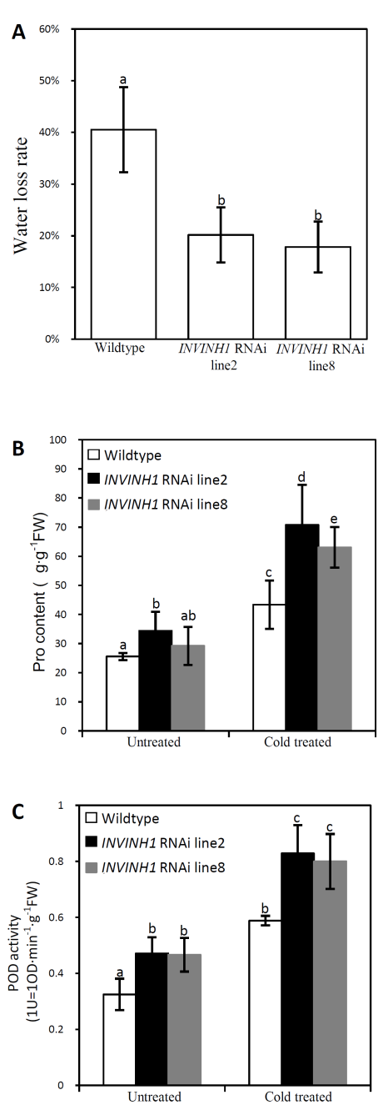
Figure S1 Phenotypic responses of INVINH1 RNAi line 2&8 and wildtype plant under cold stress.
(A) Water loss rate of the leaves from The first mature leaf from 60-d INVINH1 RNAi and wildtype plant, which were recovered at 25℃ for 2 hours after treated at 4℃ for 48 hours.
(B) The proline content of the first mature leaf from 60-d INVINH1 RNAi and wildtype plant before and after treated at 4℃ for 24 hours.
(C) The POD activity of the first mature leaf from 60-d INVINH1 RNAi and wildtype plant before and after treated at 4℃ for 24 hours. (POD activity: 1U=OD·min⁻¹·g⁻¹FW)
Each value is mean±SE of at least ten biological replicates. Lowercase letters indicate values significantly different at P <0.05.
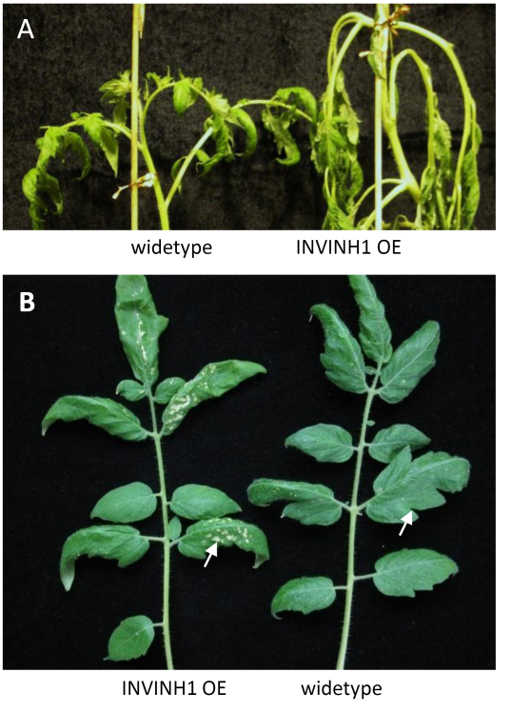
Figure S2 Phenotypic responses of INVINH1 over-expression line 21 and wildtype plant under cold stress.
(A) 65-d INVINH1 over-expression and wildtype plant were treated at 4℃ for 24 hours.
(B) The first mature leaf from 65-d INVINH1 RNAi and wildtype plant, which were recovered at 25℃ for 72 hours after treated at 4℃ for 24 hours.

