Table S1. Sampled populations, geographical variables and individual number used in the study for different marker system
Population | Location | Latitude(°N) | Longitude(°E) |  | Terrain |  |  | Soil |  |  | N_{SSR} | N_{cpDNA} | N_{GBS}
SZW | Siziwang | 42°05'47″ | 111°54'49″ |  | Hill |  |  | NA |  |  | 21 | 21 | 21
ZXB | Zhengxiangbai | 42°36'39″ | 115°12'33″ |  | Hill |  |  | Chestnut soil |  |  | 24 | 24 | 7
DL | Duolun | 42°15'14″ | 116°13'40″ |  | Basin, shady slope |  |  | NA |  |  | 22 | 22 | 15
XH | Xianghuang | 42°12'11″ | 113°50'41″ |  | High plain |  |  | NA |  |  | 24 | 24 | 8
QYH | Qahar Youyi Hou | 41°27'49″ | 113°3'5″ |  | Hill |  |  | NA |  |  | 23 | 23 | 18
XU | Xi Ujimqin | 44°30'1″ | 117°3'5″ |  | Fixed dune |  |  | NA |  |  | 22 | 22 | 12
DU | Dong Ujimqin | 45°16'9″ | 116°4'44″ |  | Hill, sunny slope |  |  | Chernozem |  |  | 18 | 18 | 6
EWK | Ewenki | 49°7′28″ | 120°7′36″ |  | Sandy land |  |  | Sandy soil |  |  | 22 | 22 | 10
CB | ChenBarag | 49°8′55″ | 118°51′38″ |  | Sandy land |  |  | Sandy soil |  |  | 24 | 24 | 10
XBY | Xin Barag you | 48°48′25″ | 116°59′48″ |  | Lakeside |  |  | Sandy soil |  |  | 21 | 21 | 20
Total |  |  |  |  |  |  |  |  |  |  | 221 | 221 | 127
NA = Not available

Table S2. The 22 SSR loci analyzed in 10 C. microphylla populations.
Markers | Genebank accession | Forward primer (5'-3') | Reverse primer (5'-3') | Expected size (bp)
CM01 | KC959482 | TGATTAACAAAGATGTGTTGCCTT | ATATTGCCCTCCTTCCTTGG | 242
CM02 | KC959488 | CCCGAAACAAACAAAAGGAA | GTACGTACGGGAAAGGGTGA | 278
CM04 | KC959490 | CCCAAAACAAACAAAGGGAA | GTACGTACGGGAAAGGGTGA | 269
CM05 | KC959491 | GGAGACTTCACCAGTGCCAT | ACCCCTAGGCTGACCTGACT | 187
CM06 | KC959491 | CCCAGTGTTTCTCACCGTTT | CTTCACCGATTCCAACTTCG | 195
CM07 | KC959493 | CAAAAACCAACCCAAAACAAA | GTACGTACGGGAAAGGGTGA | 280
CM11 | KC959498 | ATTGAAACCATTTGGATCGG | ACACCACCACAACCCATTTT | 236
CM13 | KC959501 | TCACTTGATATGATCTCCCCC | GTCCCTGTGCAAATTGTTCC | 203
CM18 | KC959507 | ATTGAAACCATTTGGATCGG | ACACCACCACAACCCATTTT | 236
CM21 | KC959511 | CAGACGAGGATTTGCTGC | AGTGAAAGTGGGTGTGGAGG | 197
CM22 | KC959511 | GTTGACTGCACGAATGTTGG | ATGCGTGTGAAGGTGAGAGA | 183
CM23 | KC959512 | CACGAAAGGCTACAACTTTGG | ACCACCGCTCTTTAATTCCC | 270
CM27 | KC959516 | TTCCCAAACCGAAGAAACAC | ATTGCGGGACATCAAATAGG | 251
CM31 | KC959521 | TTCCCAAACCGAAGAAACAC | ATTGCGGGACATCAAATAGG | 245
CM37 | KC959529 | TTATCACACGGGCATGACTC | CTAAACCCGAACCAAACCAA | 266
CM39 | KC959531 | AAGCAGATCCAGAAGTGGCA | ACAATGGGACAGTGGGTCTC | 209
CM42 | KC959533 | ACAATGGGACAGTGGGTCTC | TGCTGACAGATGATCTAGGGC | 239
CM44 | KC959535 | AAAAGGGAGTGTGGTTGTGG | TGCTGACAGATGATCTAGGGC | 210
CM45 | KC959536 | TGCTGACAGATGATCTAGGGC | ACAATGGGACAGTGGGTCTC | 239
CM49 | KC959540 | TGCTGACAGATGATCTAGGGC | ACAATGGGACAGTGGGTCTC | 238
CM52 | KC959542 | TGCTGACAGATGATCTAGGGC | ACAATGGGACAGTGGGTCTC | 240
CM54 | KC959543 | ACAATGGGACAGTGGGTCTC | TGCTGACAGATGATCTAGGGC | 242

Table S3. 19 bioclimatic variables for 10 C. microphylla populations.
Pop | Bio1 | Bio2 | Bio3 | Bio4 | Bio5 | Bio6 | Bio7 | Bio8 | Bio9 | Bio10 | Bio11 | Bio12 | Bio13 | Bio14 | Bio15 | Bio16 | Bio17 | Bio18 | Bio19
SZW | 31 | 131 | 26 | 13237 | 269 | -230 | 499 | 193 | -150 | 193 | -150 | 211 | 65 | 2 | 110 | 140 | 6 | 140 | 6
ZXB | 27 | 126 | 25 | 13315 | 259 | -232 | 491 | 187 | -156 | 187 | -156 | 310 | 86 | 2 | 106 | 207 | 8 | 207 | 8
DL | 14 | 126 | 26 | 12891 | 238 | -241 | 479 | 168 | -164 | 168 | -164 | 376 | 109 | 2 | 106 | 251 | 9 | 251 | 9
XH | 33 | 118 | 25 | 12557 | 256 | -210 | 466 | 186 | -138 | 186 | -138 | 294 | 78 | 2 | 106 | 200 | 7 | 200 | 7
QYH | 34 | 128 | 27 | 11927 | 254 | -205 | 459 | 180 | -128 | 180 | -128 | 329 | 91 | 2 | 107 | 223 | 8 | 223 | 8
XU | 13 | 135 | 26 | 13876 | 260 | -255 | 515 | 182 | -176 | 182 | -176 | 317 | 92 | 3 | 108 | 218 | 9 | 218 | 9
DU | 9 | 137 | 25 | 14316 | 266 | -262 | 528 | 184 | -185 | 184 | -185 | 257 | 72 | 2 | 109 | 178 | 6 | 178 | 6
EWK | -11 | 128 | 22 | 15531 | 254 | -304 | 558 | 177 | -189 | 177 | -224 | 379 | 107 | 3 | 110 | 262 | 12 | 262 | 12
CB | -9 | 131 | 22 | 16053 | 265 | -310 | 575 | 185 | -194 | 185 | -228 | 328 | 101 | 3 | 114 | 232 | 10 | 232 | 10
XBY | 6 | 127 | 23 | 15331 | 271 | -274 | 545 | 195 | -167 | 195 | -200 | 262 | 87 | 1 | 127 | 196 | 4 | 196 | 4
Bio1 = Annual Mean Temperature, Bio2 = Mean Diurnal Range (Mean of monthly (max temp - min temp)), Bio3 = Isothermality (P2/P7) (* 100), Bio4 = Temperature Seasonality (standard deviation *100), Bio5 = Max Temperature of Warmest Month, Bio6 = Min Temperature of Coldest Month, Bio7 = Temperature Annual Range (P5-P6), Bio8 = Mean Temperature of Wettest Quarter, Bio9 = Mean Temperature of Driest Quarter, Bio10 = Mean Temperature of Warmest Quarter, Bio11 = Mean Temperature of Coldest Quarter, Bio12 = Annual Precipitation, Bio13 = Precipitation of Wettest Month, Bio14 = Precipitation of Driest Month, Bio15 = Precipitation Seasonality (Coefficient of Variation), Bio16 = Precipitation of Wettest Quarter, Bio17 = Precipitation of Driest Quarter, Bio18 = Precipitation of Warmest Quarter, Bio19 = Precipitation of Coldest Quarter.

Table S4. Pairwise F_{ST} detected by SSRs among 10 C. microphylla populations.
 | SZW | ZXB | DL | XH | QYH | XU | DU | EWK | CB | XBY
SZW | 0.000
ZXB | 0.019* | 0.000
DL | 0.029** | 0.017* | 0.000
XH | 0.017* | 0.011^{ns} | 0.019* | 0.000 | 0.000
QYH | 0.039** | 0.051** | 0.070** | 0.035** | 0.000
XU | 0.125** | 0.131** | 0.143** | 0.133** | 0.123** | 0.000
DU | 0.047** | 0.048** | 0.062** | 0.046** | 0.056** | 0.049** | 0.000
EWK | 0.157** | 0.160** | 0.164** | 0.159** | 0.167** | 0.103** | 0.101** | 0.000
CB | 0.195** | 0.200** | 0.206** | 0.199** | 0.209** | 0.124** | 0.144** | 0.092** | 0.000 | 0.000
XBY | 0.183** | 0.179** | 0.196** | 0.199** | 0.221** | 0.124** | 0.152** | 0.139** | 0.145** | 0.000
**, significance at P < 0.01, *, significance at P < 0.05, ^{ns} significance at P > 0.05

Table S5. Pairwise F_{ST} detected by cpDNA among 10 C. microphylla populations.
 | SZW | ZXB | DL | XH | QYH | XU | DU | EWK | CB | XBY
SZW | 0.00
ZXB | 0.13** | 0.00
DL | 0.11** | 0.08* | 0.00
XH | 0.06 ^{ns} | 0.03 ^{ns} | 0.11* | 0.00
QYH | 0.03 ^{ns} | 0.13** | 0.13** | 0.00 ^{ns} | 0.00
XU | 0.44** | 0.52** | 0.38** | 0.51** | 0.50** | 0.00
DU | 0.46** | 0.55** | 0.38** | 0.54** | 0.49** | 0.07 | 0.00
EWK | 0.62** | 0.71** | 0.58** | 0.69** | 0.65** | 0.19* | 0.14 ^{ns} | 0.00
CB | 0.63** | 0.71** | 0.59** | 0.50** | 0.66** | 0.20* | 0.15 ^{ns} | 0.00 | 0.00
XBY | 0.61** | 0.69** | 0.57** | 0.69** | 0.64** | 0.19* | 0.13 ^{ns} | 0.00 | 0.00 | 0.00
**, significance at P < 0.01, *, significance at P < 0.05, ^{ns} significance at P > 0.05

Table S6. Pairwise F_{ST} detected by GBS among 9 C. microphylla populations.
 | ZXB | DL | XH | QYH | XU | DU | EWK | CB | XBY
ZXB | 0.000
DL | 0.029^{ns} | 0.000
XH | 0.073* | 0.049 ^{ns} | 0.000
QYH | 0.066* | 0.083* | 0.024 ^{ns} | 0.000
XU | 0.182** | 0.139** | 0.209** | 0.228** | 0.000
DU | 0.135** | 0.085* | 0.167** | 0.170** | 0.056* | 0.000
EWK | 0.297** | 0.234** | 0.349** | 0.366** | 0.125** | 0.138** | 0.000
CB | 0.335** | 0.263** | 0.385** | 0.398** | 0.151** | 0.170** | 0.063* | 0.000
XBY | 0.383** | 0.336** | 0.420** | 0.431** | 0.204** | 0.221** | 0.126** | 0.143** | 0.000
**, significance at P < 0.01, *, significance at P < 0.05, ^{ns} significance at P > 0.05

Fig. S1. Plots of our 10 sample localities in climate space. Each point represents the environmental values of a population on PC axes 1 and 2 (left) and PC axes 2 and 3 (right). The distribution of points across the climate space graphs shows how our sampling scheme captures a wide range of environmental variation.
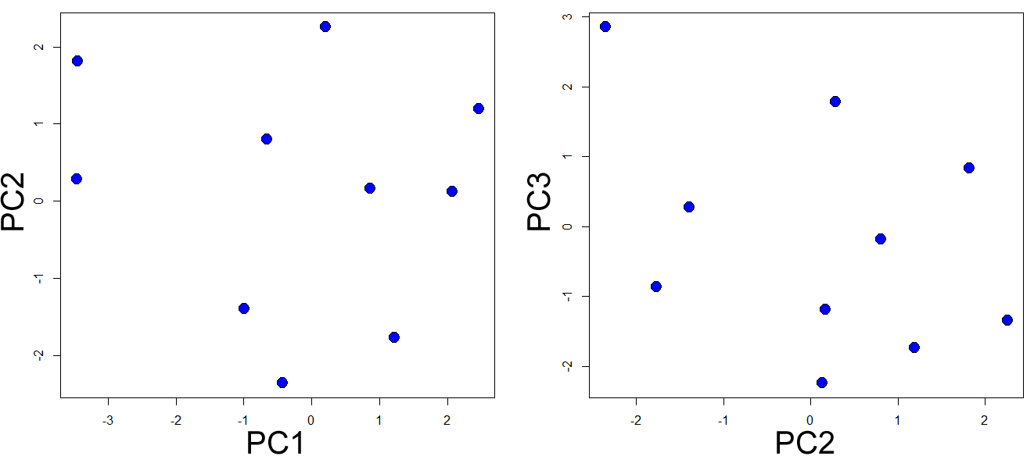

Fig. S2. Population genetic structure analysis for SSR (A) and GBS (B) based markers of C. microphylla, showing the ΔK statistics calculated according to Evanno et al. (2005).
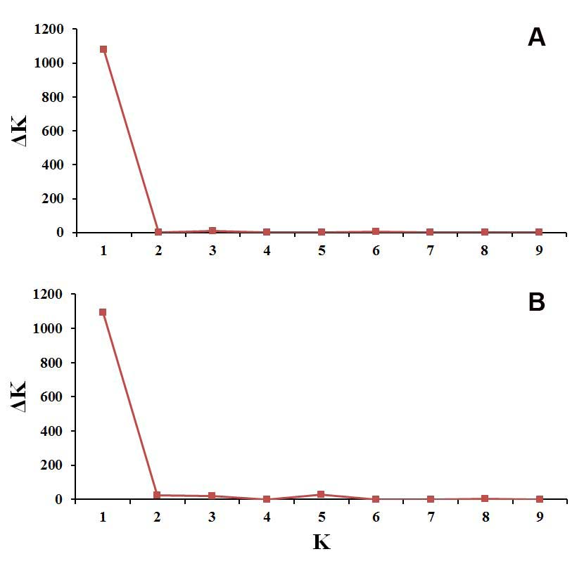

Fig. S3. Jackknife analyses of individual predictor importance for C. microphylla applied to the Maxent model, presented in relation to overall model quality or “total gain”. Dark blue bars indicate the gain achieved when including that predictor only and excluding remaining predictors; light blue bars show how the total gain is diminished without the given predictor.
