Additional file 7. Figure S3

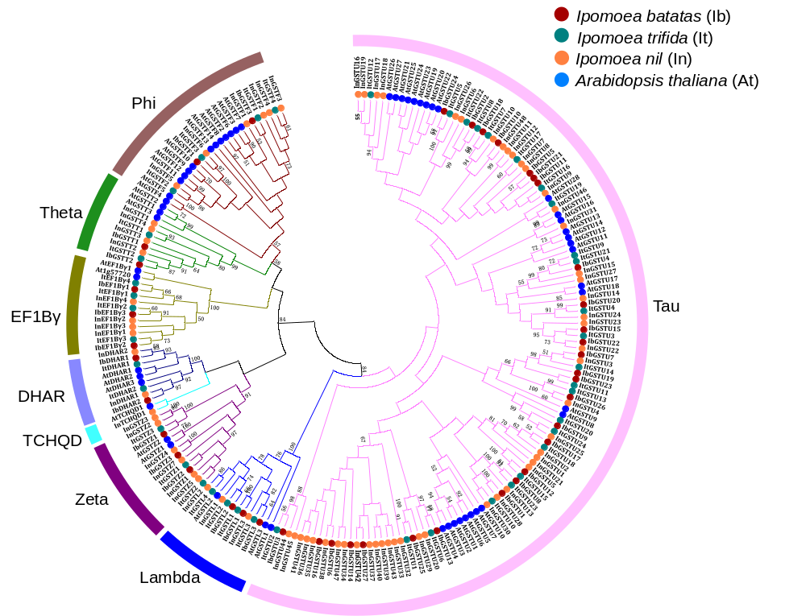

Figure S3. Phylogenetic tree and subfamily classification of GST proteins from sweet potato, Ipomoea nil, Ipomoea trifida, and Arabidopsis thaliana. Multiple alignments of amino acids were executed by Muscle Program and the phylogenetic tree was constructed using MEGA 7.0 by the Neighbor-joining (NJ) method with 1,000 bootstrap replicates.

