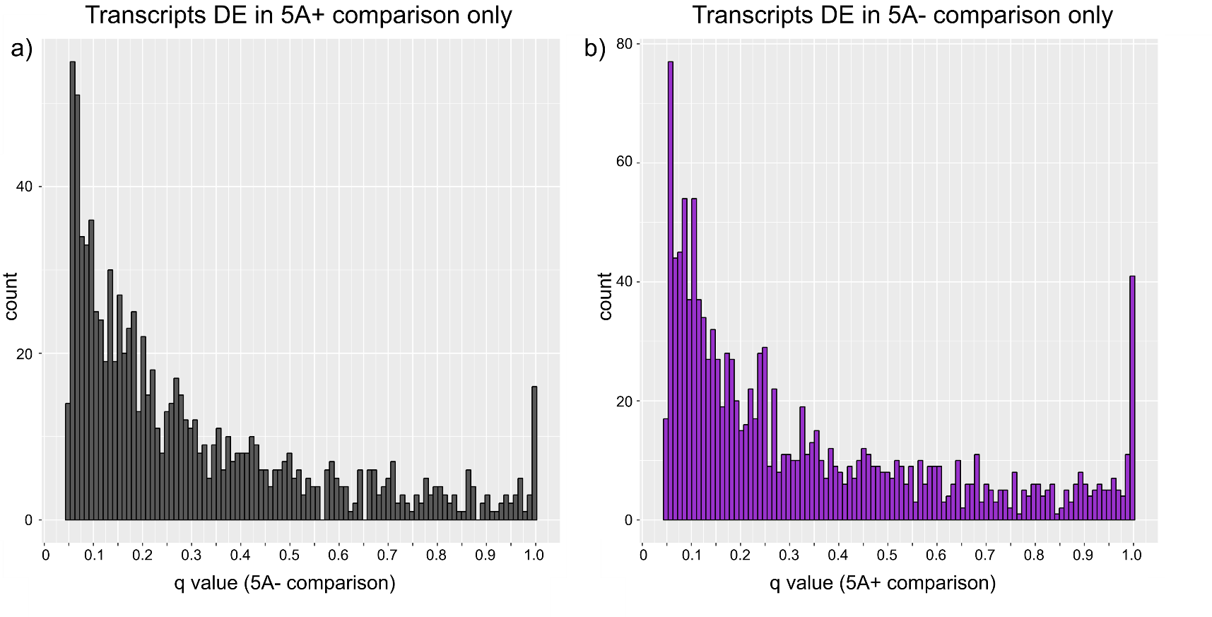
Additional file 3: q-values distributions of uniquely differentially expressed transcripts across time
a) Distribution of ${\text{5A-} }_{\text{T2}}^{\text{T1}}$ q-values for transcripts that were differentially expressed (DE) only in the ${\text{5A+} }_{\text{T2}}^{\text{T1}}$ comparison (and not the ${\text{5A-} }_{\text{T2}}^{\text{T1}}$ comparison). b) Distribution of ${\text{5A-} }_{\text{T2}}^{\text{T1}}$ q-values for DE transcripts across time in the ${\text{5A-} }_{\text{T2}}^{\text{T1}}$ comparison only. The fact that both distributions are skewed towards lower q-values shows suggests that many of the DE genes within a single comparison were borderline non-significant in the opposite comparison.

