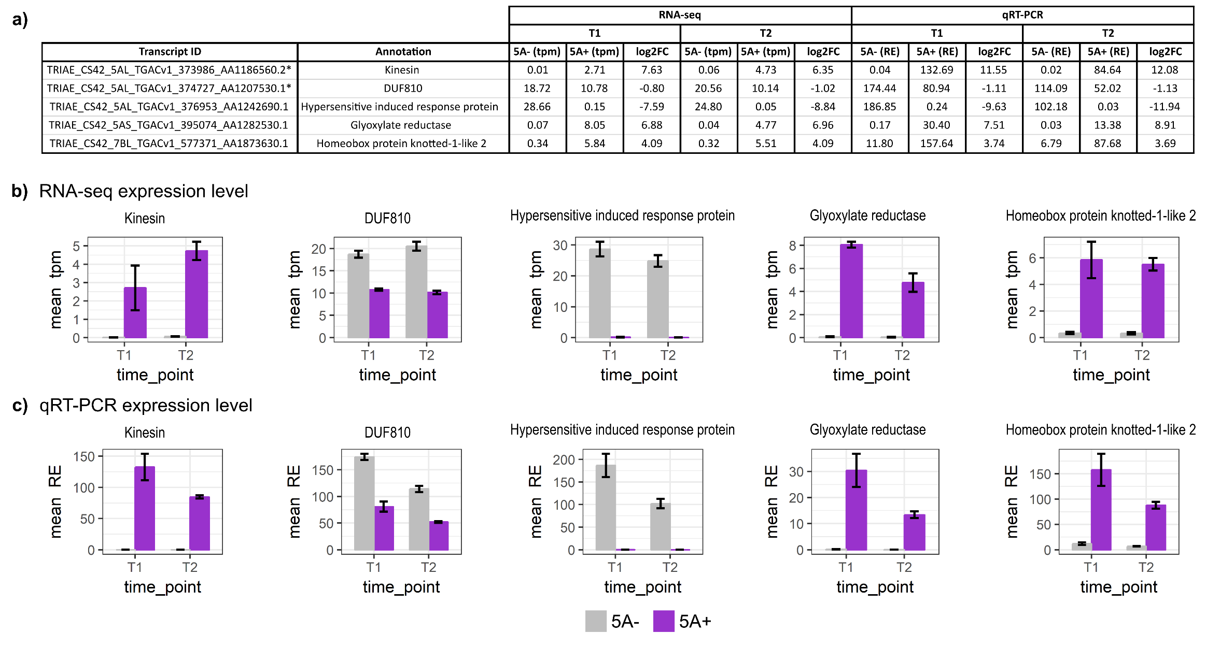
Additional file 7: Quantitative reverse-transcript PCR (qRT-PCR) of a subset of differentially expressed (DE) transcripts
a) Table of expression values for five DE transcripts obtained from RNA-seq data and qRT-PCR. tpm = transcripts per million, RE = relative expression to actin (10⁻³), log2FC = log2 fold change in expression in 5A+ near isogenic line (NIL) compared to 5A- NIL, * indicates transcripts located within the fine mapped region on chromosome 5A. b) Bar charts showing mean tpm of the five transcripts obtained using RNA-seq. c) Bar charts showing mean RE of the five transcripts obtained using qRT-PCR. In all cases error bars represent standard error of the mean, n = 3 biological replicates. Grey bars = 5A- NIL, purple bars = 5A+ NIL. All pairwise comparisons between NILs are significantly different as determined by t-tests at both timepoints 1 and 2.

