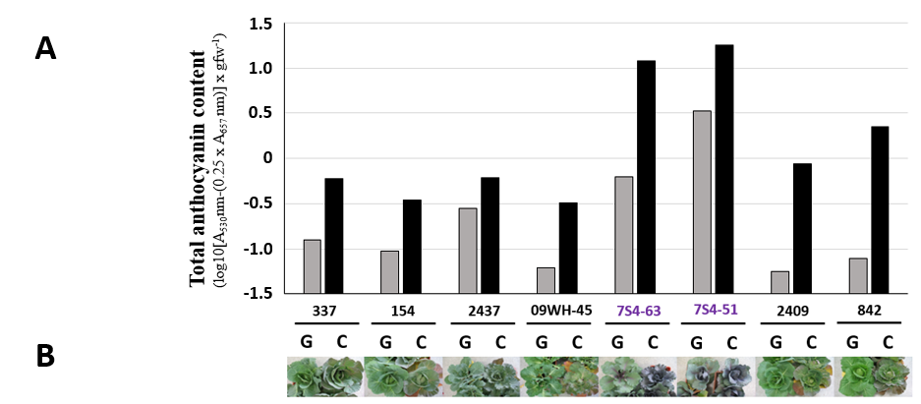

Additional file 4: Figure S1. Total anthocyanin content (A) of samples of the cabbages (B) shown in Figure 1.

