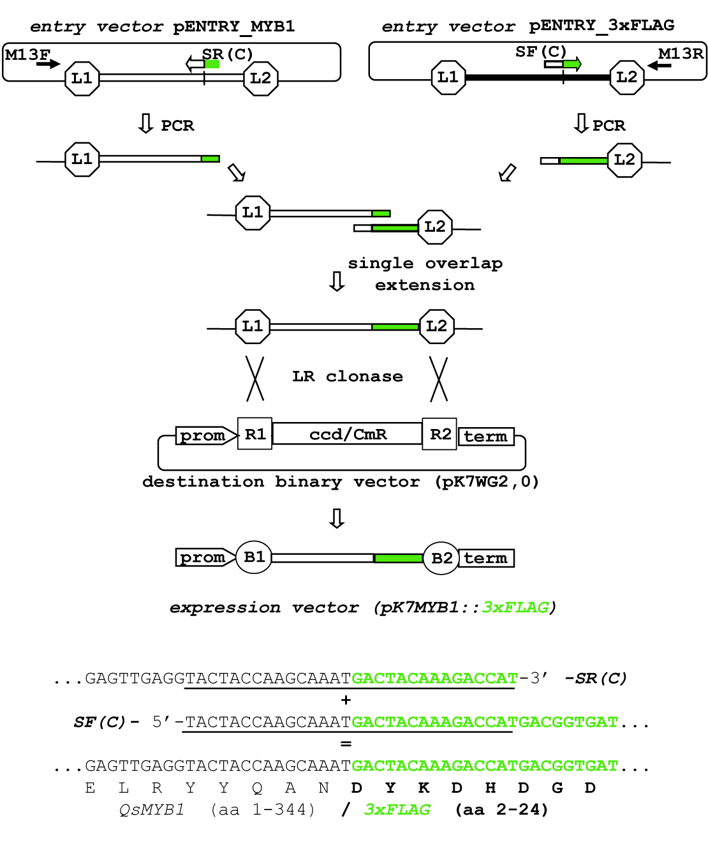
Figure S1 – Gene construction strategy used for QsMYB::triple FLAG epitope fusion protein production.

Table S1 - Primers used to generate the overexpression destination vector pK7MYB1::3xFLAG
Primer | Sequence
M13F | 5’-gtaaaacgacggccagt-3’
M13R | 5’-CAG GAA ACA GCT ATG AC-3’
SF(C) | 5’-TAC TAC CAA GCA AAT GAC TAC AAA GAC CAT-3’
SR(C) | 5’-ATG GTC TTT GTA GTC ATT TGC TTG GTA GTA-3’
3xFLAG_F_Olig | 5’- AGCTTAGACTACAAAGACCATGACGGTGATTATAAAGATCATGACATCGATTACAAGGATGACGATGACAAGTGATATCG -3’
3xFLAG_R_Olig | 5’- GATCCGATATCACTTGTCATCGTCATCCTTGTAATCGATGTCATGATCTTTATAATCACCGTCATGGTCTTTGTAGTCTA -3’
MYB1ns_attB1F | 5’- AAAAAGCAGGCTTAGAAGGAGATAGAACCATGGGGAGAGCTCCATGTTGTGACAAAG -3’
MYB1ns_attB2R | 5′- AGAAAGCTGGGTCATTTGCTTGGTAGTACCTCAACTCT -3’
attB1 adapter | 5′- GGGGACAAGTTTGTACAAAAAAGCAGGCT -3′
attB2 adapter | 5’- GGGGACCACTTTGTACAAGAAAGCTGGGT -3′

Table Ss2 - Primers used to confirm the integration of the foreign DNA delivered by the destination vector plasmid and to quantify the QsMYB1::3xFLAG transcript by RT-qPCR

Primer | Sequence
qPCRQsMYB1F | 5’-AGCCTAAAGCAAGAGATGAAGAGAG-3’
SR(C) | 5’-ATG GTC TTT GTA GTC ATT TGC TTG GTA GTA-3’
nptIIF | 5’-GAGGCTATTCGGCTATGACTG-3’
nptIIR | 5’-ATCGGGAGCGGCGATACCGTA-3’
virGF | 5’-AAGGTGAGCCGTTGAAACAC-3’
virGR | 5’-ATCTCAAGCCCATCTTCACG-3’

