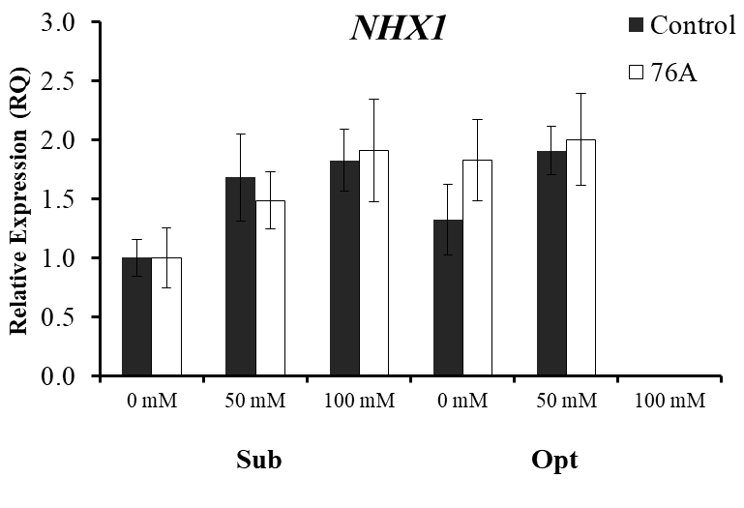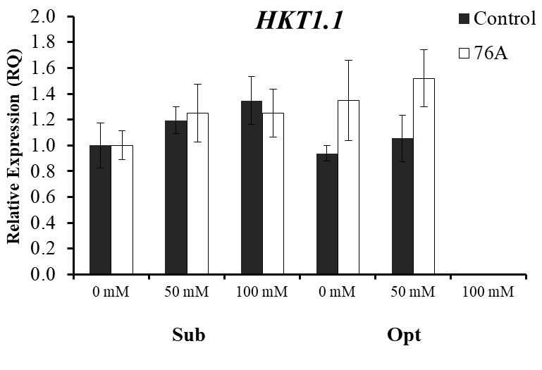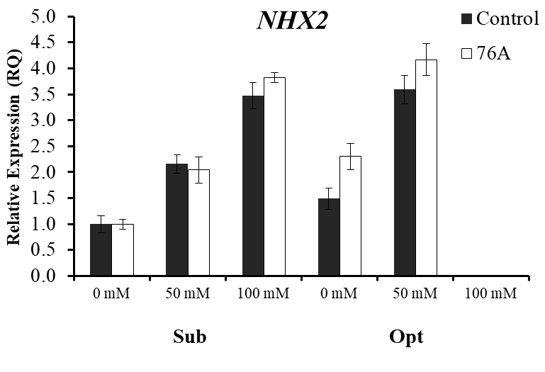
*
A
B
C
Additional file 1: Figure S1 Gene Expression of ion transporters. (A) NHX1, (B) NHX2, (C) HKT1;1, relative Expression (RQ) quantified by qRT-PCR in samples of uninoculated (control) and inoculated (76A) plants treated with: 0 mM, 50 mM, and 100 mM NaCl. Single asterisks denote significant differences according to Student (P<0.1) between untreated controls and inoculated, double asterisks denote (P<0.05) and triple asterisks denote (P<0.01) between untreated controls and inoculated plants.

Additional file 1: Table S1: Primers used in this study
SlActin-F | Solyc03g078400.2 | TGAATGCACGGTAGCAAACAACAGATT
SlActin-R | Solyc03g078400.2 | AATGCATCAGGCACCTCTCAAGTAT
SlNii-F | Solyc01g108630.2 | GGATTCATGGGATGCCTGACTAGA
SlNii-R-R | Solyc01g108630.2 | TTCTCGTGGAACTGCACCAAAGT
SlAMT2-F | Solyc04g050440.2 | TTGTACCGCCGCTCTGACAACTTT
SlAMT2-R | Solyc04g050440.2 | CATGGCTCAACAACTGCACAACCT
SlNRT2.1-F | Solyc06g074990.1 | TCCAGTCAAGGGAACGGAAGAACA
SlNRT2.1-R | Solyc06g074990.1 | ACCACGCTCTGATCGGCAATTT
SlNR-F | Solyc01g087550.2 | CAAGCAATCCATCTCCCAT
SlNR-R | Solyc01g087550.2 | CATCTCTGTATCGTCTTCAGGA
SlLEA-F | Solyc03g116390.2 | AGCGATGCTCCTCACTTGTT
SlLEA-R | Solyc03g116390.2 | CGAAGGAGAAGGCTAGTGGA
SlSOS1-F  SlSOS1-R | Solyc01g005020  Solyc01g005020 | TCGAGTGATGATTCTGGTGG  ATCACAGTGTGGAAAGGCT
SlNHX2-F  SlNHX2-R | Solyc04g056600.2  Solyc04g056600.2 | ATTGGAGGATCGGCAGGAAC  CCATGGAGCCAGATTGACCA
SlNHX1-F  SlNHX1-F | Solyc06g008820.2  Solyc06g008820.2 | CACGATATGGTGGGCTGGTT  GGGTGTGGCCAAATCTCGTA
SlHKT1.1-F | Solyc07g014680.2 | TCTAGCCCAAGAAACTCAAAT
SlHKT1.1-R | Solyc07g014680.2 | CTAATGTTACAACTCCAAGGAATT

