Figure S1. Sequence alignment of TaPDS from wheat variety Fielder and HvPDS from barley variety Golden Promise with guide sites indicated.
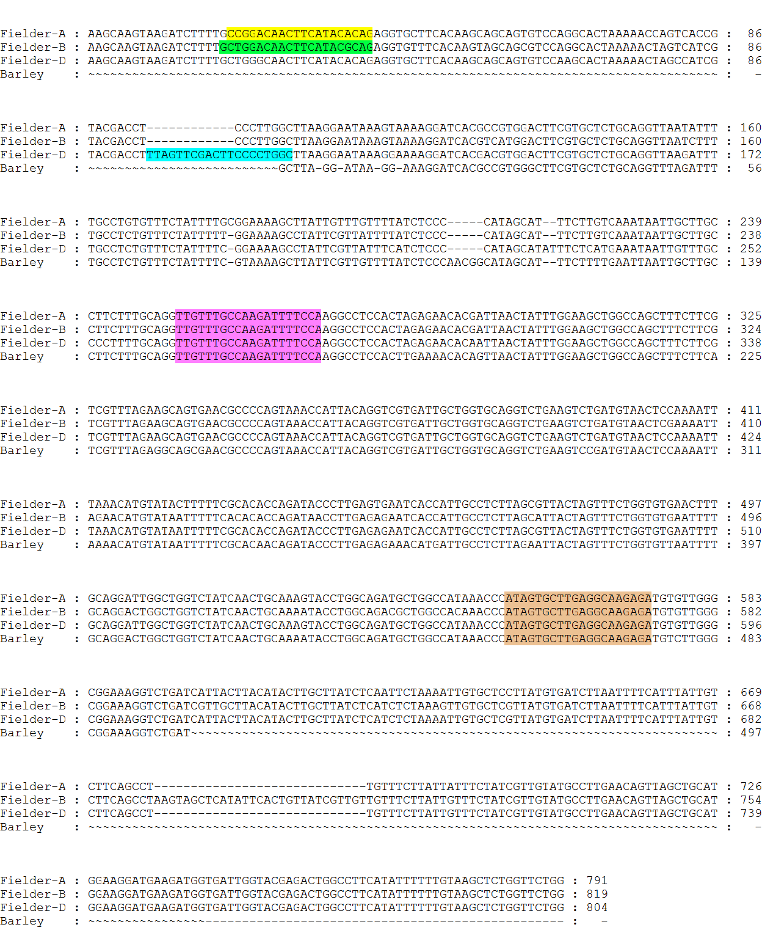

Guide regions for vectors are coloured as follows:-
Yellow, TaU6 A genome guide (pRMH120, pRMH123 and pRMH131); Green,OsU3 B genome guide (pRMH121); Blue, TaU3 D genome guide (pRMH125), Pink, TaU6 tri-genome (pRMH110); Orange, OsU3 tri-genome (pRMH131)

