B-box 2
B-box 1
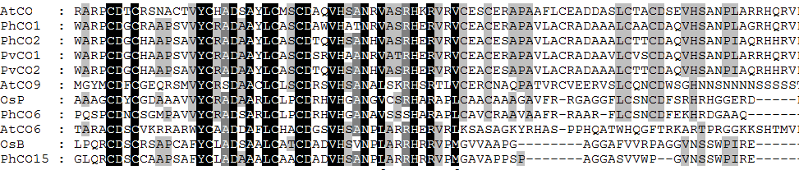
CCT domain

Group Ⅲ
GroupⅡ
GroupⅠ

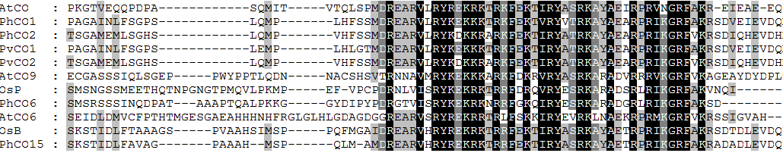
Group Ⅲ
GroupⅡ
GroupⅠ

Fig. S1. Alignment of predicted N and C amino acid sequences of partial COLs from Arabidopsisthaliana, Oryza sativa, Ph. violascens, and Ph. heterocycla. The B-box domain and CCT domain are labeled by red lines. The second diverged B-box in group II is labeled by red box.

