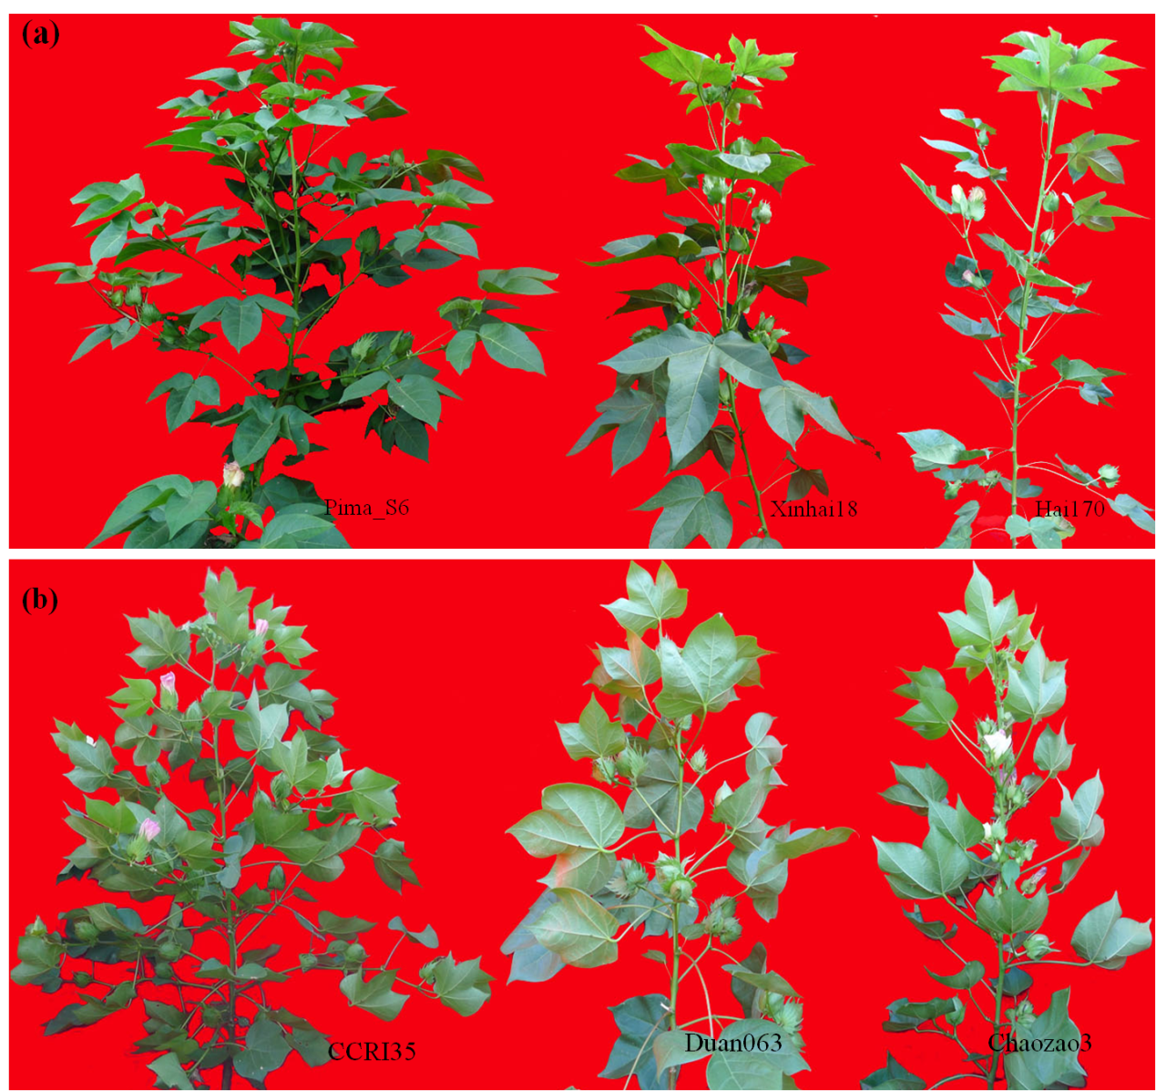

Fig. S1. Plant morphologies of WT and mutants with cl trait in G. barbadense and G. hirsutum. (a) Plant architecture in G. barbadense. Pima-S6 (WT) with indeterminate growth habit; Xinhai18 and Hai170 (mutant) in determinate growth habit with clustering fruit. (b) Plant architecture in G. hirsutum. CCRI35 (WT) with indeterminate growth habit; Duan063 and Chaozao3 (mutant) in determinate growth habit with clustering fruit. Scale bar, 20 cm.

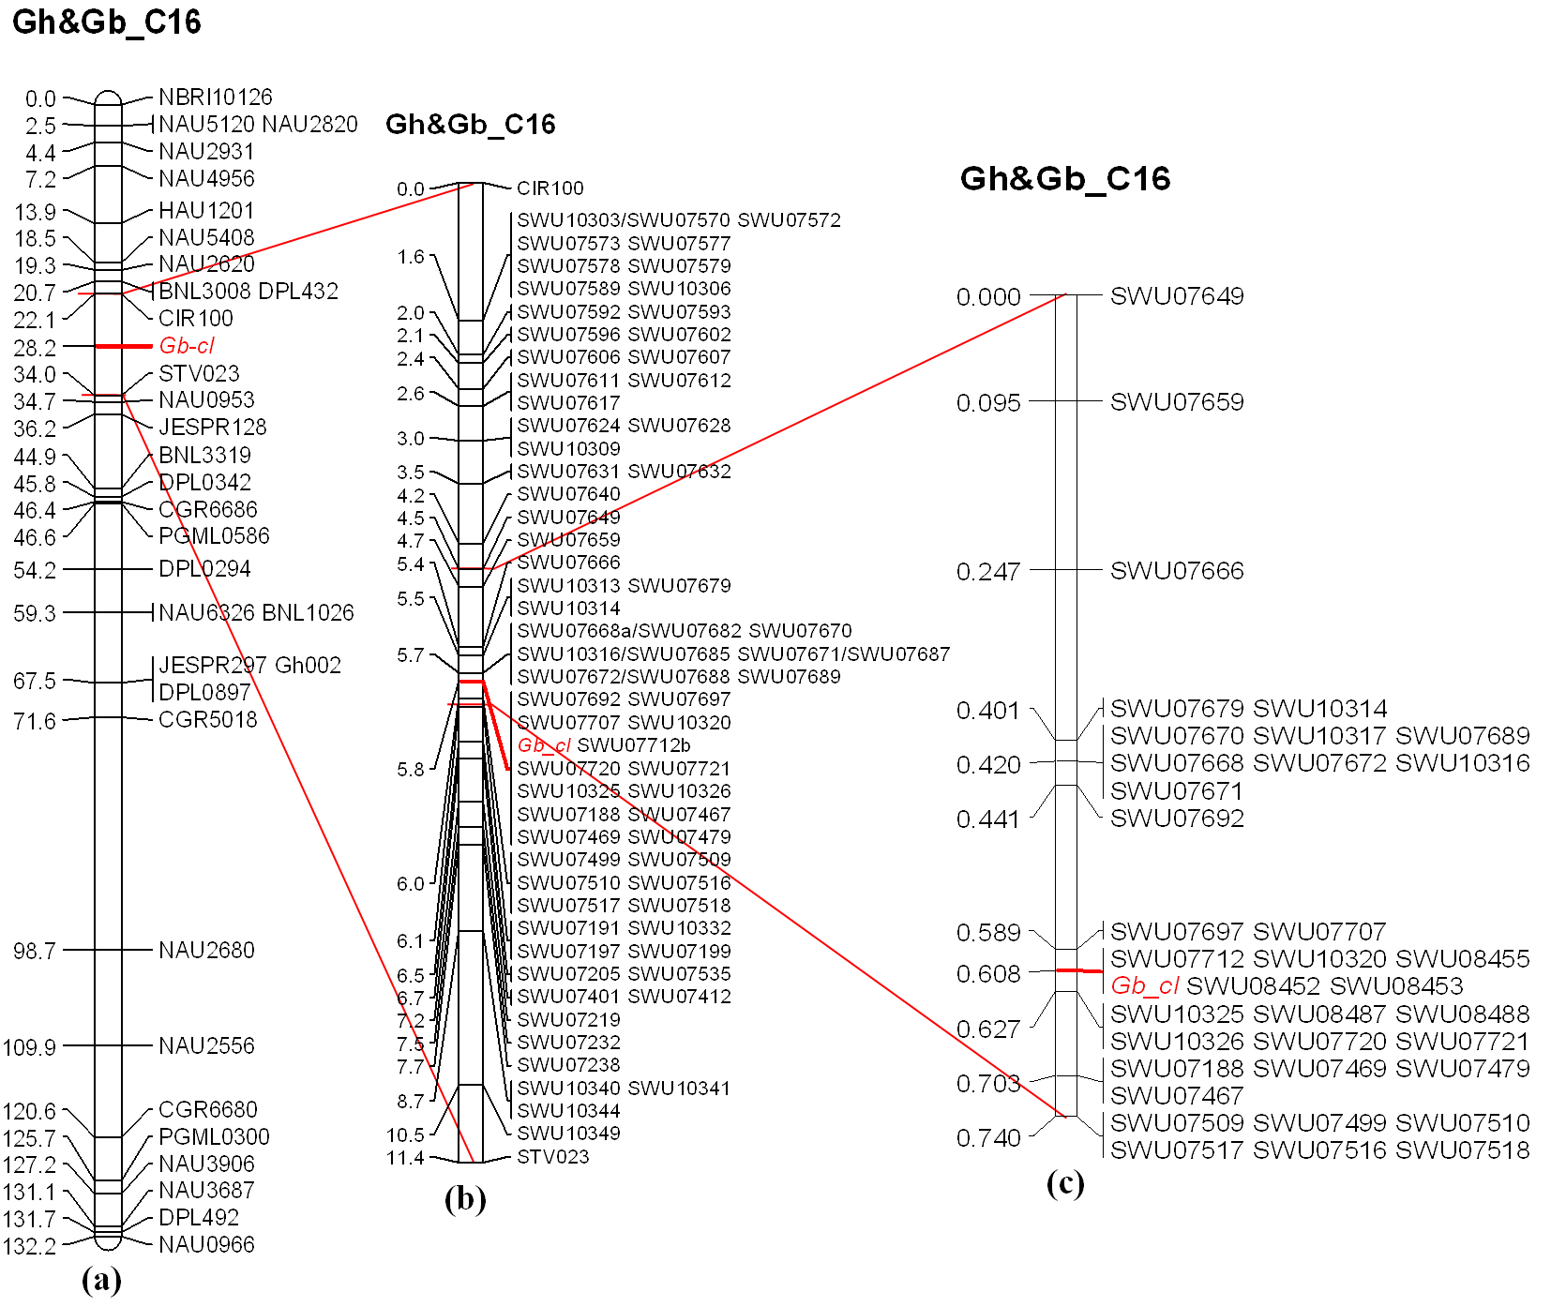
Fig. S2. Fine mapping of Gb-cl. (a) Preliminary location of Gb-cl. Gb-cl was mapped on chromosome 16 with 90 plants from (G. hirsutum cultivar CCRI 35 × G. barbadense line Hai170) F₂ population. (b) The high-density genetic map of Gb-cl region. Gb-cl was further mapped to an interval flanked by SWU07689 and SWU 07518 and co-segregated with 13 markers. New SSR primer was showed in Supplementary Data 1. (c) Fine mapping Gb-cl using a large F₂ population with 2341 plants. Gb-cl was mapped to a 0.019-cM region between marker SWU07707 and SWU08487 and co-segregated with 5 markers.

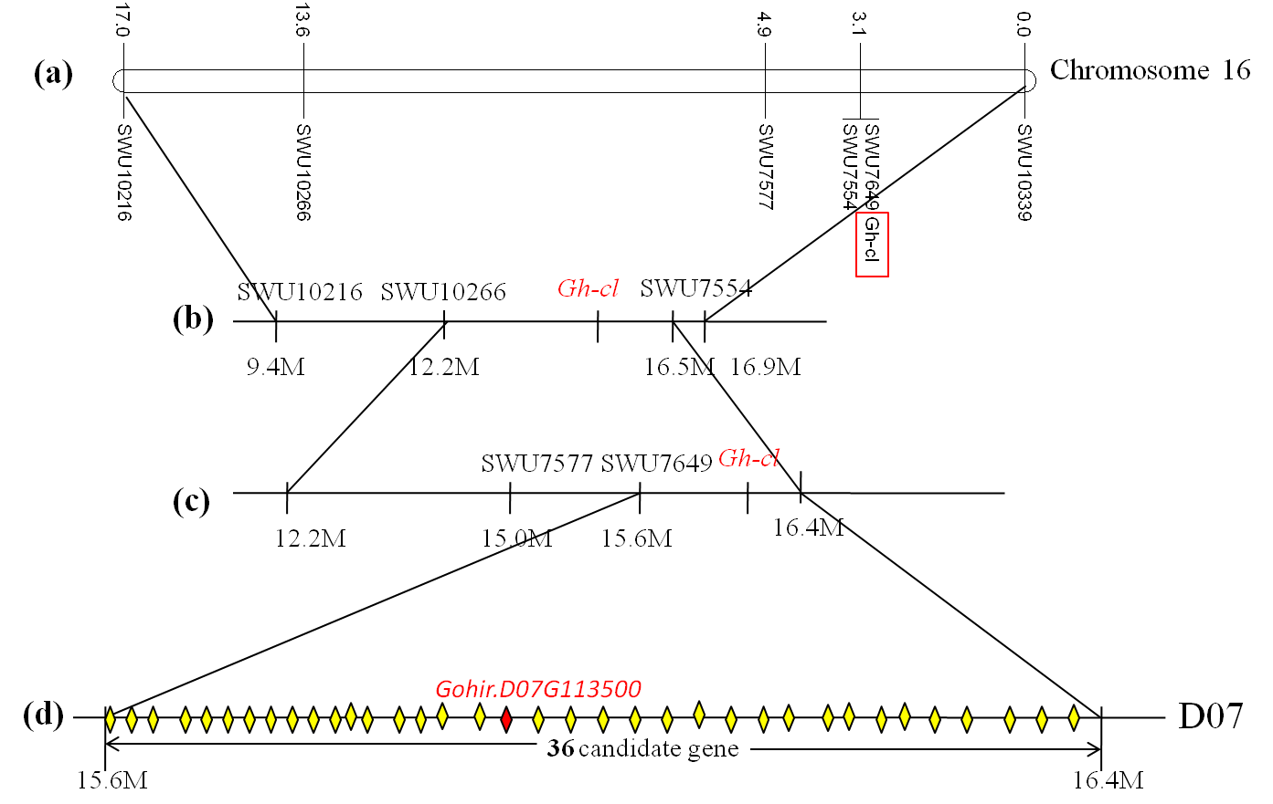
Fig. S3. Gnentic mapping of Gh-cl. (a) The preliminary location of Gh-cl. Gh-cl was maped on chromosome 16 using a G. hirsutum intraspecific F₂ population with 90 plants from a cross between Yumian1 and Chaozao3. (b and c) Fine mapping of Gh-cl. Gh-cl was narrowed to a 0.8-Mb region ﬂanked between SWU7649 and SWU7554 with a large F₂ population with 2236 plants. (d) Physical mapping for Gh-cl. Thirty-six putative open reading frames including Gohir.D07G113500 are predicted within this region, based on G.hirsutum acc.TM-1 (see Additional file 2: Date S1).

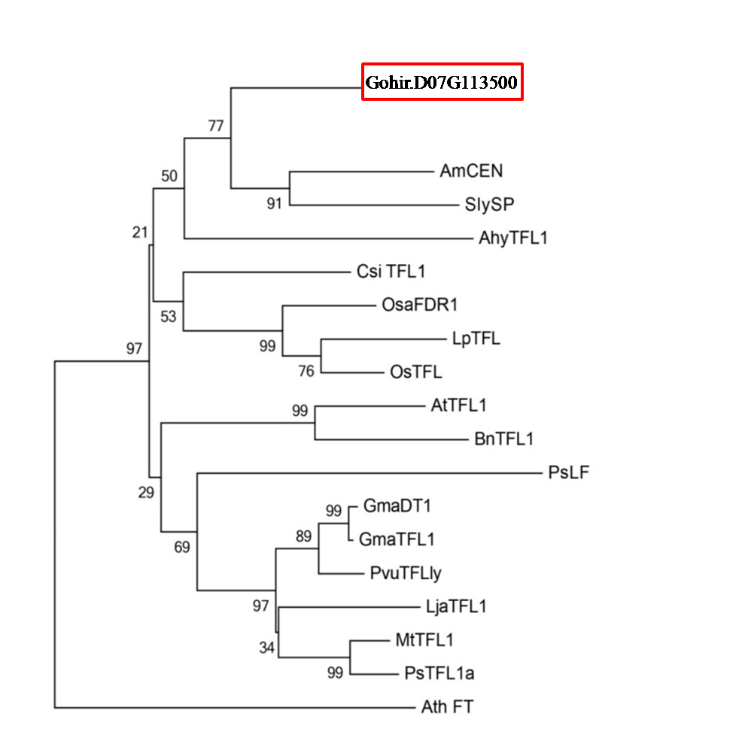
Fig. S4. Phylogenetic tree of TFL1-related proteins constructed using neighbor-joining method with the program MEGA 5.10 in tree view. The accession numbers of the known proteins of sequences in NCBI are as follows: Antirrhinum majus-AmCEN (AAB36112.1); Solanum lycopersicum-SlySP (NP_001233974); Arachis hypogaea-AhyTFL1(AFP33421); Citrus sinensis-CsiTFL1 (NP_001275848); Oryza sativa-OsaFDR1 (AAD42896); Lolium perenne_LpTFL(AAG31808); Oryza sativa-OsaFDR1 (AAD42896); Oryza sativa_OsTFL (AAD42895); Arabidopsis thaliana-AthTFL1 (NP_196004); Brassica napus-BnTFL1 (BAA33415); Pisum sativum-PsTFL1 (AAR03725); Pisum sativum-PsLF (AAQ20811); Glycine max-GmaDT1 (ADF30943); Glycine max-GmaTFL (ACU00123); Phaseolus vulgaris-PvuTFLly (ABR53775); Lotus japonicus-LjaTFL1 (AAQ93599); Medicago truncatula-MtTFL1 (XP_003625808); Arabidopsis thaliana-AthFT (BAA77838).

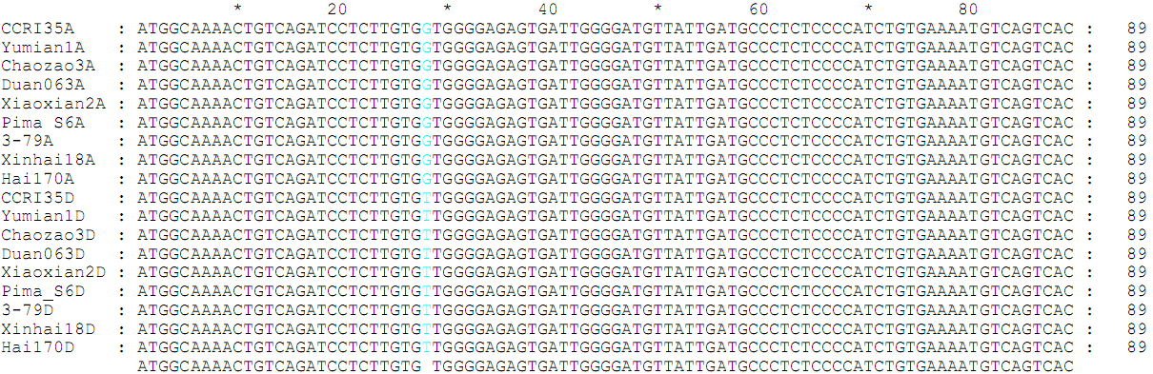

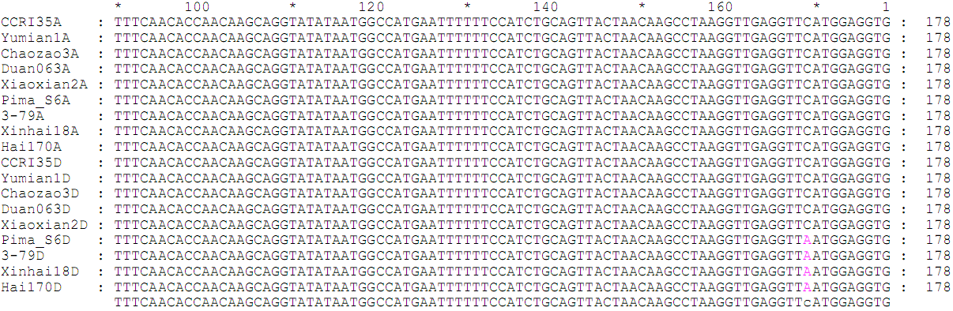

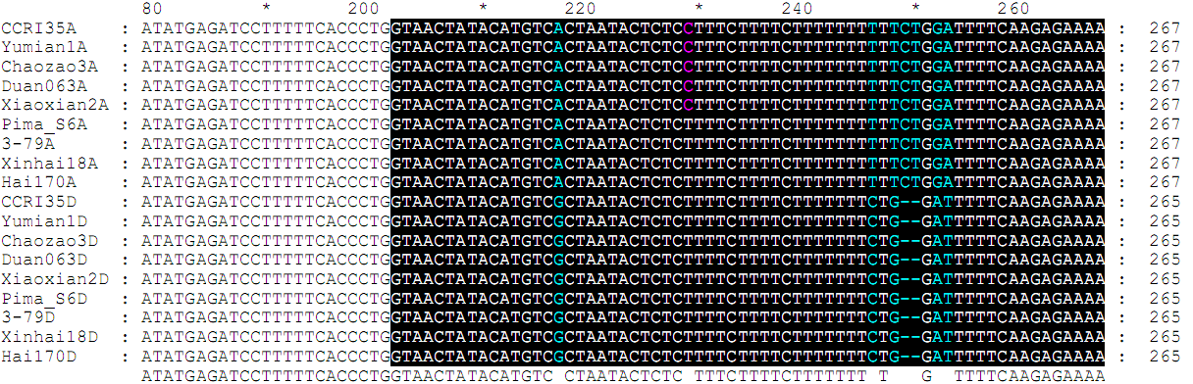

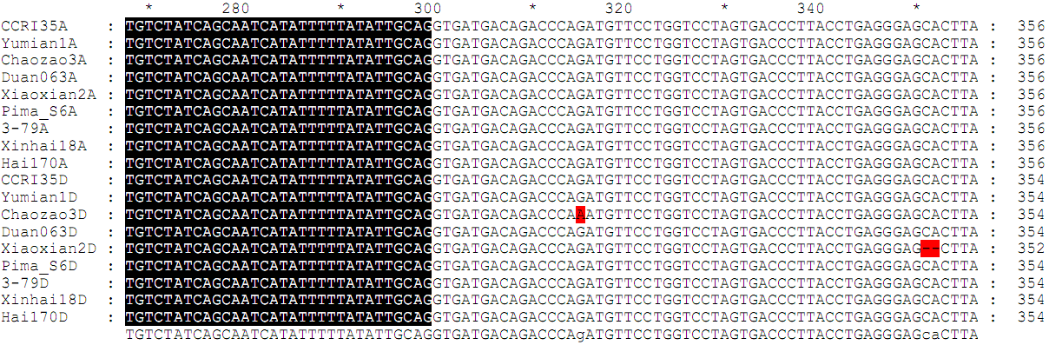

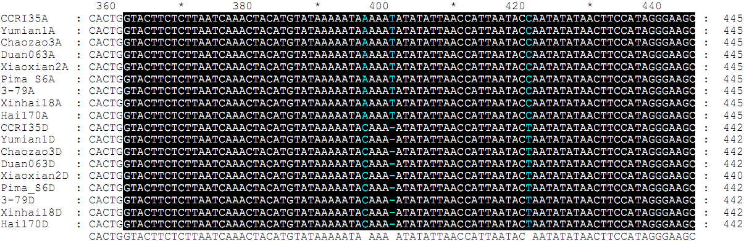

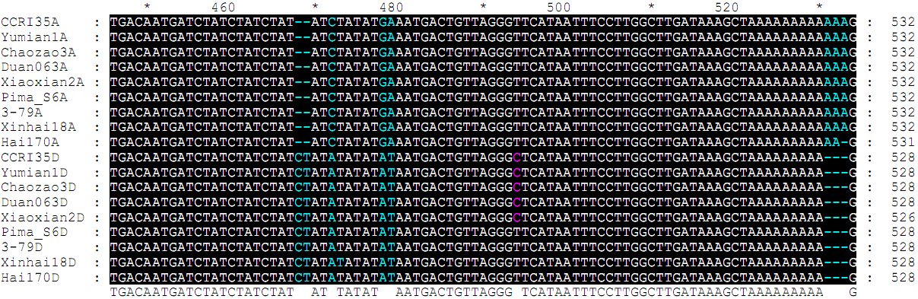

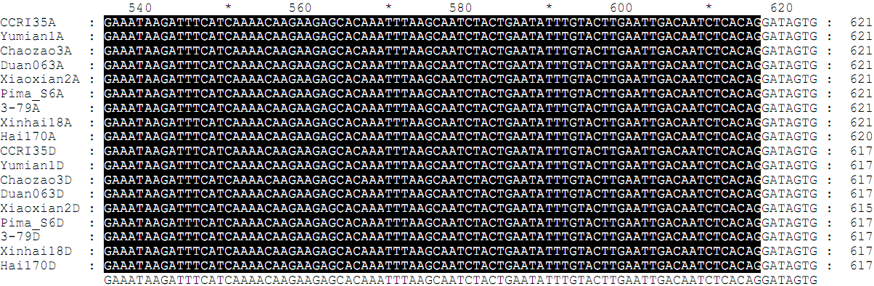

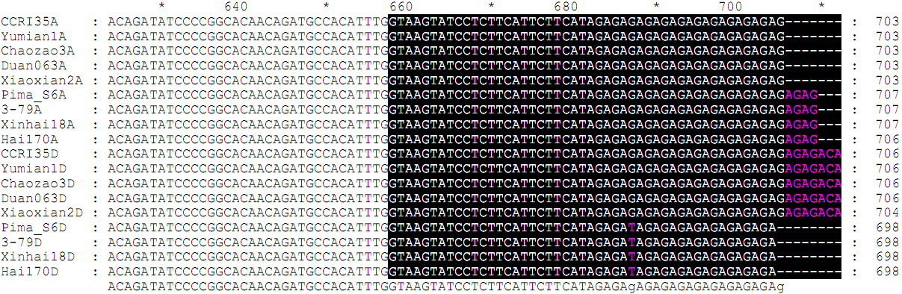

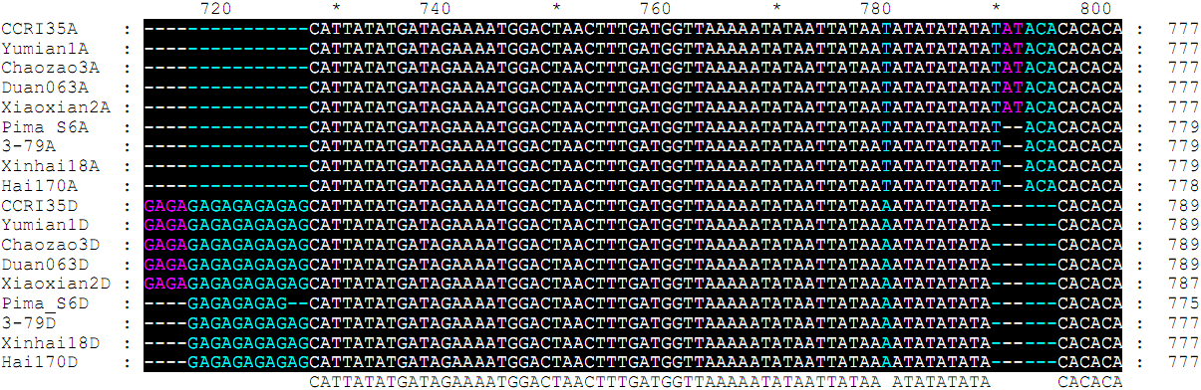

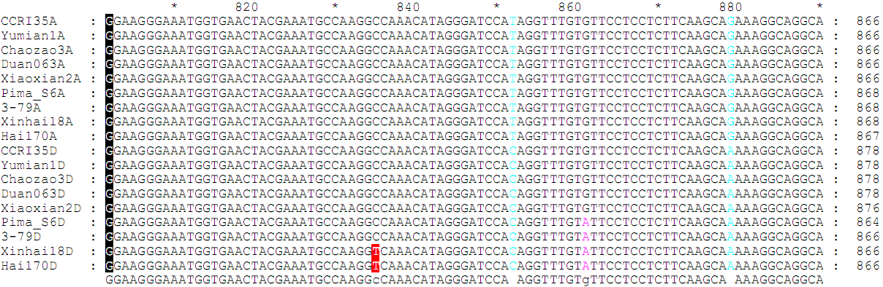

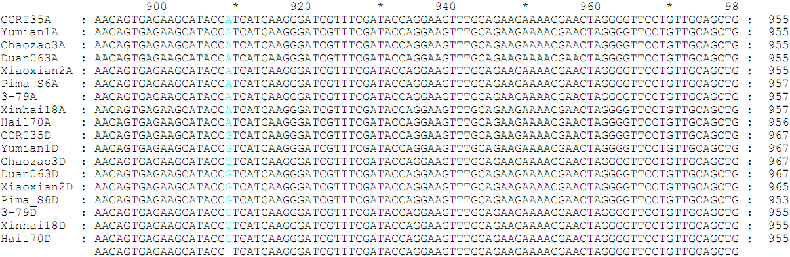

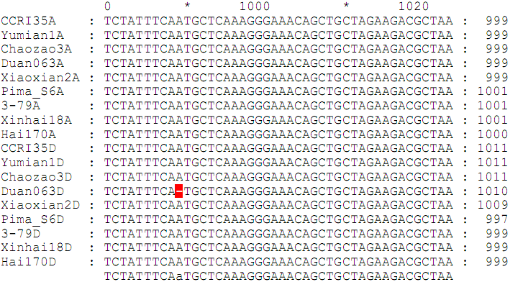
Fig. S5. The nucleotide sequence alignment of GoCEN genesfrom A-subgenome and D-subgenome from cotton cultivars/lines used in this study. Exons are in white background; Introns are inblack background. Nucleobases in blue-green showed the difference between homoeologous CEN-At and CEN-Dt. Nucleobases in violet showed the difference of GoCEN in the same subgenome between G. barbadense and G. hirsutum. Nucleobases in the red background show the cl mutations: “C” nucleotide replaced by “T” nucleotide in 825 bp in Hai170 and Xinhai18; “G” nucleotide replaced by “A” nucleotide in 304 bp in Hai170 and Xinhai18; “A” nucleotide deletion between 898 bp and 900 bp in Duan063; “CA” nucleotides deletion between 350 bp and 353 bp in Xiaoxian2.

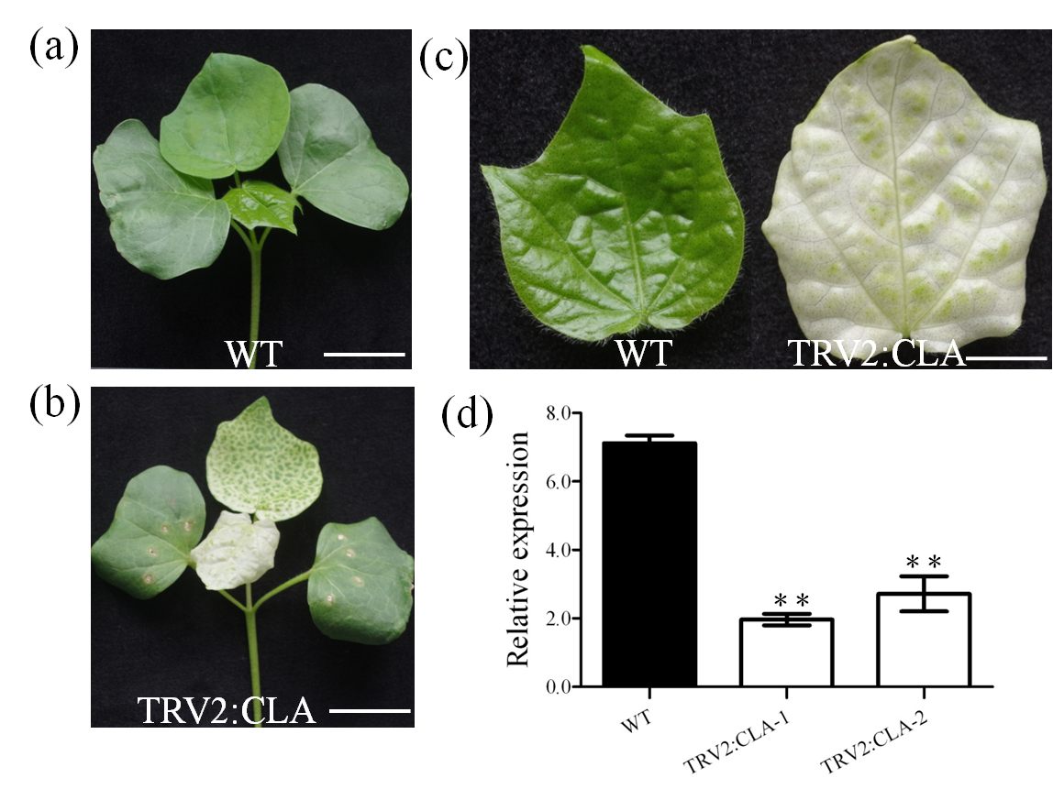
Fig. S6. Functional characterization of GoCLA by VIGS.
(a) (b) Plant morphologies of WT and plant GoCLA silencing by VIGS after twenty days post inoculation; Scale bars, 2cm. (c) Showing the presence and the absence of chloroplast in WT and plant GoCLA silencing by VIGS; Scale bars, 0.5cm . (d) Transcript level of GoCLA in normal and corresponding GoCLA -silenced leaves. The error bar represents the standard deviation of the mean values of three biological replicates. ** = p<0.01, student’s t-test, n=3. The actin gene was used as the internal control.

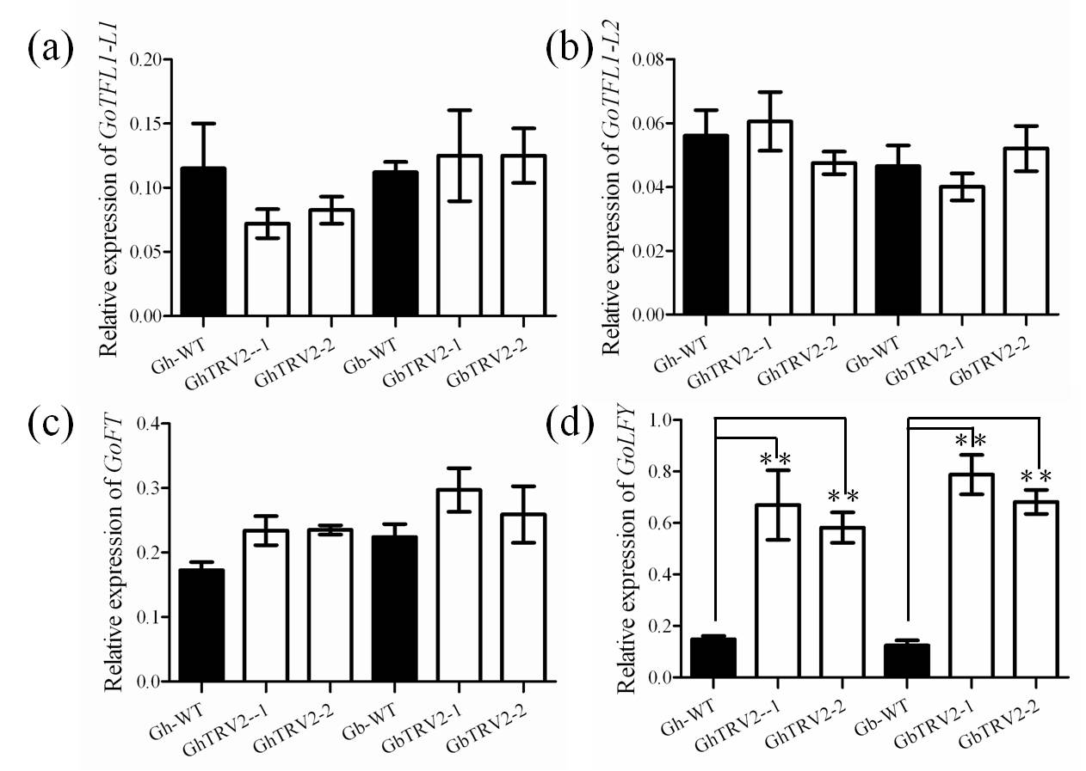
Fig. S7. Genes expression level with RT-PCR in G. hirsutum and G. barbadense between CEN-silenced and WT plant. TFL1-L1 and TFL1-L2 share homology with CEN (AtTFL1) gene in cotton. The error bar represents the standard deviation of the mean values of three biological replicates. ** = p<0.01, student’s t-test, n=3. The actin gene was used as the internal control.

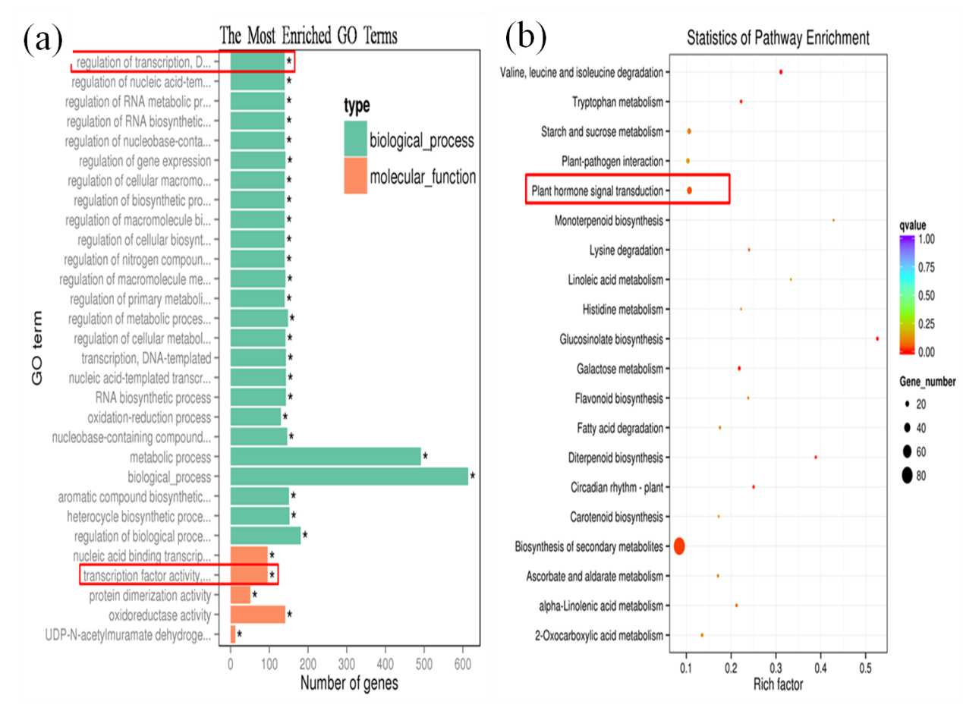
Fig. S8. GO and KEGG enrichment analysis of differentially expressed genes screening from WT and GoCEN silenced plant in G. hirsutum and G. barbadense. (a) GO enrichment analysis showed that transcription factor activity was enriched in biological process and molecular functional categories. (b) KEGG analysis of DEGS showed that functional category plant hormone signal transduction was enriched.

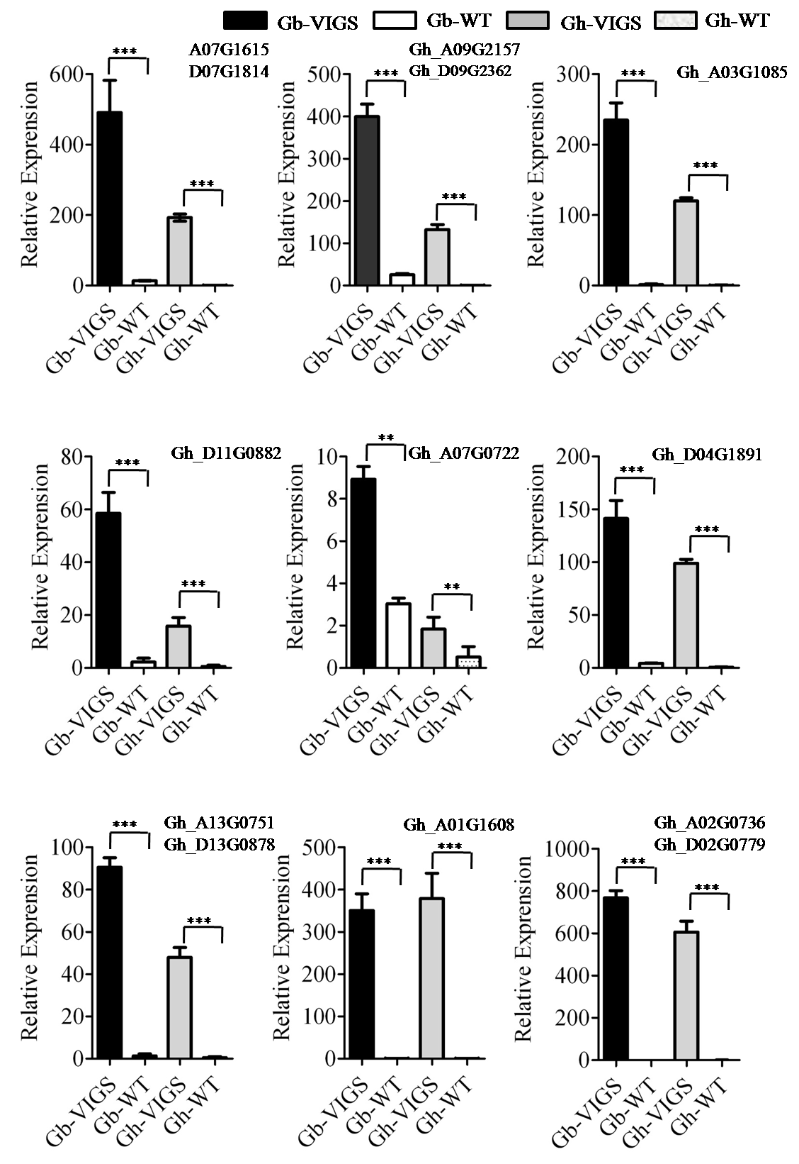
Fig. S9. qRT-PCR validation of MADS-box transcription factors in G. hirsutum and G. barbadense between CEN-silenced and WT plant. The error bar represents the standard deviation of the mean values of three biological replicates. ** = p<0.01, student’s t-test, n=3. The actin gene was used as the internal control.

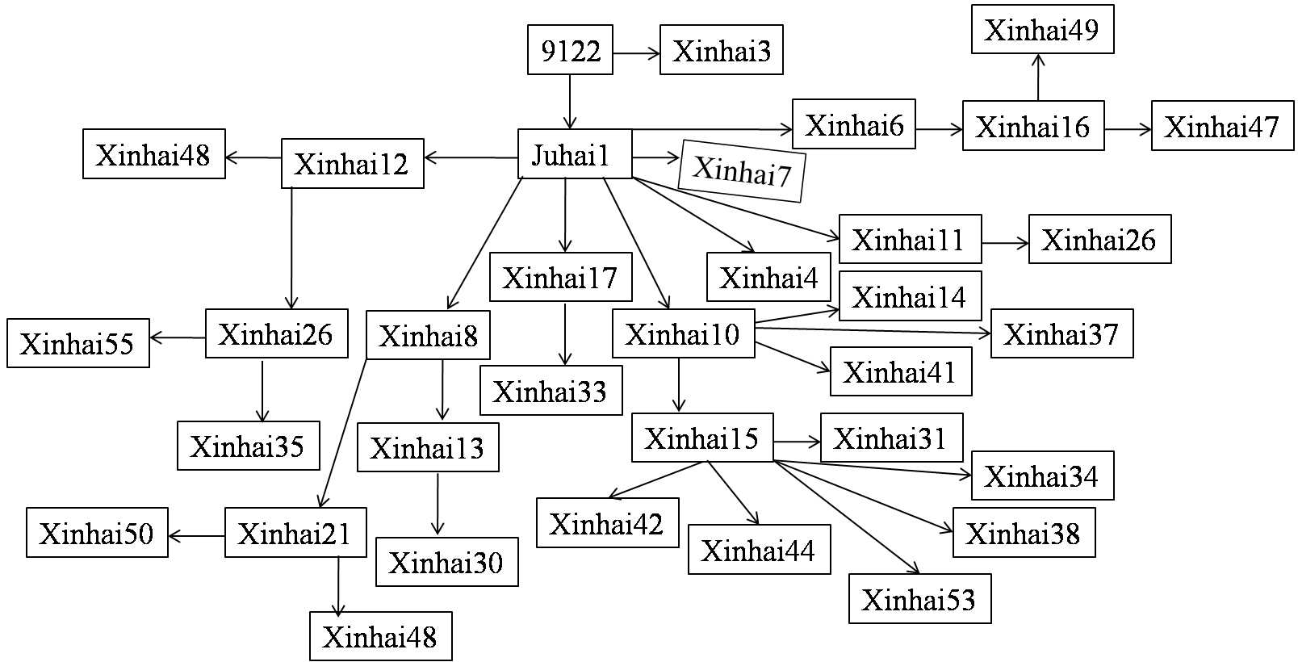

Fig. S10. The pedigree of G. barbadense commercial cultivars in Xinjiang Province. The arrow represented transfer pathway of hereditary information.

Table S1 Thirty-six candidate genes for Gh-cl and their putative function.
Gene ID | Start point | End point | Best-hit-arabi-name | Putative function
Gohir.D07G111800 | 15638402 | 15639714 | AT2G38640.1 | arabi-symbol
Gohir.D07G111900 | 15649281 | 15651240 | AT2G27740.1
Gohir.D07G112000 | 15663408 | 15664478 | AT3G22430.1
Gohir.D07G112100 | 15674226 | 15676507 | AT1G50300.1 | TAF15
Gohir.D07G112200 | 15701834 | 15706056 | AT3G44610.1
Gohir.D07G112300 | 15717796 | 15723971 | AT3G44600.1 | CYP71
Gohir.D07G112400 | 15724276 | 15725693 | AT3G44590.1
Gohir.D07G112500 | 15726304 | 15730965 | AT4G04190.1
Gohir.D07G112600 | 15733127 | 15736226 | AT4G13650.1
Gohir.D07G112700 | 15745224 | 15748743 | AT2G16650.1 | PRORP2
Gohir.D07G112800 | 15747998 | 15753494 | AT4G33790.1 | CER4,FAR3,G7
Gohir.D07G112900 | 15785955 | 15788838 | AT5G53490.3
Gohir.D07G113000 | 15813857 | 15816498 | AT2G27610.1
Gohir.D07G113100 | 15818271 | 15823297 | AT2G27600.1 | ATSKD1,SKD1,VPS4
Gohir.D07G113200 | 15836587 | 15837992 | AT2G27580.1
Gohir.D07G113300 | 15843821 | 15846190 | AT1G08280.1
Gohir.D07G113400 | 15863321 | 15866310 | AT1G08290.1 | WIP3
Gohir.D07G113500 | 16047144 | 16048462 | AT2G27550.1 | ATC
Gohir.D07G113600 | 16122405 | 16125927 | AT5G22460.2
Gohir.D07G113700 | 16180624 | 16186682 | AT1G02205.2 | CER1
Gohir.D07G113800 | 16246216 | 16251477 | AT1G08320.3 | bZIP21,TGA9
Gohir.D07G113900 | 16264618 | 16268915 | AT1G67190.1
Gohir.D07G114000 | 16314082 | 16316982 | AT2G27500.1
Gohir.D07G114100 | 16317481 | 16321243 | AT1G02410.1
Gohir.D07G114200 | 16323397 | 16326133 | AT5G22400.1
Gohir.D07G114300 | 16328107 | 16329253 | AT5G22390.1
Gohir.D07G114400 | 16355623 | 16356815 | AT3G44380.1
Gohir.D07G114500 | 16377853 | 16379250 | AT3G44350.2 | anac061,NAC061
Gohir.D07G114600 | 16379386 | 16379592
Gohir.D07G114700 | 16397670 | 16401637 | AT5G22350.1 | ELM1
Gohir.D07G114800 | 16403336 | 16407373 | AT2G27350.6
Gohir.D07G114900 | 16408735 | 16410180 | AT2G27310.1
Gohir.D07G115000 | 16413117 | 16414918 | AT1G08380.1 | PSAO
Gohir.D07G115100 | 16434449 | 16437570 | AT3G11590.1
Gohir.D07G115200 | 16438158 | 16441354 | AT5G22300.1 | AtNIT4,NIT4
Gohir.D07G115300 | 16451150 | 16451482 | AT3G11600.1

Table S2 Nucleotide sequence variations between GoCEN-A07 and GoCEN-D07 in tetraploid cotton.
Loci (bp) | Base sequence | Exon/Introne | Difference
Loci (bp) | Base sequence | Exon/Introne | At/Dt | At of G. hirsutum | Dt of G. barbadense
28 | G/T | Exon | √ | — | —
217 | A/G | Introne | — | √ | —
229 | C/T | Introne | √ | — | —
247 | T/G | Introne | √ | — | —
248-250 | TCT/G | Introne | √ | — | —
252-253 | GA/AT | Introne | √ | — | —
397 | A/C | Introne | √ | — | —
401 | T/- | Introne | √ | — | —
412 | C/T | Introne | √ | — | —
468-469 | --/CT | Introne | √ | — | —
472 | C/A | Introne | √ | — | —
484 | C/T | Introne | — | — | √
521-523 | AAA/--- | Introne | √ | — | —
687 | T | Introne | — | — | √
706-727 | SSR | Introne | √ | √ | √
781 | T/A | Introne | √ | — | —
790 | T/- | Introne | √ | — | —
791-792 | AT/-- | Introne | √ | — | —
794-796 | ACA/--- | Introne | √ | — | —
852 | T/C | Exon | √ | — | —
861 | A/G | Exon | — | — | √
880 | C/A | Exon | √ | — | —
909 | A/G | Exon | √ | — | —

Table S3 MADS-box transcription factors differentially expressed in transcriptome
Gene_ID in cotton | Gene symbol | Arabidopsis ID | FPKM in Gh_VIGS | FPKM in Gh_WT | log2FoldChange | FPKM in Gb_VIGS | FPKM in Gb_WT | log2FoldChange
Gh_A04G1264 | AP1 | AT1G69120 | 138.8 | 0.9 | 7.3 | 299.7 | 6.4 | 5.6
Gh_A13G0751 | AP1 | AT1G69120 | 265.9 | 2.3 | 6.9 | 518.0 | 9.7 | 5.7
Gh_D02G1311 | AP1 | AT1G69120 | 78.2 | 26.0 | 1.6 | 298.9 | 20.6 | 3.9
Gh_D04G1891 | AP1 | AT1G69120 | 188.3 | 0.8 | 7.8 | 481.3 | 12.8 | 5.2
Gh_D13G0878 | AP1 | AT1G69120 | 232.2 | 3.1 | 6.2 | 338.8 | 11.3 | 4.9
Gh_A07G1339 | AGL6 | AT2G45650 | 26.6 | 0.4 | 6.0 | 47.1 | 0.5 | 6.6
Gh_A08G1148 | AGL6 | AT2G45650 | 20.7 | 0.0 | Inf | 16.1 | 0.0 | Inf
Gh_A11G0754 | AGL6 | AT2G45650 | 43.8 | 0.5 | 6.5 | 53.3 | 4.4 | 3.6
Gh_D08G1430 | AGL6 | AT2G45650 | 40.4 | 0.0 | Inf | 116.9 | 3.0 | 5.3
Gh_D09G0390 | AGL6 | AT2G45650 | 463.4 | 192.5 | 1.3 | 181.3 | 42.2 | 2.1
Gh_D11G0882 | AGL6 | AT2G45650 | 75.0 | 4.6 | 4.0 | 101.2 | 2.9 | 5.1
Gh_A10G2220 | AG | AT4G18960 | 117.1 | 38.0 | 1.6 | 40.8 | 9.7 | 2.1
Gh_D10G0308 | AG | AT4G18960 | 19.6 | 0.0 | Inf | 28.8 | 0.5 | 5.8
Gh_D10G0309 | AG | AT4G18960 | 36.4 | 0.4 | 6.4 | 45.1 | 0.0 | Inf
Gh_A07G1615 | SEP2 | AT3G02310 | 102.3 | 2.3 | 5.5 | 105.8 | 6.9 | 3.9
Gh_A09G2157 | SEP2 | AT3G02310 | 36.1 | 0.9 | 5.3 | 29.2 | 0.5 | 5.9
Gh_D07G1814 | SEP2 | AT3G02310 | 58.2 | 0.4 | 7.1 | 50.0 | 1.4 | 5.1
Gh_D09G2362 | SEP2 | AT3G02310 | 64.9 | 0.0 | Inf | 49.6 | 5.8 | 3.1
Gh_A03G1085 | SEP3 | AT1G24260 | 103.4 | 1.4 | 6.2 | 59.3 | 1.0 | 5.9
Gh_D02G1502 | SEP3 | AT1G24260 | 64.9 | 0.0 | Inf | 48.4 | 0.5 | 6.7
Gh_A04G1265 | SEP4 | AT2G03710 | 170.0 | 69.2 | 1.3 | 407.2 | 39.6 | 3.4
Gh_D13G0877 | SEP4 | AT2G03710 | 166.1 | 23.2 | 2.8 | 162.0 | 2.4 | 6.1
Gh_A02G1617 | AP3 | AT3G54340 | 35.1 | 0.4 | 6.4 | 31.7 | 1.9 | 4.1
Gh_A12G0570 | AP3 | AT3G54340 | 28.7 | 6.7 | 2.1 | 46.3 | 1.0 | 5.5
Gh_D03G0105 | AP3 | AT3G54340 | 25.7 | 1.0 | 4.7 | 53.8 | 16.1 | 1.7
Gh_D05G2452 | AP3 | AT3G54340 | 91.8 | 11.8 | 3.0 | 41.5 | 14.1 | 1.6
Gh_A01G1608 | PI | AT5G20240 | 101.9 | 0.0 | Inf | 111.4 | 0.0 | Inf
Gh_A02G0736 | PI | AT5G20240 | 91.7 | 0.0 | Inf | 79.1 | 0.0 | Inf
Gh_D02G0779 | PI | AT5G20240 | 85.1 | 0.0 | Inf | 81.4 | 0.0 | Inf
Gh_Sca007246G01 | PI | AT5G20240 | 85.1 | 0.0 | Inf | 65.2 | 0.5 | 7.1
Gh_A05G1797 | AGL104 | AT1G22130 | 565.2 | 131.4 | 2.1 | 116.5 | 14.8 | 3.0
Gh_D05G1992 | AGL104 | AT1G22130 | 654.3 | 112.3 | 2.5 | 108.6 | 12.8 | 3.1
Gh_D07G0780 | AGL8 | AT5G60910 | 133.2 | 61.0 | 1.1 | 236.0 | 97.1 | 1.3
Gh_D12G2226 | AGL19 | AT4G22950 | 18.2 | 104.6 | -2.5 | 2.0 | 15.7 | -3.0
Gh_A07G0722 | CAL | AT1G26310 | 185.4 | 39.2 | 2.2 | 108.4 | 18.2 | 2.6
Gh_A13G0442 | SVP | AT2G22540 | 79.5 | 9.2 | 3.1 | 8.6 | 29.8 | -1.8
Gh_D11G0400 | SPH2 | AT2G42830 | 174.8 | 82.7 | 1.1 | 200.6 | 18.0 | 3.5
Inf indicates that the gene is undetectable in wild type plant and its expression level is significantly up-regulated in CEN-silenced cotton.

