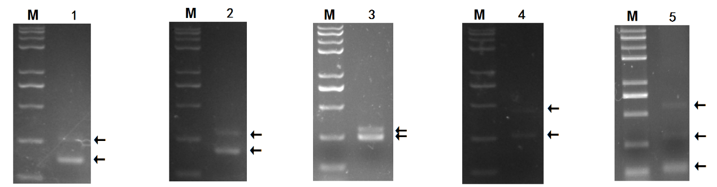
Figure S2. RT-PCR validation of AS events and isoforms in 5 candidate genes. Arrows, PCR products; M, DNA Marker DL2000 Plus II; 1, Novelgene0860; 2, Tp57577_TGAC_v2_gene10390; 3, Tp57577_TGAC_v2_gene11337; 4, Tp57577_TGAC_v2_gene11508; 5, Novelgene0380.

