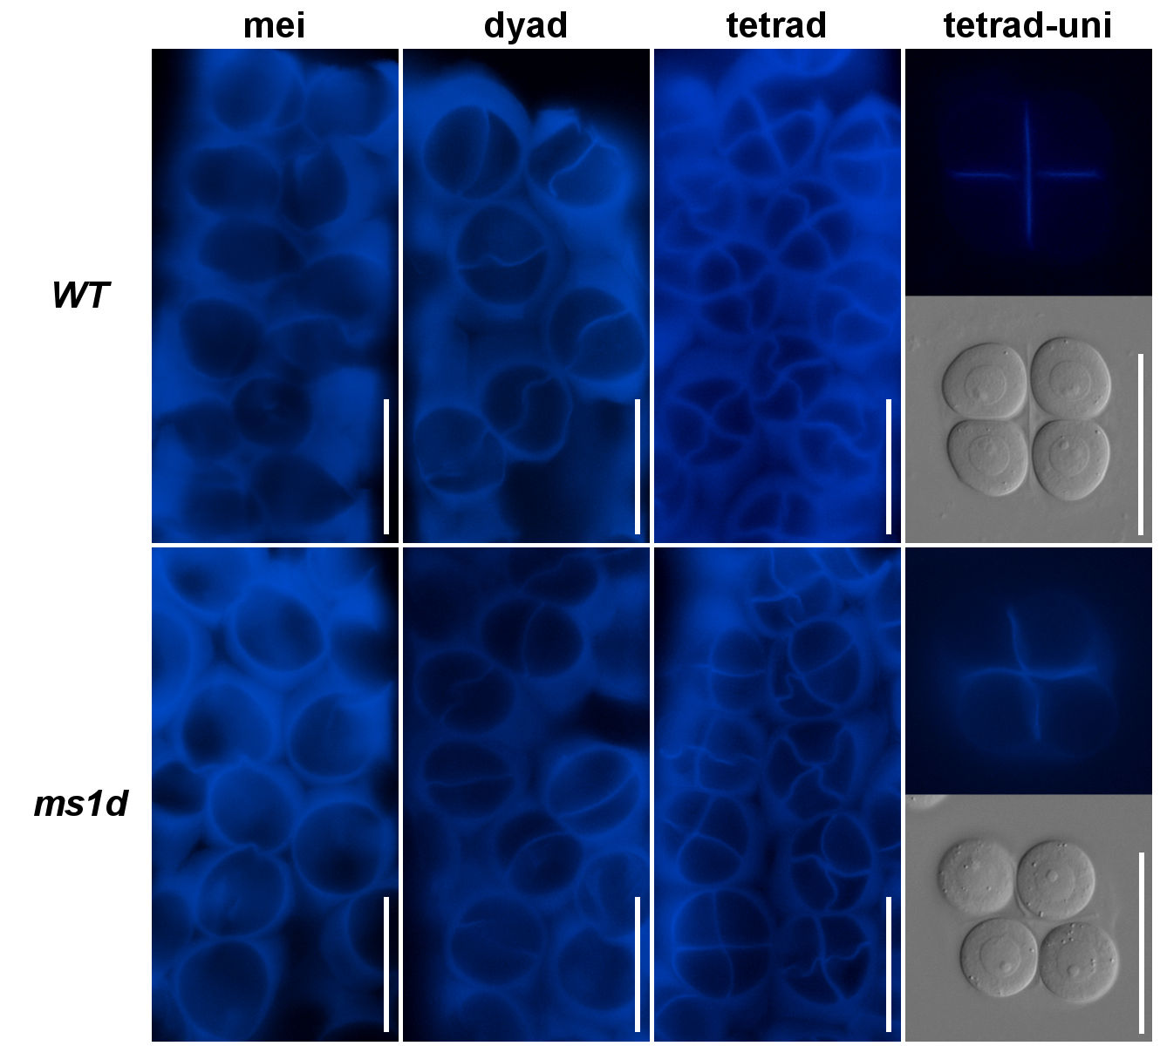

Additional file 2: Callose deposition during meiosis in WT and ms1d mutant anther. Anthers containing meiocytes (mei), dyad, tetrad were dissected and stained by aniline blue solution. WT (top) and ms1d (bottom) samples for each stage were shown. Right panels show tetrad microspores undergoing callose wall degradation and transitioning to uninucleate microspore. Top is callose staining image and bottom is DIC image of same tetrad microspores. Bars in all panels = 50 µm.

