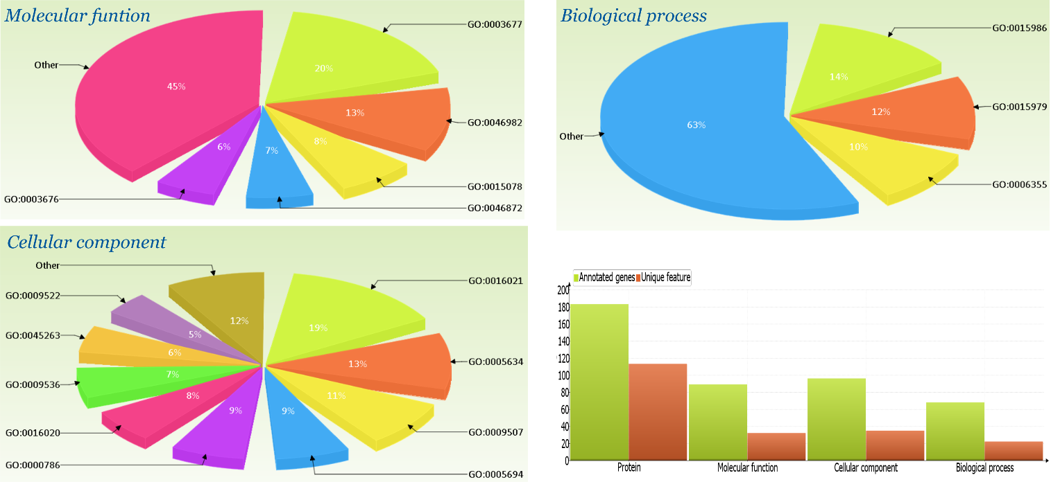

FigureS4. Pie charts of prevalent terms (more than 5% of all genes) of three aspects of gene ontology. The name and fraction of prevailing terms are indicated. Histogram represents the distribution of the number of annotated genes and unique terms for each GO aspect.

