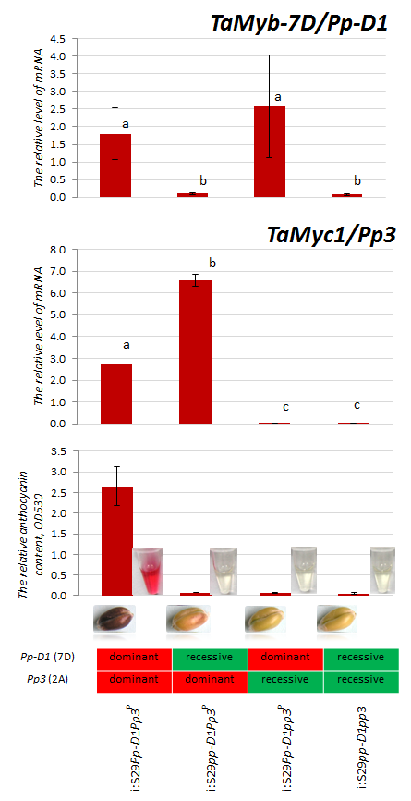 | Additional file 2. Expression level of the TaMyb-7D and TaMyc1 genes in wheat near isogenic lines with different alleles of the complementary genes Pp-D1 and Pp3, determining anthocyanin pigmentation of grain pericarp. The lines were developed by Gordeeva et al. (2015). Expression of TaMyc1 in the created lines was monitored earlier (Shoeva et al. 2014). Expression of the TaMyb-7D was assessed in the current study using cDNA from previous investigation (Shoeva et al. 2014) and primers (Forward 5’gaggagatcaagagggagac3’, Reverse 5’catgtgcagggacttgag3’) amplifying part of the TaC1-D1 (AB983542) gene identified as gene candidate for Rc (red coleoptile) (Himi and Taketa 2015). The TaC1-D1 gene is identical to TaPpm1, encoding R2R3-MYB transcriptional factor regulating with its bHLH counterpart from chromosome 2A anthocyanin biosynthesis in wheat pericarp (Jiang et al. 2018).  References  Gordeeva EI, Shoeva OY, Khlestkina EK. Marker-assisted development of bread wheat near-isogenic lines carrying various combinations of purple pericarp (Pp) alleles. Euphytica. 2015;203(2):469-476. doi:10.1007/s10681-014-1317-8.  Himi E, Taketa S. Isolation of candidate genes for the barley Ant1 and wheat Rc genes controlling anthocyanin pigmentation in different vegetative tissues. Mol. Genet. Genomics. 2015;290(4):1287-1298. doi: 10.1007/s00438-015-0991-0.  Jiang W, Liu T, Nan W, Jeewani DC, Niu Y, Li C, Wang Y, Shi X, Wang C, Wang J, Li Y, Gao X, Wang Z. Two transcription factors TaPpm1 and TaPpb1 co-regulate anthocyanin biosynthesis in purple pericarps of wheat. J Exp Botany. 2018;69(10):2555–2567. doi:10.1093/jxb/ery101.  Shoeva OY, Gordeeva EI, Khlestkina EK. The regulation of anthocyanin synthesis in the wheat pericarp. Molecules. 2014;19:20266–20279. doi: 10.3390/molecules191220266.

