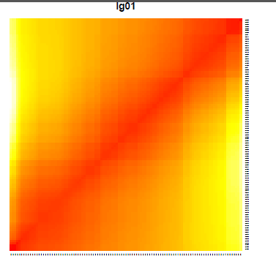 | 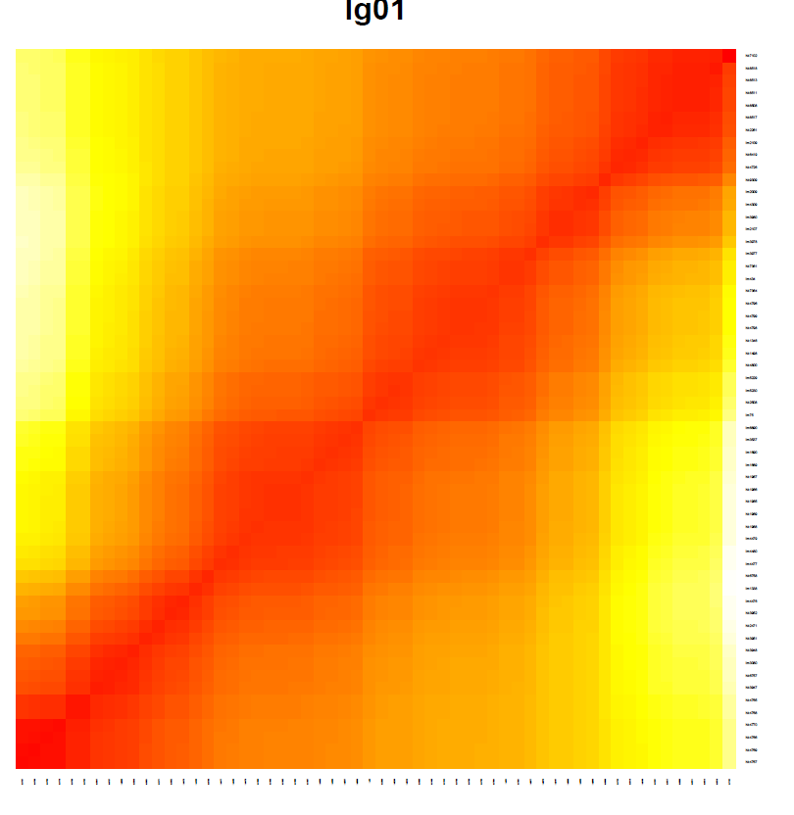
A | B
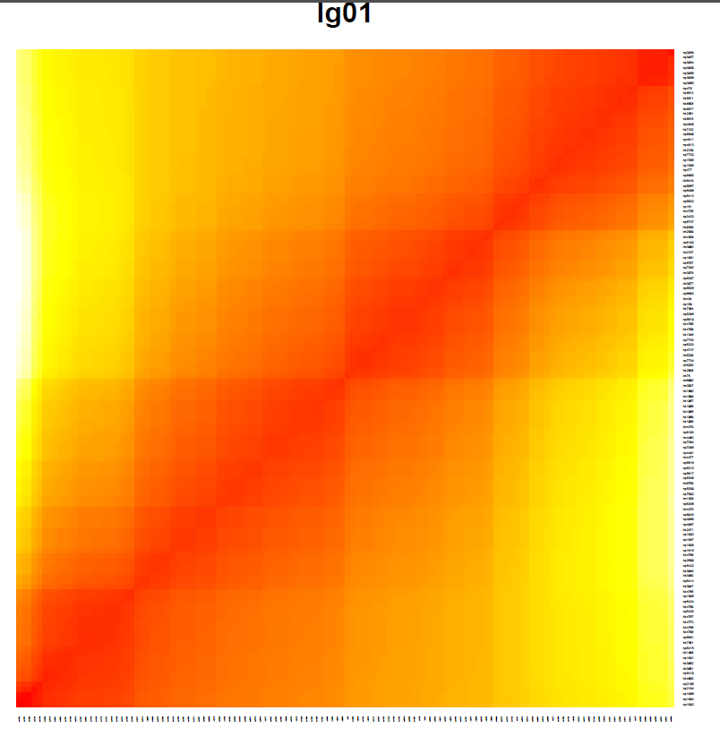
C
Additional file 4: Figure S1 Heat map of the group 1 of the male map (A), female map (B) and integrate map (C). The x-axis and y-axis are the names of the markers. The color is correlated with linkage strength.

