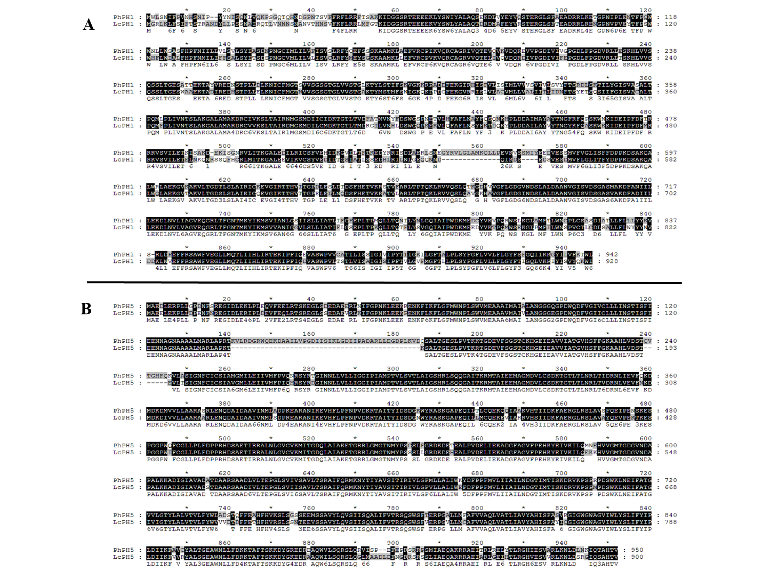

Figure S1 Alignment of the amino acid sequences of PhPH1 and LcPH1 (A), PhPH5 and LcPH5 (B)

Figure S2 Phylogenetic relationships of LcPH1 and LcPH5 with homolog proteins from other species (Sequences are from Li Y, Provenzano S, Bliek M, et al. Evolution of tonoplast P-ATPase transporters involved in vacuolar acidification[J]. New Phytologist, 2016, 211(3):1092-1107.).

Figure S3 Total flavonoid contents of leaf and petal in wild types and LcMYB5 over-expressed tobacco lines.

Table S1. Primers used for real-time PCR

Name | Forward primer  (5' to 3') |  | Reverse primer  (5'to 3')
LcMYB5 |  | CGGTAACAGATGGTCTTTGAT | TGTAGTAGAAGGCGGTGGTG
LcACTIN |  | ACCGTATGAGCAAGGAAATCACTG | TCGTCGTACTCACCCTTTGAAATC
LcGAPDH |  | GATACAGTTCCCGTGTTGTTGAC | CATAAAGACACATAACACCACACTC
LcbHLH1 |  | CGAAGCCTGTTTGCTCTG | ATTCATCACCTCCATCCTGA
LcPH1 |  | CAAATCAAAGACAGCGAGGA | TTATTGCCAGGGAGAGTGAA
LcPH5 |  | CAAAGGAGACAGGCAGACGA | TCAGGGAATACACCAGCAAA
PhPH1 |  | AGTCCAATATTCAATGTGGTTATC | TCAGTT CTCGACCCTCCATC
PhPH3 |  | GTTTAATGCAGGTACTATGACAGGA | CATCTTTGTCAAGTACTTCACTAGT
PhPH5 |  | tagcaatcctaaatgatggcact | caactatcaggtcttggagatgg
PhDFR |  | ACCTATGGATTTCGAGTCCAAAGA | CACATGATTCAATGATGCTTAGCAT
PhAN1 |  | CTTCCAATCCCACCACATTT | TCGTCCTCCTCATCCTCATC
PhSAND |  | CTTACGACGAGTTCAGATGCC | TAAGTCCTCAACACGCATGC

Table S2. Primers used in protein interaction experiments
Name | Sequences (5＇-3＇) | Function
LcMYB5-GFP_F | CAAATTCGCGACCGGTATGAGGAACCCAACACCATC | Fusion GFP
LcMYB5-GFP_R | TGCTAGCCATACCGGTTGCATGGTGACGATCCGTAG | Fusion GFP
LcMYB5-BD_F | CATGGAGGCCGAATTCATGAGGAACCCAACACCATCTT | Yest two hybrid
LcMYB5-BD_R | GCAGGTCGACGGATCCTTATGCATGGTGACGATCCG | Yest two hybrid
N-LcMYB5-BD_R | GCAGGTCGACGGATCCTTACAAAGGTTTGTGTGTTCTCG | Yest two hybrid
C-LcMYB5-BD_F | CATGGAGGCCGAATTCATGAACCCACCACCGCCTT | Yest two hybrid
LcMYB5-NYFP_F | CAAATTCGCGACCGGTATGAGGAACCCAACACCATC | BiFC
LcMYB5-NYFP_R | TGCTCACCATACCGGTTGCATGGTGACGATCCGTAG | BiFC

