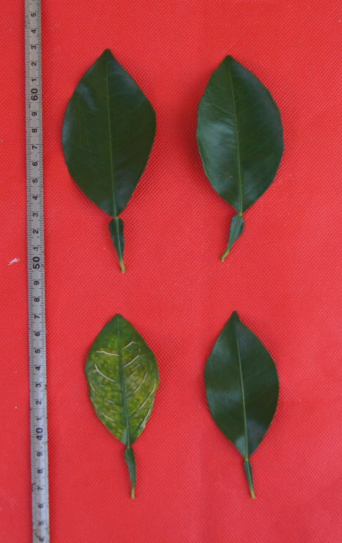
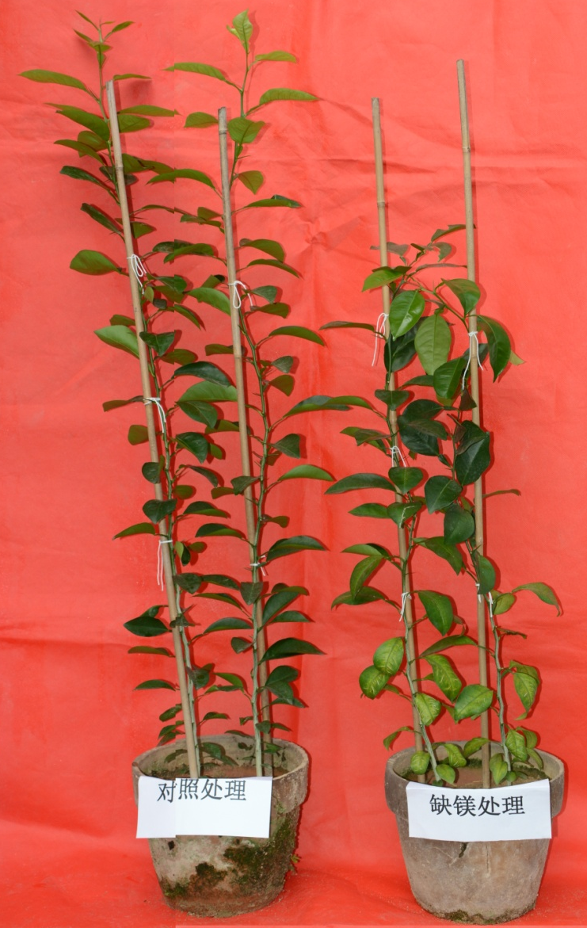
b
a
Control

Mg-deficiency

Lower leaves Upper leaves

Mg-deficiency
Control

Additional file 1: Figure S1. Mg-deficiency effects on Citrussinensis seedling growth (a) and Mg-deficient symptoms in the upper and lower leaves (b).

Additional file 2: Table S1. PCA for physiological parameters of upper leaves. -D, enzyme activity expressed on a dry weight (DW) basis; -P, enzyme activity expressed on a protein basis.
Variables | PC1 | PC2 | PC3 | PC4 | PC5 | PC6 | PC7 | PC8 | PC9
Mg | -0.9764 | 0.0640 | 0.0585 | -0.1264 | -0.0826 | -0.0322 | 0.0367 | 0.0461 | -0.0522
Electrolyte leakage, ROS production rates, MDA and MG
Electrolyte leakage | -0.4002 | 0.5023 | 0.3515 | 0.0948 | 0.2824 | 0.5415 | 0.0249 | -0.1891 | 0.1315
Superoxide anion production rate | 0.7166 | 0.1918 | -0.6181 | -0.0618 | -0.0091 | -0.0831 | -0.1449 | -0.1350 | 0.0940
H₂O₂ production rate | -0.0722 | -0.1719 | -0.5987 | 0.6075 | 0.0664 | 0.2721 | 0.1919 | 0.2629 | -0.2219
MDA | 0.9766 | -0.0136 | -0.0269 | -0.0416 | 0.0750 | 0.1226 | 0.0190 | -0.0785 | -0.0050
MG | 0.8772 | -0.1963 | -0.0830 | 0.1364 | 0.2370 | -0.1313 | 0.1178 | 0.0656 | -0.2616
Antioxidant enzymes
APX-D | 0.7096 | -0.3846 | 0.1544 | -0.2852 | -0.3020 | 0.1908 | 0.0514 | 0.2237 | 0.1636
APX-P | 0.8692 | -0.2838 | 0.0968 | -0.1960 | -0.2182 | 0.1179 | 0.0320 | 0.1401 | 0.1338
MDHAR-D | 0.5927 | -0.1550 | -0.4758 | -0.3495 | 0.3076 | 0.2215 | 0.2015 | 0.1037 | 0.2230
MDHAR-P | 0.7267 | -0.1341 | -0.4236 | -0.2918 | 0.2706 | 0.1782 | 0.1664 | 0.0723 | 0.1862
DHAR-D | 0.7811 | -0.3553 | 0.2299 | 0.1201 | -0.0869 | 0.0424 | 0.2307 | 0.0664 | 0.3402
DHAR-P | 0.8362 | -0.3118 | 0.1939 | 0.1076 | -0.0840 | 0.0260 | 0.2005 | 0.0382 | 0.3008
SOD-D | 0.7628 | 0.2266 | -0.4965 | -0.0017 | 0.2771 | 0.0637 | 0.0399 | -0.0392 | -0.1397
SOD-P | 0.8216 | 0.1969 | -0.4414 | 0.0056 | 0.2481 | 0.0568 | 0.0286 | -0.0359 | -0.1223
GuPX-D | -0.1308 | 0.9375 | 0.2304 | 0.0325 | 0.0650 | 0.0219 | 0.0351 | 0.1085 | 0.1790
GuPX-P | -0.0757 | 0.9456 | 0.2277 | 0.0538 | 0.0640 | 0.0125 | 0.0230 | 0.1168 | 0.1640
CAT-D | -0.7408 | 0.1987 | -0.2698 | -0.1582 | 0.3844 | 0.0004 | -0.0249 | 0.4038 | 0.0287
CAT-P | -0.6440 | 0.2317 | -0.3242 | -0.1714 | 0.4435 | -0.0026 | -0.0369 | 0.4440 | 0.0237
S metabolism-related enzymes
GST-D | -0.4782 | 0.2658 | -0.3982 | -0.1982 | 0.2576 | 0.5574 | -0.2913 | -0.1562 | 0.1166
GST-P | -0.1372 | 0.2918 | -0.4636 | -0.1907 | 0.3181 | 0.6052 | -0.3372 | -0.2018 | 0.1197
GR-D | 0.3458 | -0.3607 | 0.4536 | 0.4635 | 0.3806 | -0.0242 | 0.2882 | 0.0391 | 0.0390
GR-P | 0.5957 | -0.3113 | 0.3847 | 0.4179 | 0.3313 | -0.0330 | 0.2387 | 0.0101 | 0.0443
ATPS-D | 0.6028 | 0.0909 | 0.3138 | 0.3159 | 0.5216 | -0.1602 | -0.2610 | -0.1614 | 0.1751
ATPS-P | 0.8036 | 0.0722 | 0.2065 | 0.2431 | 0.3761 | -0.1223 | -0.2131 | -0.1436 | 0.1287
APR-D | -0.8695 | -0.1922 | 0.0090 | 0.4282 | -0.0231 | 0.0703 | 0.0002 | -0.0393 | -0.0961
APR-P | -0.6803 | -0.2536 | -0.0074 | 0.6435 | -0.0268 | 0.0970 | -0.0187 | -0.1000 | -0.1301
GlPX-D | -0.0609 | 0.6921 | 0.5537 | 0.2337 | -0.0556 | 0.1089 | 0.1647 | 0.2431 | 0.2021
GlPX-P | 0.0923 | 0.6943 | 0.5441 | 0.2609 | -0.0671 | 0.0917 | 0.1505 | 0.2340 | 0.1899
CS-D | -0.3198 | 0.3781 | 0.3944 | -0.4544 | -0.1352 | 0.0929 | 0.4837 | -0.3342 | -0.1195
CS-P | 0.2687 | 0.3942 | 0.3819 | -0.4334 | -0.1367 | 0.0766 | 0.4956 | -0.3889 | -0.1070
γGT-D | -0.8363 | -0.5034 | -0.0443 | -0.1052 | -0.0547 | -0.0846 | 0.0251 | -0.0368 | 0.1352
γGT-P | -0.1599 | -0.8838 | -0.1344 | -0.1299 | -0.0685 | -0.1845 | 0.0072 | -0.1639 | 0.2782
γGCS-D | -0.0757 | -0.2716 | 0.6464 | -0.4055 | 0.3421 | -0.2693 | -0.3000 | 0.2328 | -0.0581
γGCS-P | 0.1576 | -0.2672 | 0.6313 | -0.3941 | 0.3409 | -0.2842 | -0.3269 | 0.2075 | -0.0375
GS-DW | -0.7059 | -0.0966 | -0.3441 | -0.0078 | 0.3635 | -0.2037 | 0.4205 | 0.0621 | 0.0113
GS-P | -0.4031 | -0.1147 | -0.4704 | 0.0074 | 0.4669 | -0.2535 | 0.5248 | 0.0468 | 0.0208
SiR-D | -0.0700 | -0.5041 | 0.4078 | -0.1834 | 0.2012 | 0.5780 | 0.2074 | 0.1472 | -0.2188
SiR-P | -0.3093 | -0.3169 | 0.6665 | -0.1319 | 0.1901 | 0.3517 | 0.0397 | 0.3008 | -0.2114
Gly I and Gly II
Gly I-D | -0.5069 | 0.8051 | -0.0012 | 0.0748 | -0.0139 | -0.2069 | -0.0976 | -0.0091 | 0.0917
Gly I-P | -0.2035 | 0.9117 | -0.0133 | 0.1198 | -0.0081 | -0.2421 | -0.1335 | -0.0159 | 0.0930
Gly II-D | -0.3630 | 0.8578 | -0.0483 | -0.0561 | -0.2271 | 0.0490 | 0.1625 | 0.1496 | -0.0119
Gly II-P | 0.3235 | 0.8869 | -0.0867 | 0.0011 | -0.2145 | 0.0207 | 0.1434 | 0.1271 | -0.0133
Antioxidants
GSH + GSSG | -0.3626 | -0.4625 | -0.0505 | 0.6850 | -0.2402 | 0.2788 | -0.0934 | 0.0149 | 0.1780
GSH | -0.6932 | -0.5926 | 0.0571 | 0.1753 | -0.2066 | 0.1916 | -0.0563 | 0.0473 | 0.1941
GSSG | 0.7362 | 0.5006 | -0.1286 | 0.3147 | 0.1079 | -0.0527 | 0.0059 | -0.0585 | -0.1415
GSH/(GSH + GSSG) | -0.7468 | -0.5179 | 0.1361 | -0.2570 | -0.1330 | 0.0688 | 0.0030 | 0.0322 | 0.1529
ASC + DHA | 0.8140 | 0.0853 | -0.0923 | -0.0044 | -0.3593 | 0.1104 | -0.1182 | 0.2449 | -0.1348
ASC | 0.8034 | 0.0825 | -0.1324 | -0.0086 | -0.3743 | 0.0997 | -0.1076 | 0.2574 | -0.1260
DHA | 0.7996 | 0.1014 | 0.3332 | 0.0390 | -0.1505 | 0.2036 | -0.2097 | 0.0791 | -0.2045
ASC/(ASC + DHA) | 0.0264 | -0.0353 | -0.8157 | -0.0510 | -0.4048 | -0.1511 | 0.1087 | 0.3072 | 0.1371
Eigen value | 17.8944 | 10.2366 | 6.5415 | 3.6593 | 3.1976 | 2.3879 | 2.0893 | 1.6336 | 1.2024
Variation percent (%) | 35.7888 | 20.4732 | 13.0829 | 7.3186 | 6.3951 | 4.7758 | 4.1787 | 3.2672 | 2.4048

Additional file 3: Table S2. PCA for physiological parameters of lower leaves. -D, enzyme activity expressed on a dry weight (DW) basis; -P, enzyme activity expressed on a protein basis.
Variables | PC1 | PC2 | PC3 | PC4 | PC5
Mg | -0.9787 | -0.1217 | -0.0756 | 0.0302 | -0.0308
Electrolyte leakage, ROS production rates, MDA and MG
Electrolyte leakage | 0.8656 | 0.0113 | -0.2261 | -0.3030 | 0.2355
Superoxide anion production rate | 0.9683 | 0.2065 | 0.0221 | -0.0294 | -0.0781
H₂O₂ production rate | 0.8098 | -0.0644 | 0.2377 | 0.4395 | -0.0694
MDA | 0.9772 | 0.0982 | -0.0127 | 0.0983 | -0.0847
MG | 0.9682 | 0.0241 | -0.0585 | 0.0456 | 0.1443
Antioxidant enzymes
APX-D | 0.9577 | 0.2186 | -0.0356 | -0.0175 | -0.0633
APX-P | 0.9613 | 0.2108 | -0.0327 | -0.0175 | -0.0615
MDHAR-D | 0.9619 | 0.0274 | -0.1151 | 0.0074 | 0.1290
MDHAR-P | 0.9781 | 0.0315 | -0.0966 | 0.0063 | 0.0848
DHAR-D | 0.9599 | 0.1477 | -0.0176 | 0.0376 | 0.0786
DHAR-P | 0.9820 | 0.1134 | -0.0234 | 0.0146 | 0.0334
SOD-D | 0.9450 | 0.1747 | 0.1289 | -0.0003 | -0.1385
SOD-P | 0.9723 | 0.1341 | 0.0887 | -0.0018 | -0.0997
GuPX-D | 0.8831 | -0.3818 | -0.1004 | -0.0990 | 0.1245
GuPX-P | 0.9301 | -0.3198 | -0.0736 | -0.0718 | 0.0854
CAT-D | -0.9353 | -0.0768 | 0.1803 | 0.2527 | 0.0619
CAT-P | -0.7873 | -0.0998 | 0.3410 | 0.4475 | 0.0485
S metabolism-related enzymes
GST-D | -0.9785 | 0.0111 | -0.1392 | 0.0164 | 0.0983
GST-P | -0.8762 | 0.1511 | -0.3342 | 0.0409 | 0.1853
GR-D | 0.9484 | 0.0792 | 0.0224 | 0.0551 | 0.0859
GR-P | 0.9787 | 0.0807 | 0.0150 | 0.0428 | 0.0296
ATPS-D | 0.9307 | 0.0330 | 0.1657 | 0.0656 | -0.1749
ATPS-P | 0.9756 | 0.0423 | 0.0998 | 0.0278 | -0.1105
APR-D | -0.9801 | 0.0741 | -0.1374 | -0.0980 | -0.0019
APR-P | -0.7075 | 0.4170 | -0.4446 | -0.3129 | -0.0534
GlPX-D | 0.7879 | -0.5450 | -0.1395 | 0.0933 | 0.1372
GlPX-P | 0.8594 | -0.4507 | -0.0975 | 0.0887 | 0.1126
CS-D | -0.9960 | -0.0156 | 0.0388 | -0.0110 | 0.0288
CS-P | -0.9883 | 0.0280 | 0.0752 | -0.0059 | 0.0121
γGT-D | -0.9831 | 0.1088 | 0.0838 | 0.0376 | 0.0192
γGT-P | 0.7303 | 0.5899 | 0.2457 | 0.0993 | -0.1050
γGCS-D | 0.9706 | 0.2036 | 0.0487 | 0.0501 | 0.0447
γGCS-P | 0.9815 | 0.1714 | 0.0277 | 0.0345 | 0.0131
GS-D | -0.7322 | -0.3738 | 0.3764 | -0.4170 | 0.0084
GS-P | 0.4765 | -0.4541 | 0.5152 | -0.5283 | -0.1029
SiR-D | 0.9202 | 0.2660 | -0.1202 | 0.0145 | 0.0160
SiR-P | 0.9325 | 0.2848 | -0.0413 | -0.0130 | -0.0150
Gly I and Gly II
Gly I-D | -0.9806 | -0.0739 | -0.0518 | 0.0860 | 0.1311
Gly I-P | -0.8825 | -0.1112 | -0.1748 | 0.2382 | 0.3008
Gly II-D | 0.9755 | -0.1470 | -0.0754 | 0.0203 | 0.0411
Gly II-P | 0.9837 | -0.1190 | -0.0637 | 0.0125 | 0.0314
Antioxidants
GSH + GSSG | 0.2663 | 0.4590 | 0.4261 | -0.1275 | 0.7161
GSH | -0.5472 | 0.7460 | 0.2171 | -0.0963 | 0.2557
GSSG | 0.7934 | -0.5428 | 0.0338 | 0.0253 | 0.1801
GSH/(GSH + GSSG) | -0.7741 | 0.5824 | -0.0052 | -0.0333 | -0.1482
ASC + DHA | 0.9753 | 0.1176 | -0.0949 | -0.0502 | -0.0101
ASC | 0.9728 | 0.1234 | -0.0949 | -0.0511 | -0.0122
DHA | 0.9897 | 0.0693 | -0.0946 | -0.0418 | 0.0072
ASC/(ASC + DHA) | -0.8894 | 0.1344 | -0.0072 | -0.1005 | -0.1324
Eigen value | 40.781 | 3.667 | 1.548 | 1.293 | 1.108
Variation percent (%) | 81.561 | 7.334 | 3.095 | 2.587 | 2.216

Additional file 4: Table S3. PCA for physiological parameters of roots. -D, enzyme activity expressed on a dry weight (DW) basis; -P, enzyme activity expressed on a protein basis.
Variables | PC1 | PC2 | PC3 | PC4
Mg | -0.9662 | -0.0566 | 0.1588 | 0.0616
Electrolyte leakage, ROS production rates, MDA and MG
Electrolyte leakage | 0.9849 | -0.1243 | -0.0185 | -0.0169
Superoxide anion production rate | 0.9834 | 0.0773 | 0.1346 | 0.0626
H₂O₂ production rate | 0.9017 | -0.1120 | -0.0678 | 0.1423
MDA | 0.9966 | -0.0497 | 0.0489 | -0.0309
MG | 0.9478 | 0.2093 | 0.1734 | 0.0101
Antioxidant enzymes
APX-D | 0.9785 | 0.0740 | 0.1858 | -0.0360
APX-P | 0.9797 | 0.0714 | 0.1812 | -0.0319
MDHAR-D | 0.9376 | 0.0526 | -0.2417 | 0.1800
MDHAR-P | 0.9473 | 0.0530 | -0.2189 | 0.1697
DHAR-D | 0.6853 | -0.1249 | 0.6551 | -0.1476
DHAR-P | 0.7322 | -0.1143 | 0.6154 | -0.1463
SOD-D | 0.9613 | -0.0250 | -0.0479 | 0.1554
SOD-P | 0.9639 | -0.0241 | -0.0439 | 0.1519
GuPX-D | 0.7330 | 0.6246 | -0.1811 | 0.1647
GuPX-P | 0.7750 | 0.5838 | -0.1622 | 0.1563
CAT-D | -0.9064 | 0.0441 | -0.0168 | 0.2943
CAT-P | -0.8668 | 0.0624 | -0.0165 | 0.3424
S metabolism-related enzymes
GST-D | 0.9936 | 0.0295 | 0.0858 | 0.0240
GST-P | 0.9938 | 0.0282 | 0.0863 | 0.0253
GR-D | 0.9424 | -0.2655 | -0.0092 | -0.0108
GR-P | 0.9447 | -0.2613 | -0.0060 | -0.0080
ATPS-D | 0.7520 | 0.0102 | -0.5875 | -0.0753
ATPS-P | 0.8687 | 0.0122 | -0.4435 | -0.0330
APR-D | -0.9671 | 0.1579 | -0.1105 | 0.0838
APR-P | -0.9552 | 0.1916 | -0.1213 | 0.0970
GlPX-D | 0.9796 | 0.0753 | -0.1534 | 0.0882
GlPX-P | 0.9812 | 0.0726 | -0.1436 | 0.0895
CS-D | -0.9172 | -0.2004 | 0.1307 | 0.2347
CS-P | -0.8803 | -0.2396 | 0.1695 | 0.2732
γGT-D | -0.9799 | -0.1360 | 0.0564 | 0.0770
γGT-P | -0.9411 | -0.2031 | 0.1435 | 0.1423
γGCS-D | 0.9853 | 0.0071 | 0.1000 | 0.0482
γGCS-P | 0.9871 | 0.0091 | 0.0982 | 0.0446
GS-D | -0.7931 | 0.3190 | 0.1937 | 0.4540
GS-P | -0.6900 | 0.3958 | 0.2337 | 0.5230
SiR-D | -0.9833 | -0.1278 | -0.0224 | -0.0289
SiR-P | -0.9785 | -0.1474 | -0.0127 | -0.0286
Gly I and Gly II
Gly I-D | -0.9572 | 0.1041 | -0.0357 | -0.1823
Gly I-P | -0.9424 | 0.1323 | -0.0198 | -0.2082
Gly II-D | 0.9710 | -0.0227 | 0.0886 | 0.0322
Gly II-P | 0.9758 | -0.0204 | 0.0901 | 0.0305
Antioxidants
GSH + GSSG | 0.3091 | 0.8896 | 0.1880 | -0.1085
GSH | -0.4335 | 0.8654 | 0.1101 | -0.2095
GSSG | 0.8197 | -0.5033 | -0.0077 | 0.2022
GSH/(GSH + GSSG) | -0.7507 | 0.6242 | 0.0003 | -0.1925
ASC + DHA | -0.9857 | -0.0713 | -0.1070 | -0.1020
ASC | -0.9858 | -0.0751 | -0.1067 | -0.0977
DHA | -0.9814 | -0.0252 | -0.1095 | -0.1528
ASC/(ASC + DHA) | -0.8922 | -0.3522 | -0.1280 | -0.0272
Eigen value | 41.0420 | 3.8815 | 2.0523 | 1.3766
Variation percent (%) | 82.0840 | 7.7630 | 4.1046 | 2.7532

