Supplementary data

Table S1. P-values of one-way ANOVA evaluating the effect of three soil Zn levels on arbuscular mycorrhizal fungal (AMF) root colonization of bread wheat and barley inoculated with Rhizophagus irregularis and sampled at physiological maturity (Zadok's growth stage 90).
Factor ª | AMF root colonization
Factor ª | Bread wheat | Barley
Soil Zn application ^{b} | 0.045 ^{c} | 0.009
ª Soil Zn application is used as a fixed factor.
^{b} Soil Zn levels: 0, 20 and 75 mg kg⁻¹ soil in the form of ZnSO₄.
^{c} In bold statistically significant values (P ≤ 0.05) (No of replicates=5).

Table S2. Effect of AMF inoculation with Rhizophagus irregularis (+M versus mock inoculum, -M) and three soil Zn levels on arbuscular mycorrhizal fungal (AMF) root colonization and plant physiological traits of bread wheat sampled at physiological maturity (Zadok's growth stage 90).

Factors |  |  | Aboveground biomass (g) | Chaff dry weight (g) | Spike fertility Index ª | Grain P content (mg P plant⁻¹) | Straw P content (mg P plant⁻¹)
+M | Low Zn | mean | 2.74 | 0.48 | 77.78 | 3.62 | 1.62
 |  | s.e. | 0.06 | 0.04 | 8.40 | 0.06 | 0.07
 | Medium Zn | mean | 3.00 | 0.55 | 71.02 | 3.69 | 1.59
 |  | s.e. | 0.06 | 0.08 | 12.60 | 0.12 | 0.14
 | High Zn | mean | 2.75 | 0.62 | 54.38 | 3.44 | 1.50
 |  | s.e. | 0.04 | 0.04 | 4.81 | 0.12 | 0.05
-M | Low Zn | mean | 2.84 | 0.79 | 34.86 | 2.84 | 3.04
 |  | s.e. | 0.06 | 0.08 | 4.68 | 0.16 | 0.12
 | Medium Zn | mean | 2.91 | 0.80 | 39.82 | 2.96 | 2.66
 |  | s.e. | 0.09 | 0.08 | 4.78 | 0.24 | 0.10
 | High Zn | mean | 2.83 | 0.71 | 42.88 | 3.50 | 2.10
 |  | s.e. | 0.04 | 0.15 | 6.88 | 0.18 | 0.06

ª Spike Fertility Index: No of kernels per spike/ chaff dry weight.

Table S3. Effect of AMF inoculation with Rhizophagus irregularis (+M versus mock inoculum, -M) and three soil Zn levels on arbuscular mycorrhizal fungal (AMF) root colonization and plant physiological traits of barley sampled at physiological maturity (Zadok's growth stage 90).

Factors |  |  | Aboveground biomass (g) | Chaff dry weight (g) | Spike fertility Index ª | Grain P content (mg P plant⁻¹) | Straw P content (mg P plant⁻¹)
+M | Low Zn | mean | 2.82 | 0.60 | 40.96 | 2.10 | 3.20
 |  | s.e. | 0.08 | 0.04 | 1.84 | 0.17 | 0.56
 | Medium Zn | mean | 2.88 | 0.65 | 45.56 | 3.05 | 2.96
 |  | s.e. | 0.11 | 0.10 | 6.69 | 0.74 | 0.52
 | High Zn | mean | 3.01 | 0.60 | 57.12 | 3.05 | 2.74
 |  | s.e. | 0.09 | 0.16 | 13.48 | 0.85 | 0.54
-M | Low Zn | mean | 2.78 | 0.36 | 62.62 | 2.41 | 3.69
 |  | s.e. | 0.09 | 0.06 | 13.21 | 0.20 | 0.30
 | Medium Zn | mean | 2.83 | 0.52 | 57.34 | 2.24 | 4.52
 |  | s.e. | 0.07 | 0.05 | 5.19 | 0.17 | 0.44
 | High Zn | mean | 2.88 | 0.40 | 65.74 | 1.98 | 3.89
 |  | s.e. | 0.04 | 0.05 | 5.68 | 0.14 | 0.17

ª Spike Fertility Index: No of kernels per spike/ chaff dry weight

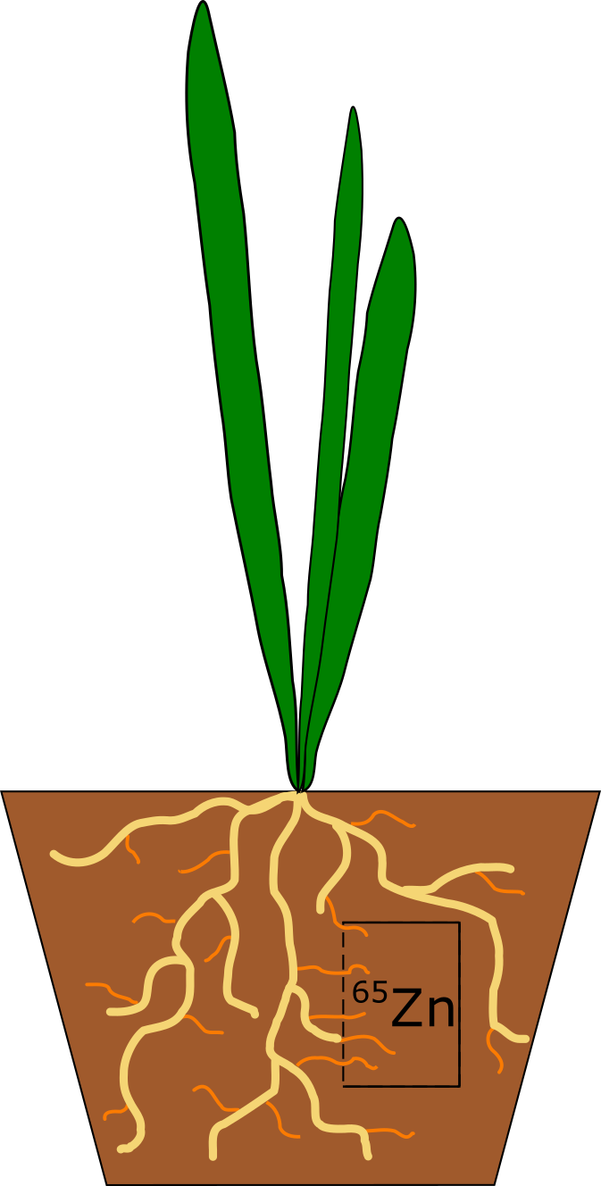

Figure S1. Diagram of the experimental pot set-up including a hyphal compartment (HC) containing soil mixed with radioactive ⁶⁵Zn, accessible by the hyphae of the mycorrhizal fungi Rhizophagus irregularis, but not by the roots.

