Supplemental Tables
Table S1: List of gene studied
Name | Gene ID |  | Name | Gene ID |  | Name | Gene ID
ZmNPF4.10 | GRMZM2G137421 |  | ZmNPF7.12 | GRMZM2G061303 |  | ZmAMT1.1A | GRMZM2G175140
ZmNPF6.2 | GRMZM2G064091 |  | ZmNRT2.1 | GRMZM2G010280 |  | ZmAMT1.1B | GRMZM2G118950
ZmNPF6.3 | GRMZM2G476069 |  | ZmNRT2.2 | GRMZM2G010251 |  | ZmAMT1.3 | GRMZM2G028736
ZmNPF6.4 | GRMZM2G086496 |  | ZmNRT2.3 | GRMZM2G163866 |  | ZmAMT2.1 | GRMZM2G080045
ZmNPF6.5 | GRMZM2G161483 |  | ZmNRT2.5 | GRMZM2G455124 |  | ZmAMT3.1 | GRMZM2G335218
ZmNPF6.6 | GRMZM2G161459 |  | ZmNRT3.1A | GRMZM2G179294 |  | ZmAMT3.2 | GRMZM2G338809
ZmNPF6.7 | GRMZM2G112154 |  | ZmNRT3.1B | GRMZM2G163494 |  | ZmAMT3.3 | GRMZM2G043193
ZmNPF6.8 | GRMZM2G176253 |  | ZmAMF1.1 | GRMZM2G062024 |  | ZmAMT4 | GRMZM2G473697
ZmNPF7.10 | GRMZM2G044851 |  | ZmAMF1.2 | GRMZM2G164743

Table S2
One-way ANOVA results of root gene expression between control (C), starved (S) and resupplied (R) plants. Bold text denotes p<0.05.
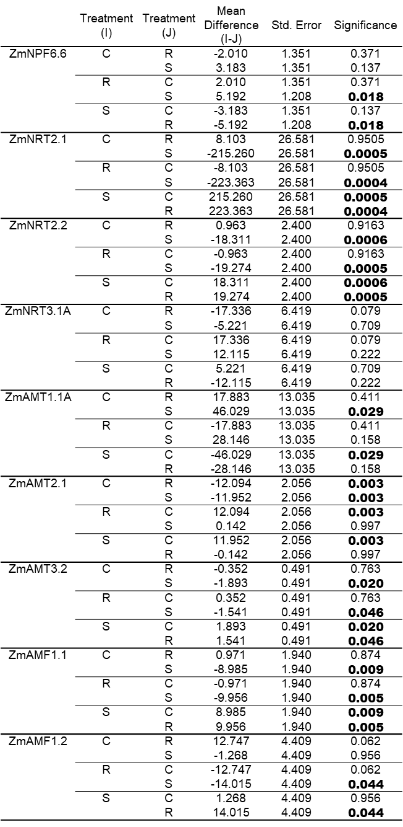

Table S3
One-way ANOVA results of shoot gene expression between control (C), starved (S) and resupplied (R) plants. Bold text denotes p<0.05.
