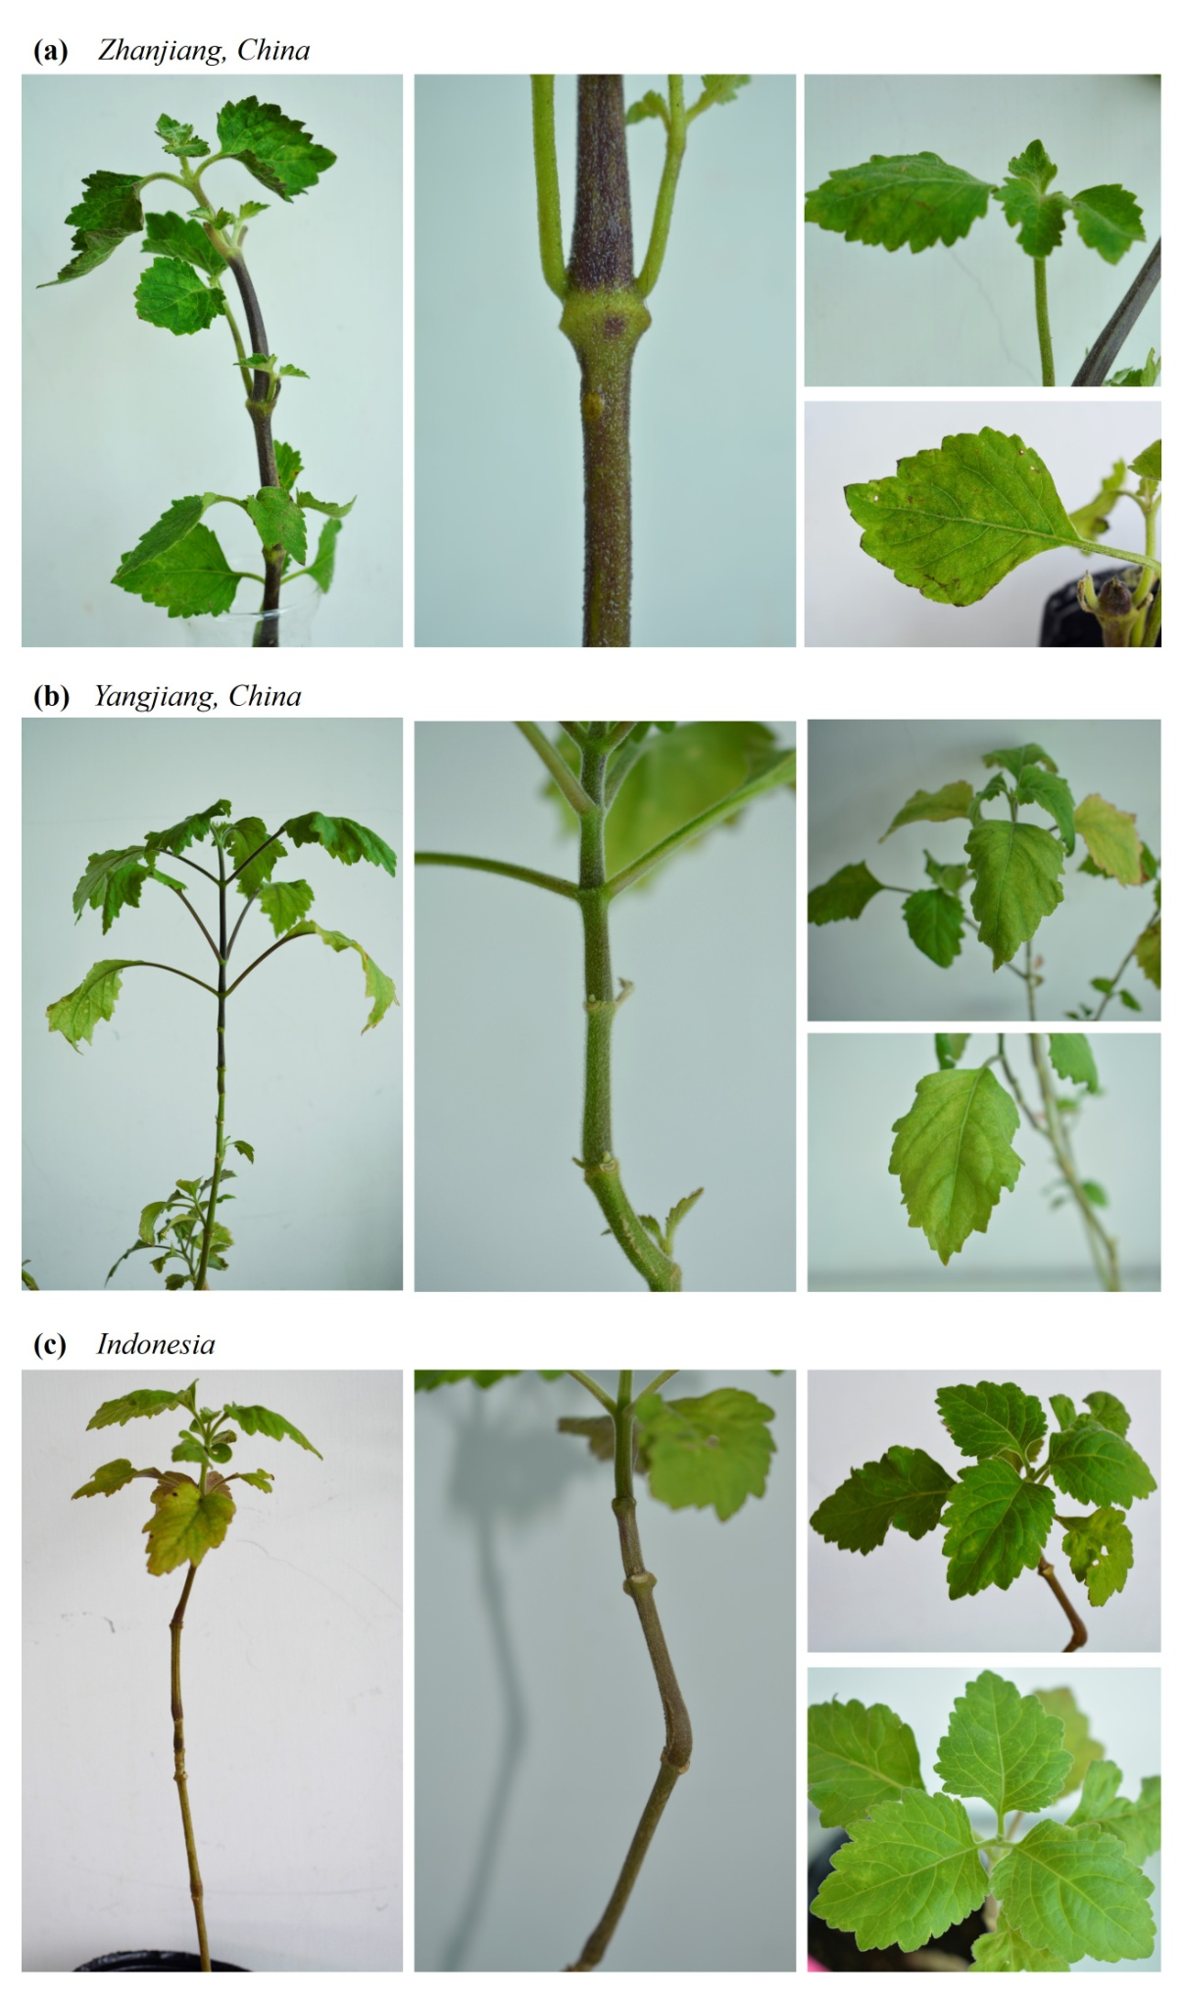
Fig. S1 Morphology characteristics of different Pogostemon cablin cultivars, including (a) P. cablin cv. ‘Zhanxiang’, (b) P. cablin cv. ‘Yangjiang’, and (c) P. cablin cv. ‘Indonesia’.

