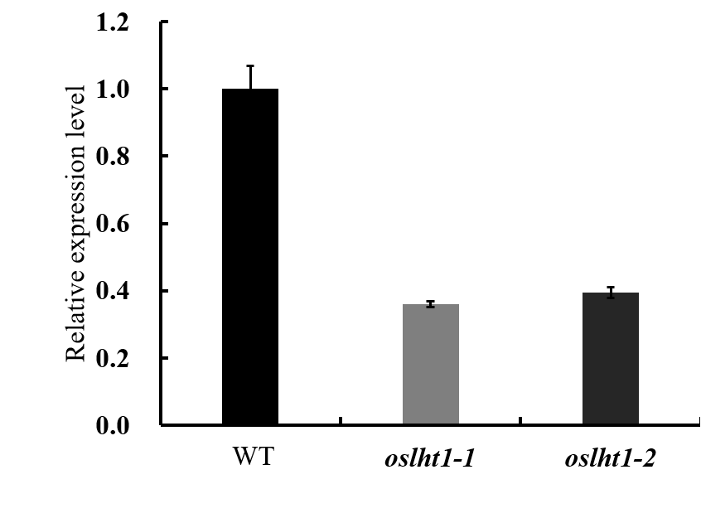
Figure S1 Transcript level of OsLHT1 in root of the wild-type and oslht1 plants, analyzed by qRT-PCR. The data are shown as the mean ± SD (n = 3).

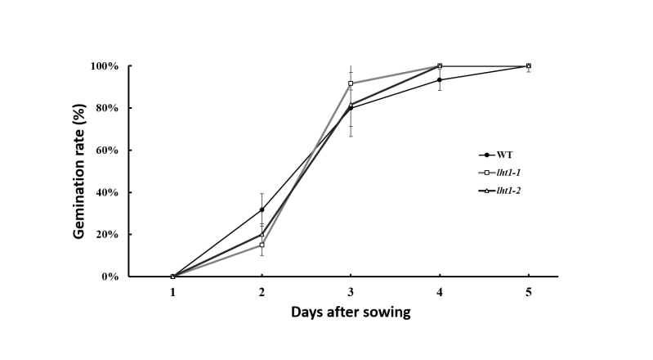
Figure S2 Germination rates of the wild-type and oslht1 seeds.
Seeds of wild-type and oslht1 plants were cultured in 0.5mM CaCl₂ solution at 28°C for 5 days. Results are averages of 3 independent experiments. Error bars indicate standard deviations.

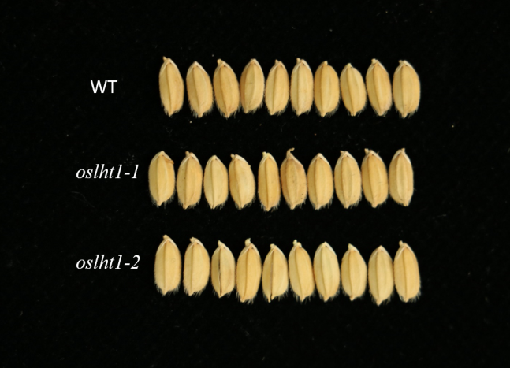
Figure S3 Grains of the wild-type and lht1 mutants.

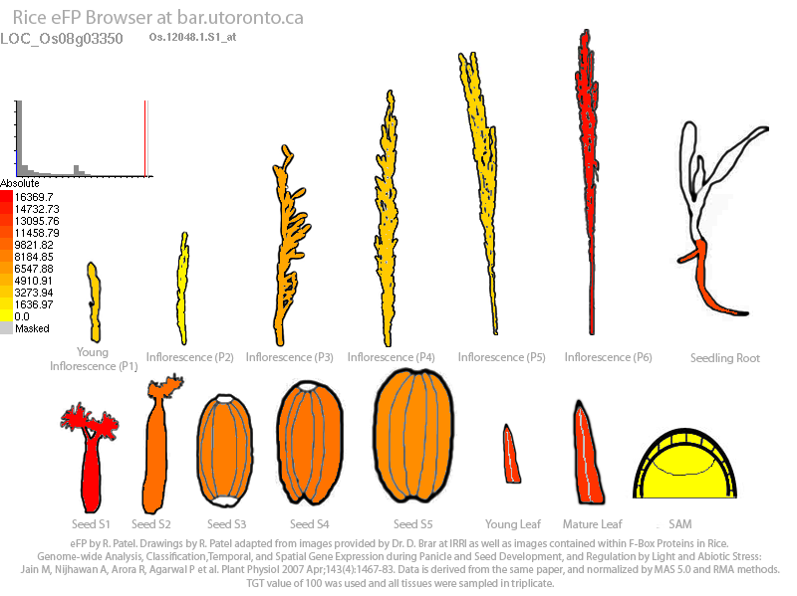

Figure S4 Transcript level of OsLHT1 in the developing organs. Pictograms were extracted from the eFP browser database [25].

Table S1 Raw qRT-PCR data in this study (Fig. 4a).
 | Ct value of Histone | Ct value of OsLHT1
Young panicle | 18.14 | 19.65
 | 18.66 | 21.93
 | 18.17 | 21
 | 18.95 | 20.89
Flag leaf | 18.41 | 19.5
 | 18.14 | 19.49
 | 18.53 | 19.95
 | 18.21 | 19.57
Flag leaf sheath | 18.48 | 20.28
 | 19.03 | 21.31
 | 18.12 | 19.95
 | 18.4 | 21.2
Lower internode | 19.03 | 24.55
 | 19.43 | 26.74
 | 19.01 | 24.38
 | 19.24 | 24.05
Root | 19.34 | 21.17
 | 19.15 | 21.38
 | 18.83 | 21.2
 | 19.61 | 21.41

