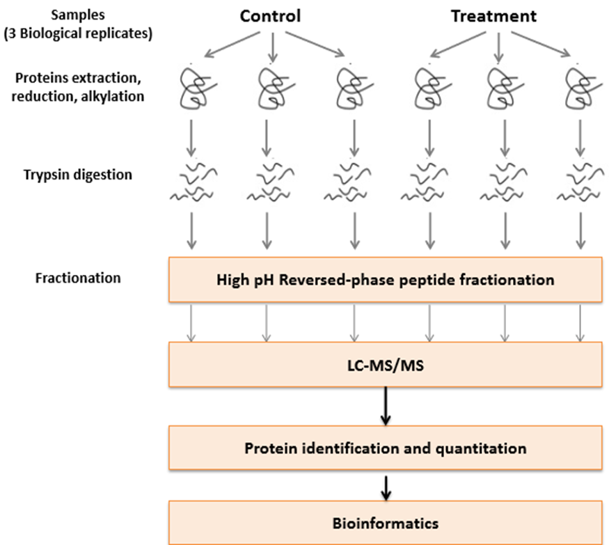
Additional file 1: Figure S1. Simply Label free experiment design and analysis.

