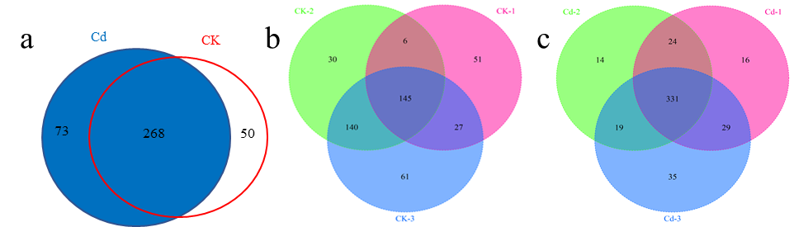
Additional file 3: Figure S3. Numbers of identified proteins in the control and Cd-treated samples.
Venn diagram of the number of proteins (a) identified in (b) the control and (c) Cd-treated xylem sap samples of hydroponic-grown Brassica napus.

