Fig S1. Sequence logo representing target site preference of Mariam. The logo was created using WebLogo 3.0 package. The letter height notes the probability of each nucleotide at a given position.

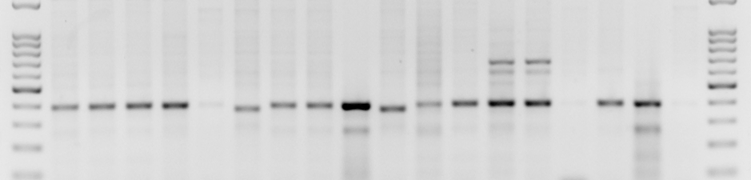
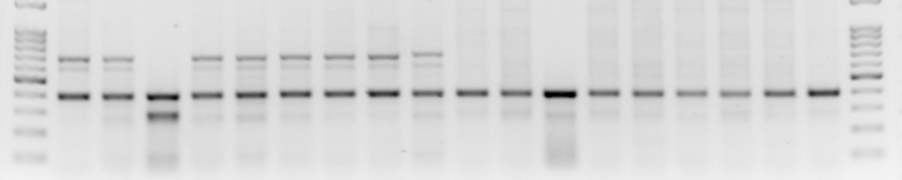
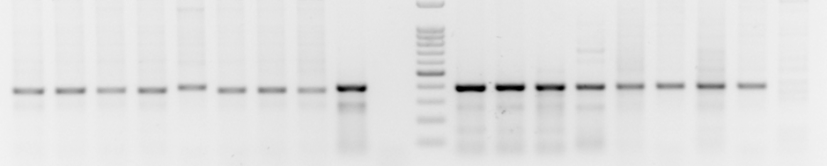
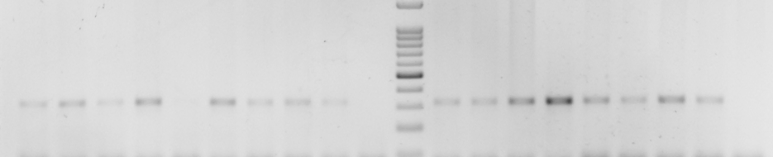
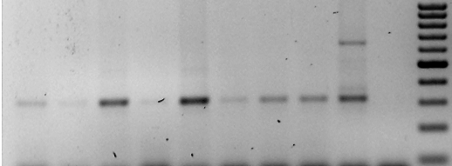
5 10 11 13 19 33 44 46 54 6 7 10 16b 17 18 20 23 28
1 2 3 5 6 7 8 9 10 1 2 3 4 5 7 8 9 10
1 4 8 11 13 16 24 25 89 1 2 3 4 5 6 7 8
M Mt. Hermon Amiad M
M Tabgha Jaba M
Mt. Amasa NC M T. aestivum
a.
5 10 11 13 19 34 44 46 54 6 7 10 16b 17 18 20 23 28
1 2 3 5 6 7 8 9 10 1 2 3 4 5 7 8 9 10
M Mt. Hermon Amiad M
M Tabgha Jaba M
Mt. Amasa NC M T. aestivum
3 4 8 11 13 16 24 25 89 1 2 3 4 5 6 7 8
b.

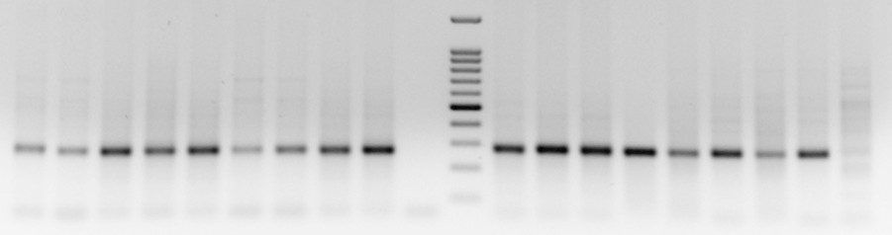
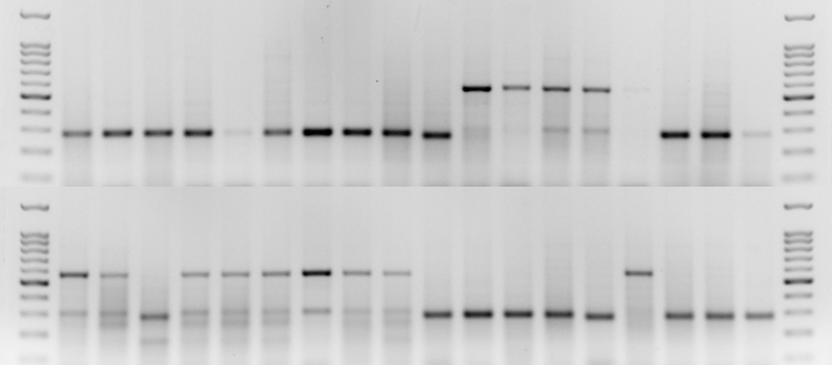
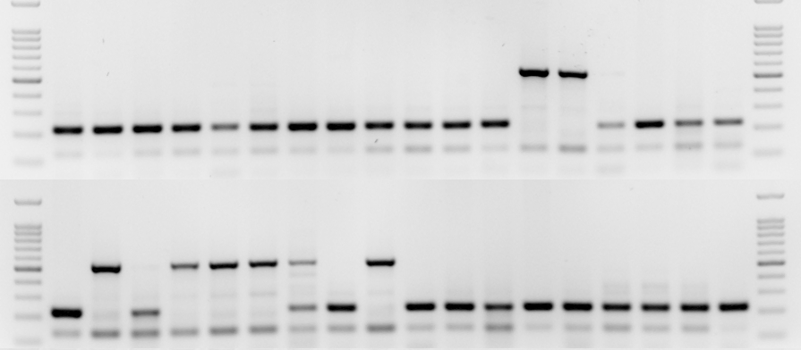
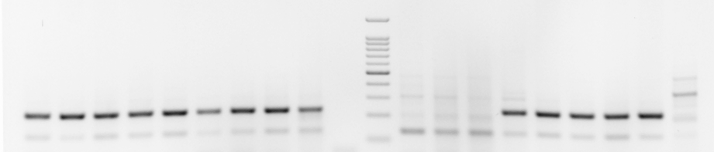
5 10 13 17 19 33 44 46 54 6 7 10 16b 17 18 20 23 28
1 2 3 5 6 7 8 9 10 1 2 3 4 5 7 8 9 10
M Mt. Hermon Amiad M
M Tabgha Jaba M
Mt. Amasa NC M T. aestivum
1 3 4 8 11 16 24 25 89 1 2 3 4 5 6 7 8
d.
5 10 13 17 19 33 44 46 54 6 7 10 16b 17 18 20 23 28
1 2 3 5 6 7 8 9 10 1 2 3 4 5 7 8 9 10
M Mt. Hermon Amiad M
M Tabgha Jaba M
Mt. Amasa NC M T. aestivum
1 3 4 8 11 16 24 25 89 1 2 3 4 5 6 7 8
c.

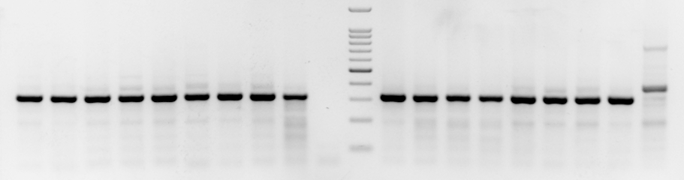
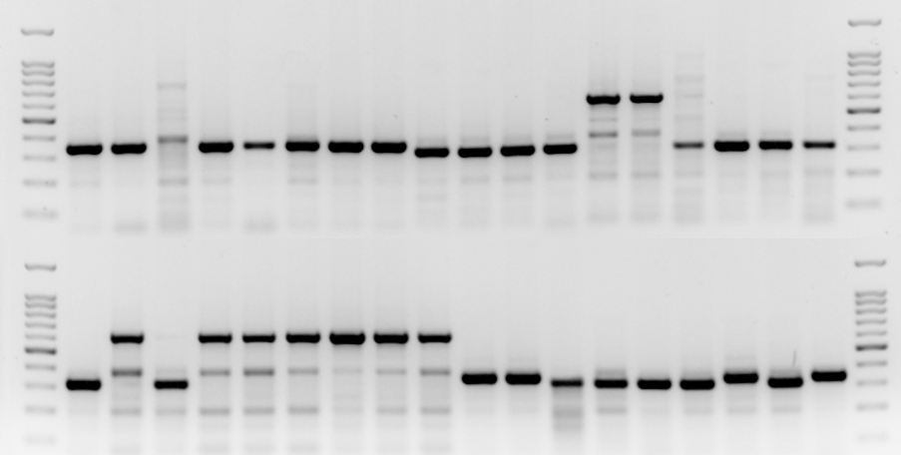
Mt. Amasa NC M T. aestivum
5 10 13 17 19 33 44 46 54 6 7 10 16b 17 18 20 23 28
1 2 3 5 6 7 8 9 10 1 2 3 4 5 7 8 9 10
M Mt. Hermon Amiad M
M Tabgha Jaba M
1 3 4 8 11 16 24 25 89 1 2 3 4 5 6 7 8
e.
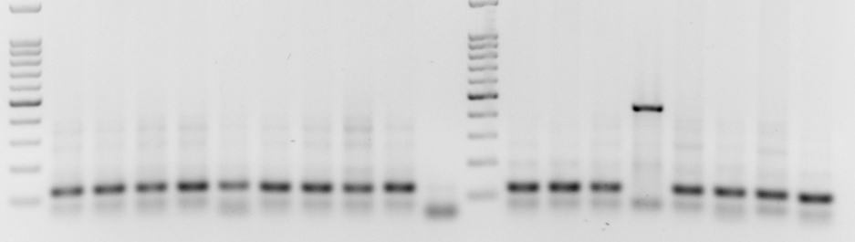
5 10 11 13 19 33 44 46 54 6 7 10 16b * 18 20 23 28
M Mt. Hermon Amiad M
1 2 3 5 6 7 * 9 10 1 2 3 4 5 7 8 9 10
M Mt. Amasa NC M T. aestivum
1 4 8 11 13 16 24 25 89 1 2 3 4 5 6 7 8
M Tabgha Jaba M
f.

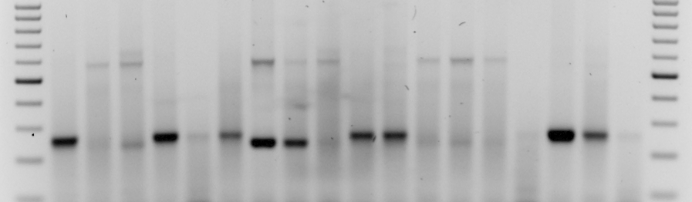
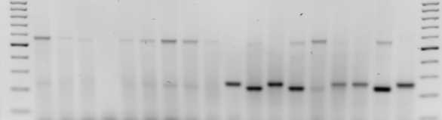
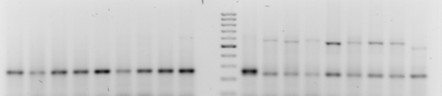
5 10 13 17 19 33 44 46 54 6 7 10 16b 17 18 20 23 28
1 2 3 * 6 7 8 9 10 1 2 3 4 5 7 8 9 10
M Mt. Hermon Amiad M
M Tabgha Jaba M
Mt. Amasa NC M T. aestivum
1 3 4 8 11 16 24 25 89 1 2 3 4 5 6 7 8
g.

Fig S2. Site-specific PCR analyses of Mariam insertions.
Analyses were performed with 5 populations of wild emmer wheat (top, middle, bottom left) and 8 accessions of bread wheat (bottom right, see additional file 2).
a, d, e, f – genome-specific primers; b, c – primers complementary to A, B and D subgenomes. Full and empty sites are indicated by arrows. M denotes size marker.
a – A6-2 site: a polymorphic insertion in Amiad and Tabgha populations (some accessions have a 683 bp band indicating full site in addition to the lower band indicating an empty site); all accessions of Mt. Hermon, Jaba, Mt. Amasa and bread wheat have only the lower empty site band (~380-400 bp, its exact length varies between accessions).
b – A7-5 site: a polymorphic insertion in Amiad, Tabgha and Mt. Amasa populations (some accessions have a 639 bp band indicating full site in addition to a 318 bp empty site); all accessions of Mt. Hermon, Jaba and bread wheat have only the lower empty site band.
c – B3-4 site: a polymorphic insertion in Amiad and Tabgha populations (each accession has either 545 bp band indicating full site or 228 bp band indicating empty site); all accessions of Mt. Hermon, Jaba and Mt. Amasa, and five bread wheat accessions (4-8) demonstrate a monomorphic empty site, in other bread wheat accessions no bands of expected size were detected.
d – B7-4 site: a polymorphic insertion in Amiad, Tabgha and Jaba populations (each accession has either 576 bp band indicating full site or a lower band indicating empty site); all accessions of Mt. Hermon and Mt. Amasa and all bread wheat accessions have the lower band indicating an empty site (~270-290 bp, its exact length varies between accessions).
e – B7-6 site: A polymorphic insertion found in some accessions of the Amiad (top right) and Tabgha (middle left) populations indicated by the upper 621 bp band. An empty site (lower 300-320 bp bands) is present in the other Amiad and Tabgha accessions and in all wild emmer from other populations and all bread wheat accessions.
f – A4-1 site: a polymorphic insertion in Amiad and Tabgha populations (each accession has either 437 bp band indicating full site or 119 bp band indicating empty site); the only bread wheat accession demonstrating a full site is TAA01; all accessions of Mt. Hermon, Jaba and Mt. Amasa, and seven bread wheat accessions demonstrate a monomorphic empty site.
g – B1-4 site: a polymorphic insertion in Mt. Hermon, Amiad, Jaba and Mt. Amasa populations as well as bread wheat accessions (each accession has either 575 bp band indicating full site and/or a 261 bp band indicating empty site); all Tabgha accessions have the higher full site band.

