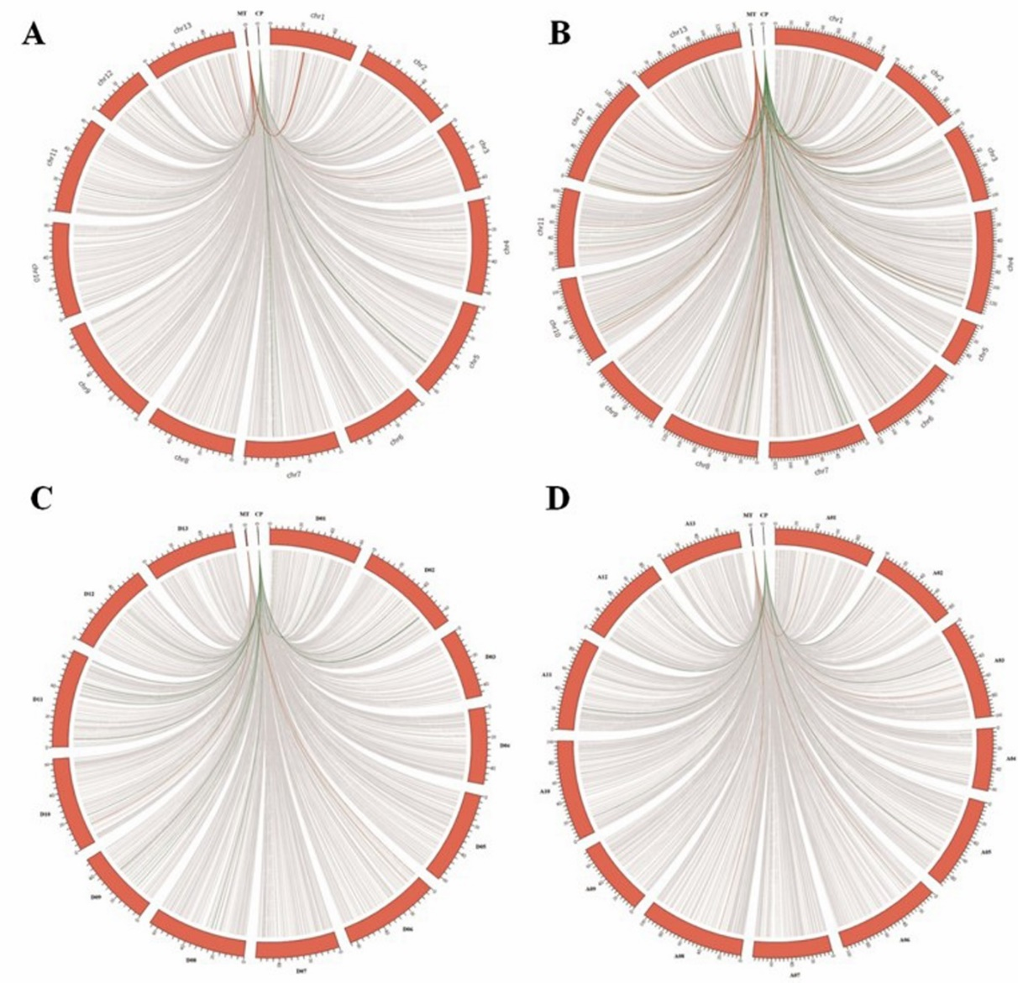
Additional file 4：The identification of nuclear organellar DNA in Gossypium. A: G. raimondii. B: G. arboreum. C: G. hirsutum (A_{t}). D: G. hirsutum (D_{t}). Red bands around the circles indicate the nuclear chromosomes. Orange and green lines represent insertions more than 5 kb from mitogenome and chloroplast genome, respectively. While grey lines represent insertions between 100bp to 5 kb from both genomes. MT: mitochondrial genome. CP: chloroplast genome.

