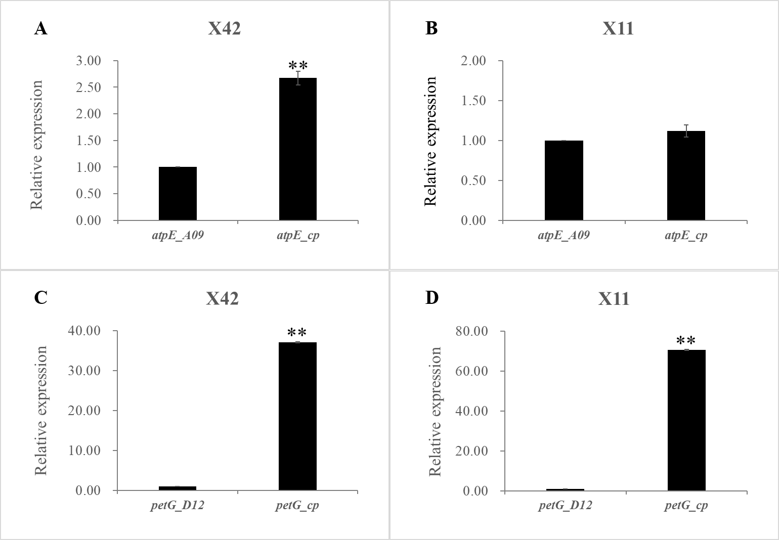
Additional file 7: Relative expression levels of chloroplast genes atpE_cp/petG_cp and their nuclear copies, atpE_A09/petG_D12, in two G. hirsutum varieties. X42: Xinluzao 42; X11: Xinluzao 11. The relative expression values are calculated with the method of 2^{−△△Ct}. **, p<0.01. See methods for details.

