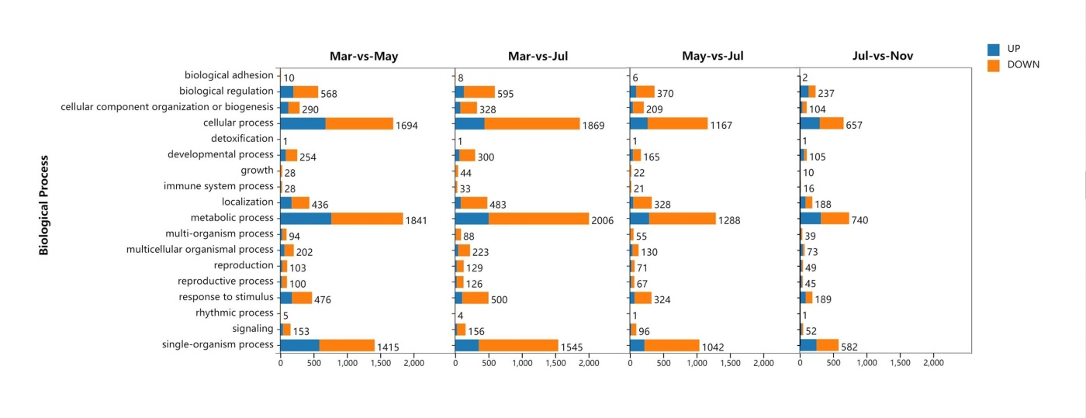
Additional file 2：Figure S1. Functional categories of up- and down-regulated unigenes at each developmental stage of P.notoginseng taproots. The classification was preformed according to gene ontology (GO) biological process.

