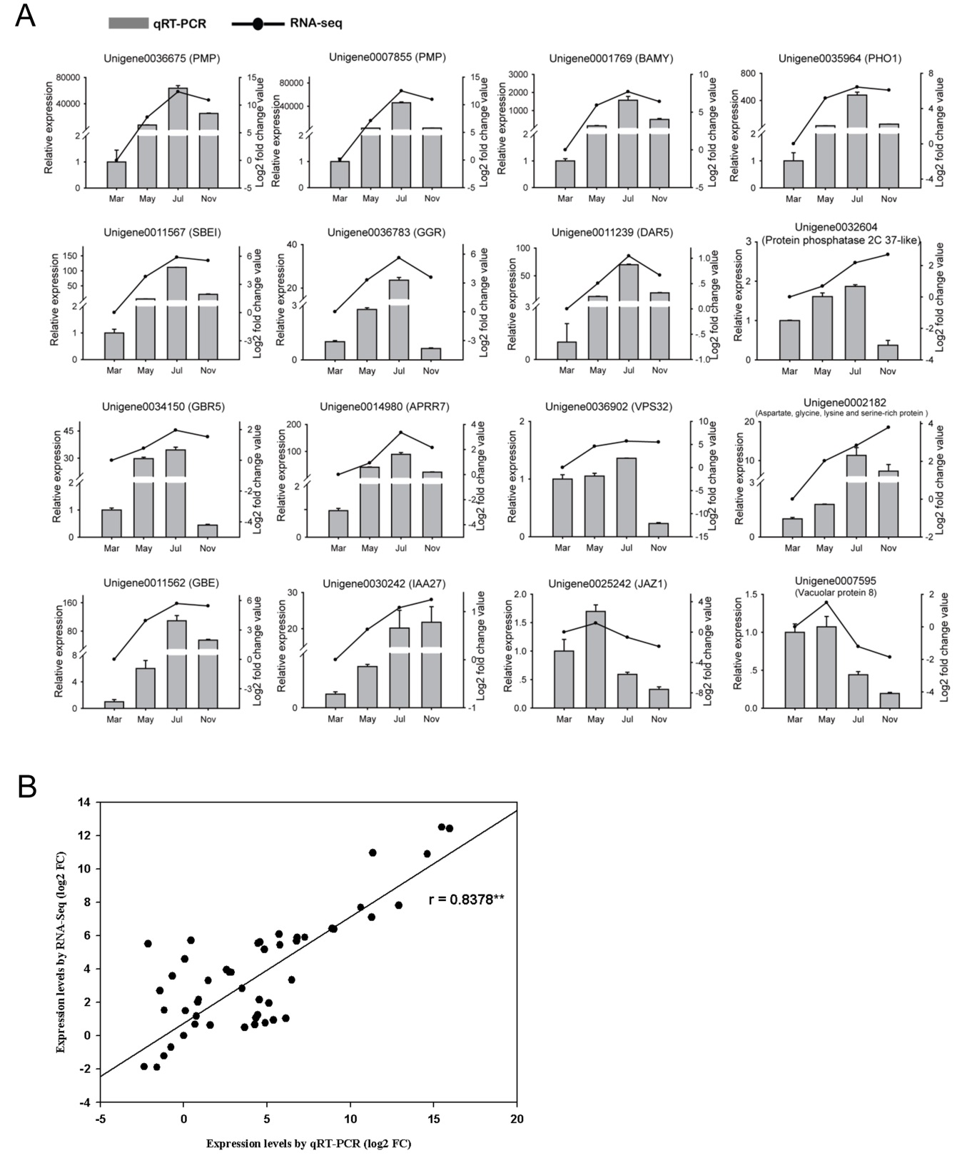

Additional file 3: Figure S2. qRT-PCR verification diagram of DEGs during the thickening process in the taproots of P. notoginseng. a The expression levels determined by qRT-PCR and RNA-seq from four stages. b Correlation of gene expression ratio between RNA-Seq results (RPKM) and qPCR (2^{-ΔΔCt)} results. Results were calculated using log₂ (Fold Change) values. The r value indicates the correlation coefficient. ** indicates significant difference at p ≤ 0.01.

