Transcriptomic Analysis Reveals Flavonoid Biosynthesis of Syringa oblata Lindl. in Response to Different Light Intensity
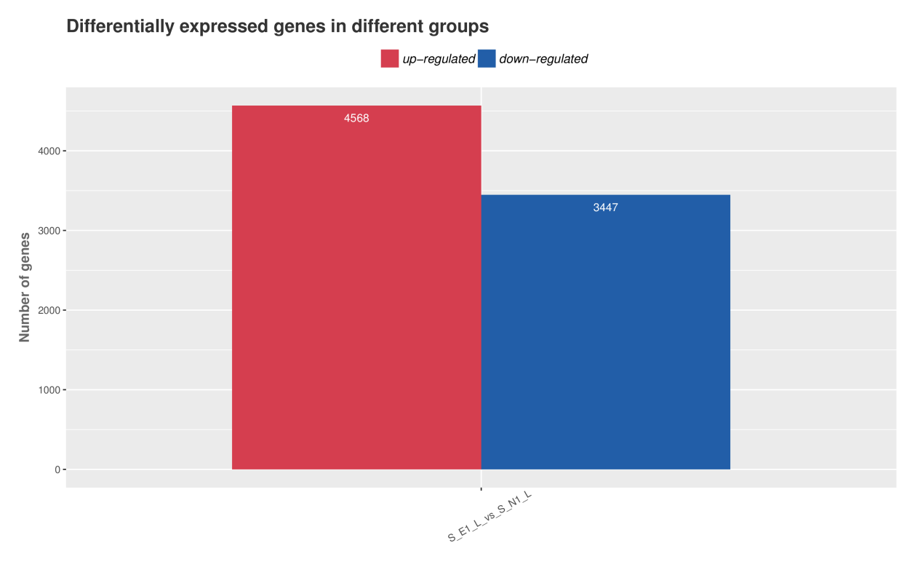Figure S1 Genes with significant differential expression in Syringa oblata Lindl.
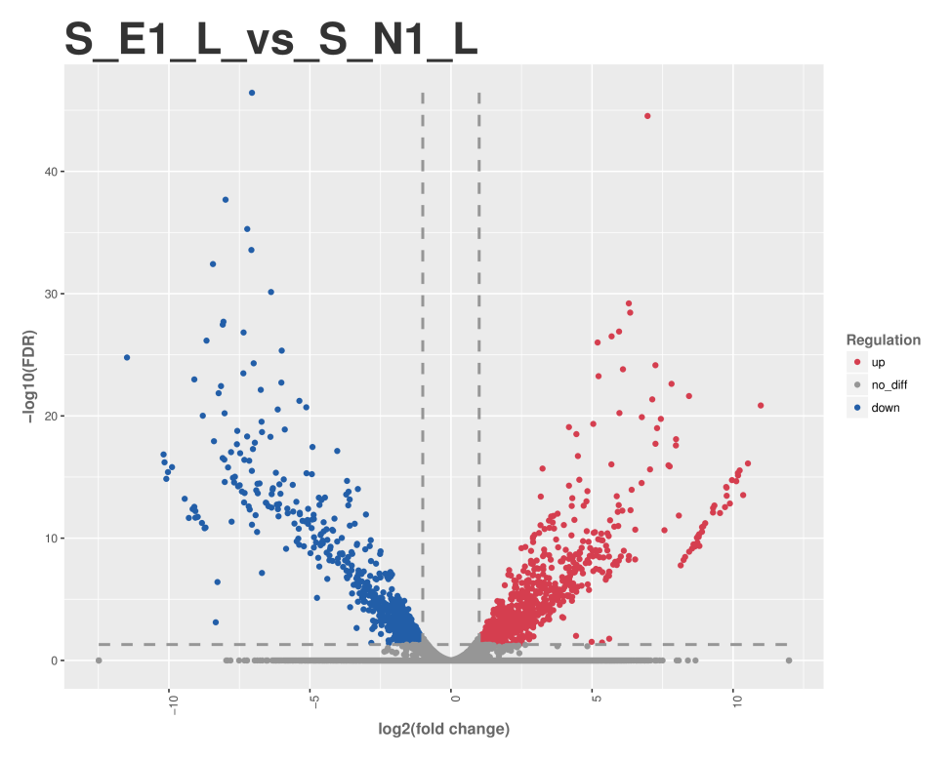
Figure S2 Volcano diagram of differentially expressed Unigenes between two groups in Syringa oblata Lindl.
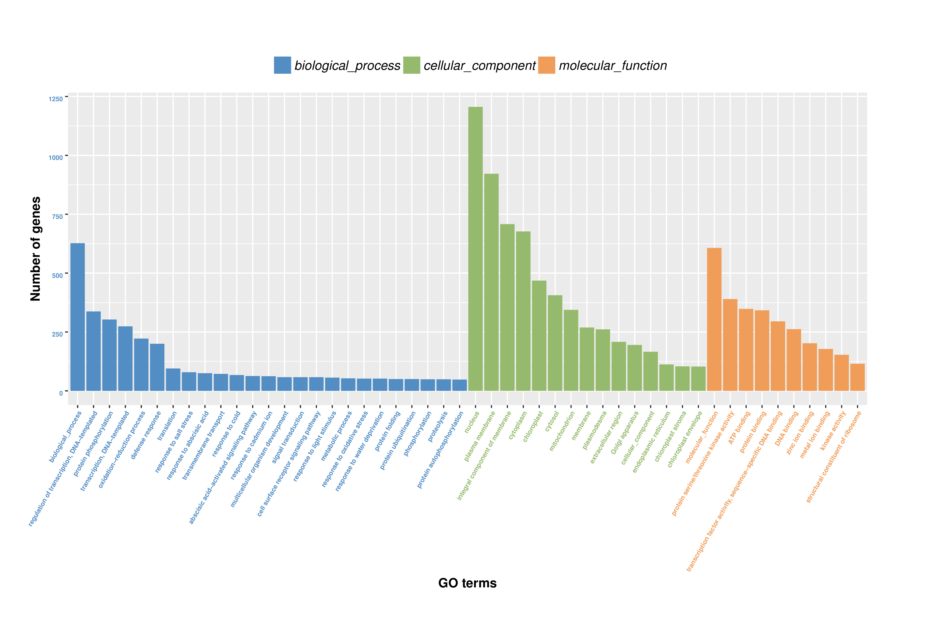
Figure S3 GO enrichment analysis of differentially expressed Unigenes in Syringa oblata Lindl.
Table S1 Air pollution index for May to October in 2017.
Month | AQI | Range | Quality level | PM  2.5 | PM  10 | SO₂ | CO | NO₂ | O₃
May | 85 | 37~297 | Good | 24 | 65 | 11 | 0.877 | 31 | 122
June | 68 | 32~148 | Good | 24 | 45 | 9 | 0.723 | 37 | 114
July | 74 | 42~128 | Good | 21 | 50 | 8 | 0.713 | 37 | 124
August | 48 | 27~85 | Excellent | 16 | 38 | 7 | 0.574 | 28 | 88
September | 48 | 29~70 | Excellent | 21 | 48 | 8 | 0.637 | 33 | 74
October | 119 | 35~473 | Mild pollution | 94 | 122 | 17 | 0.848 | 49 | 84
Table S2 Fluorescence quantitative real-time PCR primer sequence.
Gene_ID | Primer | Primer sequence（5' - 3'）
TRINITY_DN36967_c0_g1 (PAL) | Forward | AGATTGAGGCTGCTGCTGTGATG
TRINITY_DN36967_c0_g1 (PAL) | Reverse | CGATCCTGCTTCGGCTTCTGC
TRINITY_DN35155_c0_g1 (4CL1) | Forward | GGACGCAGGAGAAGTTCCAGTTG
TRINITY_DN35155_c0_g1 (4CL1) | Reverse | CGACGGAGACTTAGGAATGGCATC
TRINITY_DN29851_c0_g2 (CYP73A) | Forward | CGCCGCCTCTGTTCCATTCTC
TRINITY_DN29851_c0_g2 (CYP73A) | Reverse | ATAATCCGGCATGGTGGAAGAAGC
TRINITY_DN31867_c0_g1 (HST) | Forward | CATGGTCTGATATGGCTCGTGGTC
TRINITY_DN31867_c0_g1 (HST) | Reverse | CGGCTGGTACTCGATGTGCTTG
TRINITY_DN31867_c0_g2 (HST) | Forward | TTCTAGGCTCCAACCTCCACTTCC
TRINITY_DN31867_c0_g2 (HST) | Reverse | GGAGATCACCAGCTACTGCGATTG
TRINITY_DN35859_c0_g3 (CHS2) | Forward | TGGTTACGGTTGAGGATGTTCGTC
TRINITY_DN35859_c0_g3 (CHS2) | Reverse | CAATTCGGTGGCGTTGCAGTG
TRINITY_DN35859_c0_g2 (CHS) | Forward | GCAGAGCACCACAGGCGAAG
TRINITY_DN35859_c0_g2 (CHS) | Reverse | CAGAACCACGGTCTCAACTGTCAG
TRINITY_DN32109_c0_g3 (CHS) | Forward | GCCGACTACCAACTCACCAAGC
TRINITY_DN32109_c0_g3 (CHS) | Reverse | TGTTGTTCTCCGCCAAGTCCTTG
TRINITY_DN36563_c0_g1 (FHT) | Forward | GATGACGATGACGGCGGCAAG
TRINITY_DN36563_c0_g1 (FHT) | Reverse | TGTCGAACCGGAGCTTCTCTATGG
TRINITY_DN36038_c0_g2 (DLO2) | Forward | GGACGCTGGTGCCTTGACAATC
TRINITY_DN36038_c0_g2 (DLO2) | Reverse | CTCGGAATTGACCTTCGCTCTGTG
TRINITY_DN28124_c3_g2 (DMR6) | Forward | AACTTATGGTCTTCCGGCTCATGC
TRINITY_DN28124_c3_g2 (DMR6) | Reverse | TGCCATCCTTGAGAACTTGCAGAC
TRINITY_DN29800_c0_g2 (SGR1) | Forward | CGCCTCTTCCACCCAAGAAC
TRINITY_DN29800_c0_g2 (SGR1) | Reverse | GAGGCTGTGCCACCAATTCT
TRINITY_DN31579_c2_g5 (CYP75B1) | Forward | ACATGCATACGACTTACCGTGG
TRINITY_DN31579_c2_g5 (CYP75B1) | Reverse | GCGGGTGGAGATTGGTCTATG
TRINITY_DN28965_c1_g8 (BHLH) | Forward | GGAAGACAGTTCAGCCGACAGAAG
TRINITY_DN28965_c1_g8 (BHLH) | Reverse | GGCGACAAGGCAGCAGAAGG
TRINITY_DN36649_c0_g3 (CPR) | Forward | GTCCAACACAAGATGGCTGAGAGG
TRINITY_DN36649_c0_g3 (CPR) | Reverse | AGCCTTGGTGCTGTCTAGAGATCC

