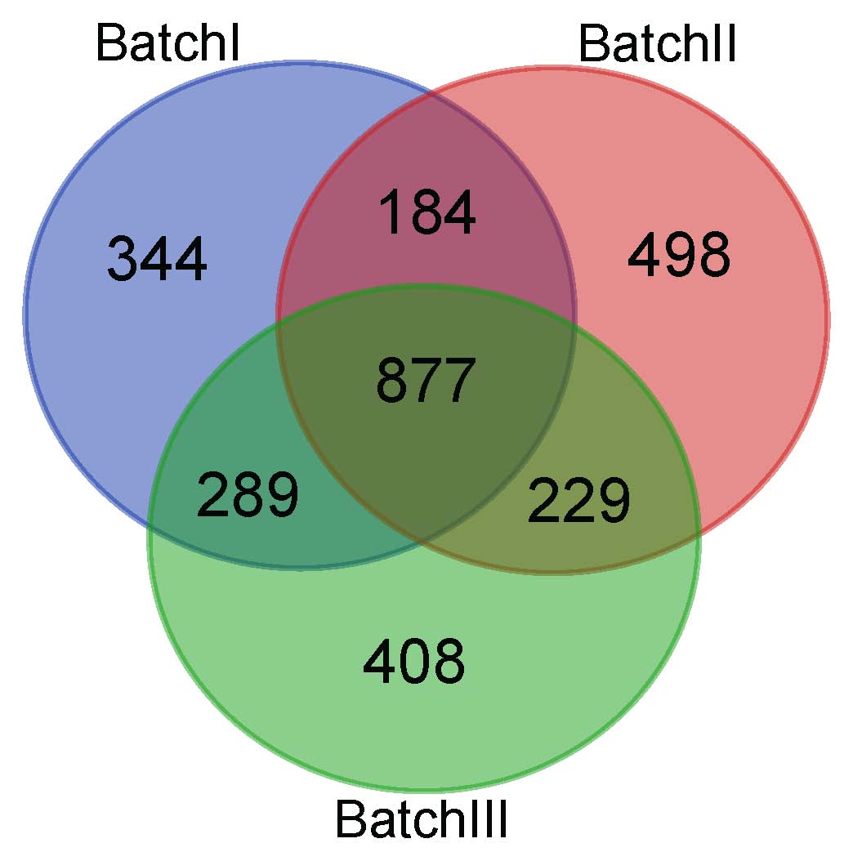

Fig. S1. Venn diagrams showing the overlapping of identified proteins in the three batches.

