Fig. S2A. Functional categorization of DAPs between TW-1-M-1 and TW-1-1.
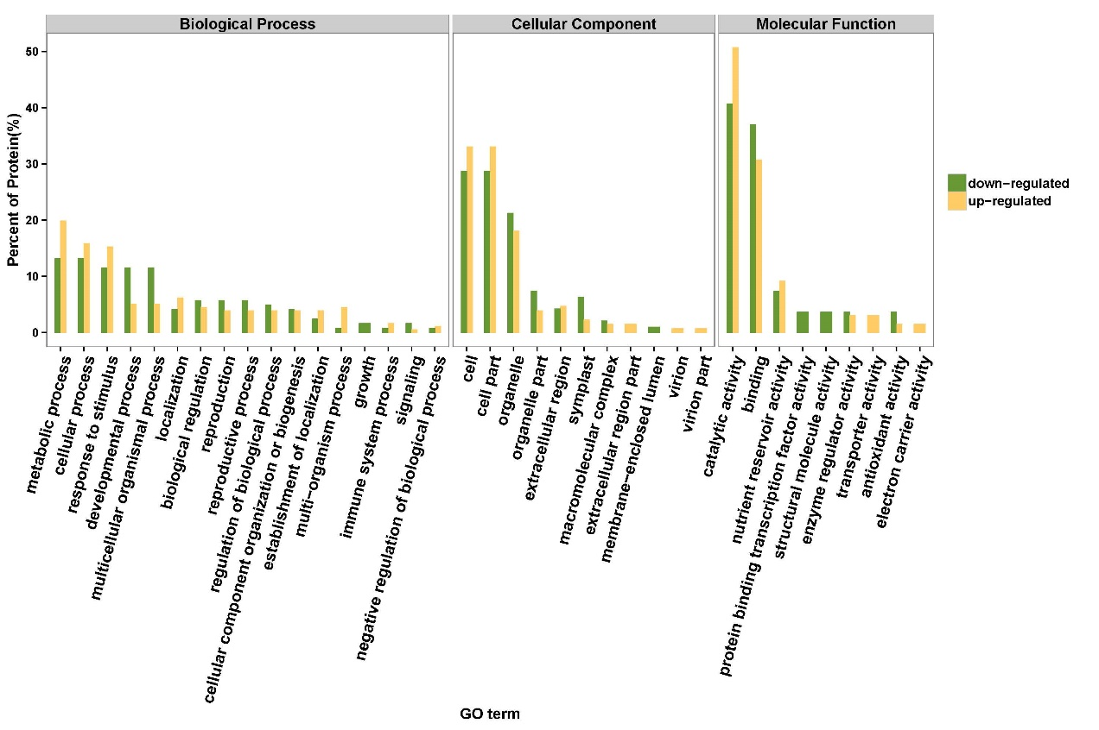
Fig. S2B. Functional categorization of DAPs between TW-1-M-2 and TW-1-2.
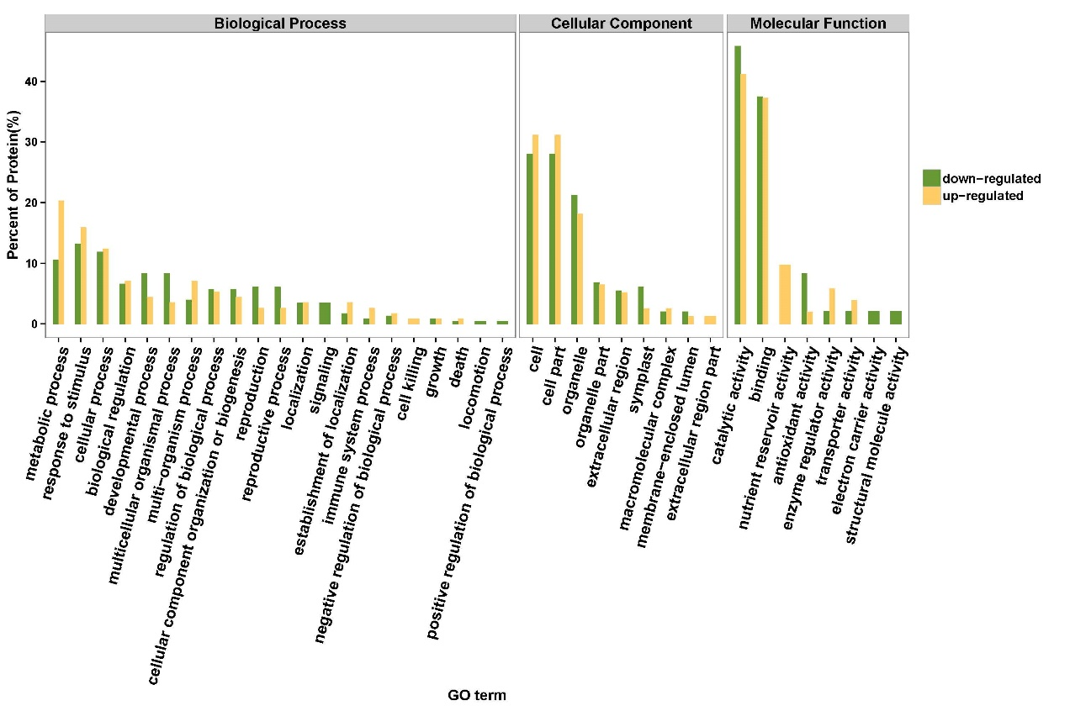
Fig. S2C. Functional categorization of DAPs between TW-1-M-3 and TW-1-3.

Fig. S2. Functional categorization of DAPs during the seed germination stage. A. Functional categorization of DAPs between TW-1-M-1 and TW-1-1. B. Functional categorization of DAPs between TW-1-M-2 and TW-1-2. C. Functional categorization of DAPs between TW-1-M-3 and TW-1-3.

