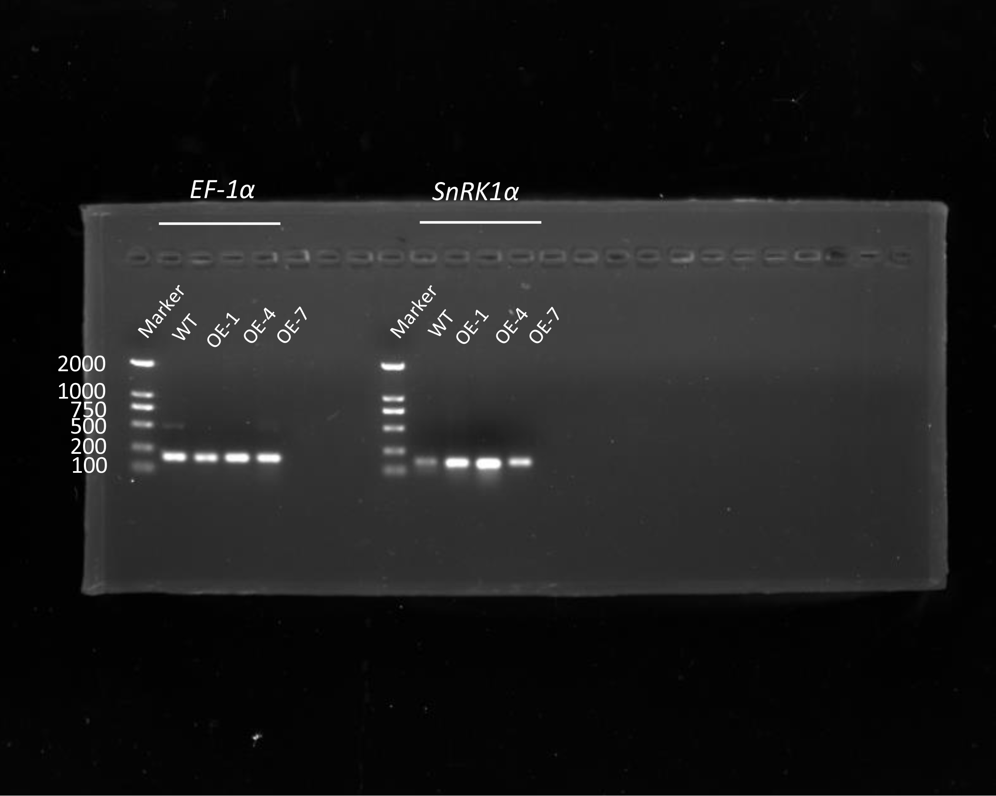
Figure S1 Relative expression level of SnRK1α (the original, uncropped gel of figure 1a). The expression levels of SnRK1α in WT, OE-1, OE-4, and OE-7 were detected by PCR, EF-1α was used as a control. 10 ul of each PCR product was taken for agarose gel electrophoresis.

