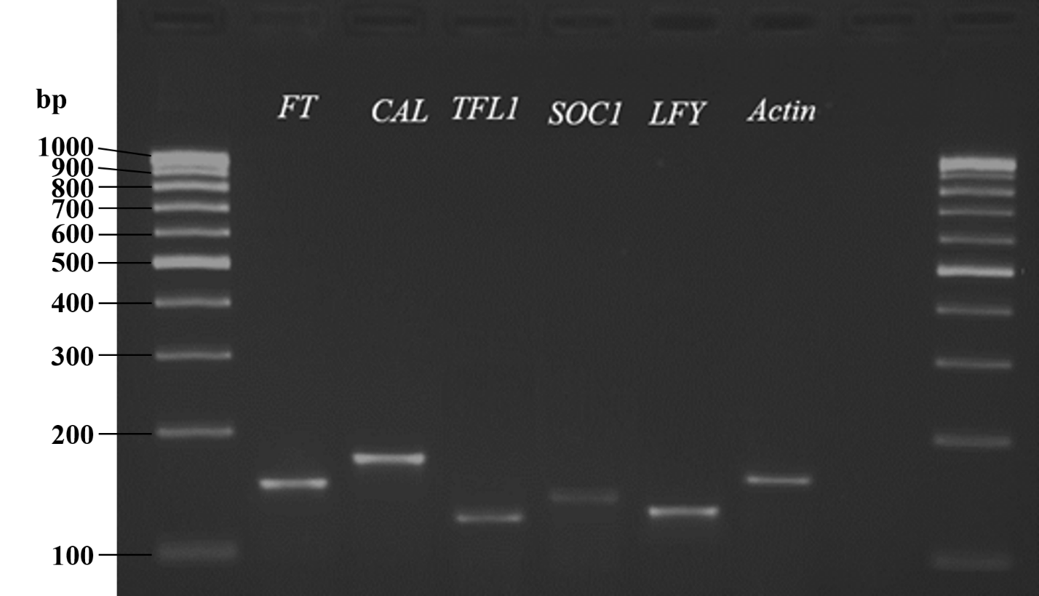
Additional file 1. Agarose gel electrophoresis of PCR products of the designed primer involved in flowering including FT (≈130 bp), CAL (≈170 bp), TFL1 (≈120 bp), SOC1 (≈130 bp), LFY (≈125 bp) and Actin (≈140 bp) genes

