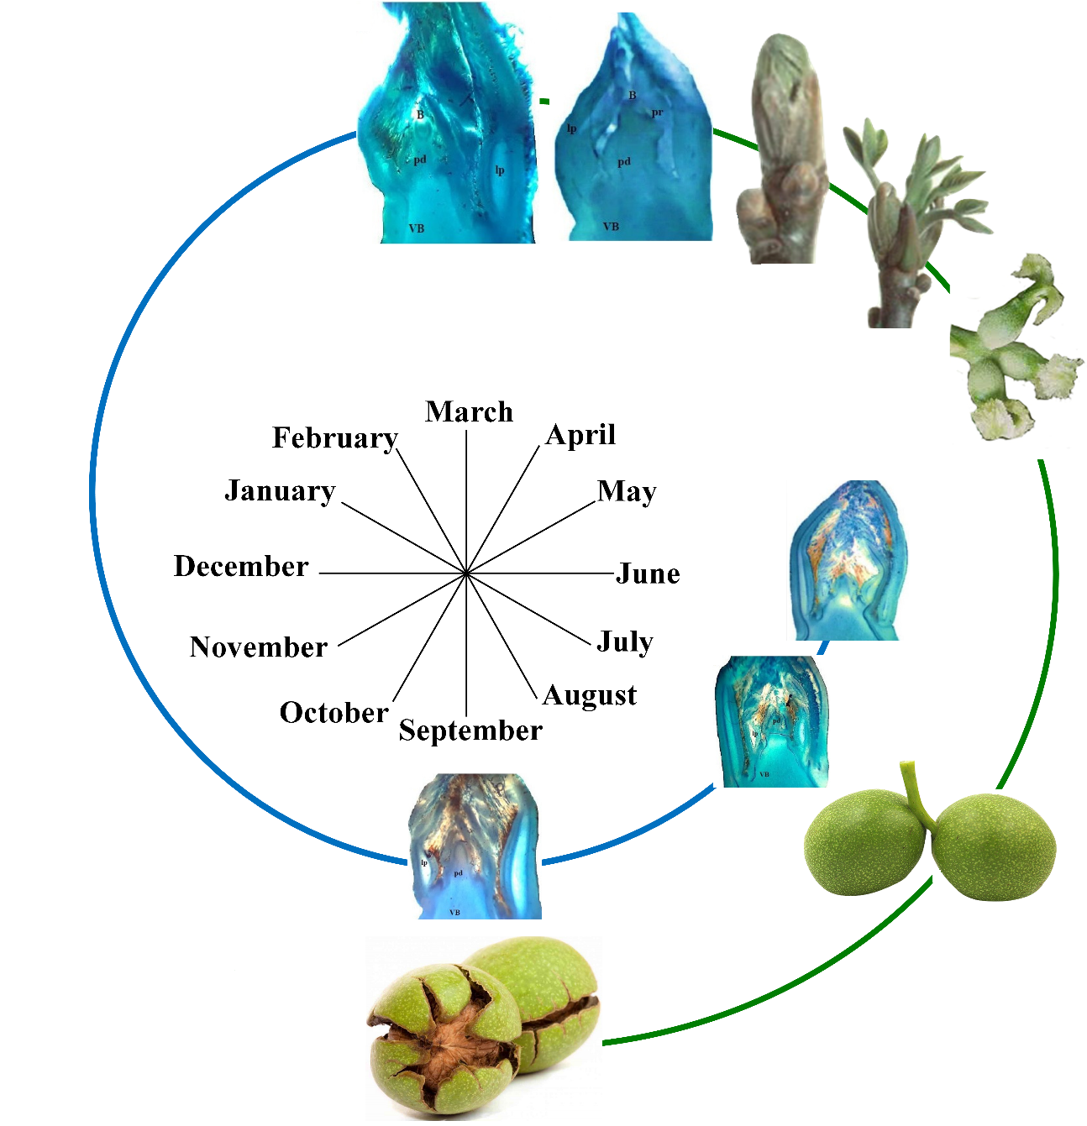
Additional file 2. Different flowering and fruit development stages of walnut during in three consecutive years (2014-2016) (Blue line: last year; Green line: following year)

