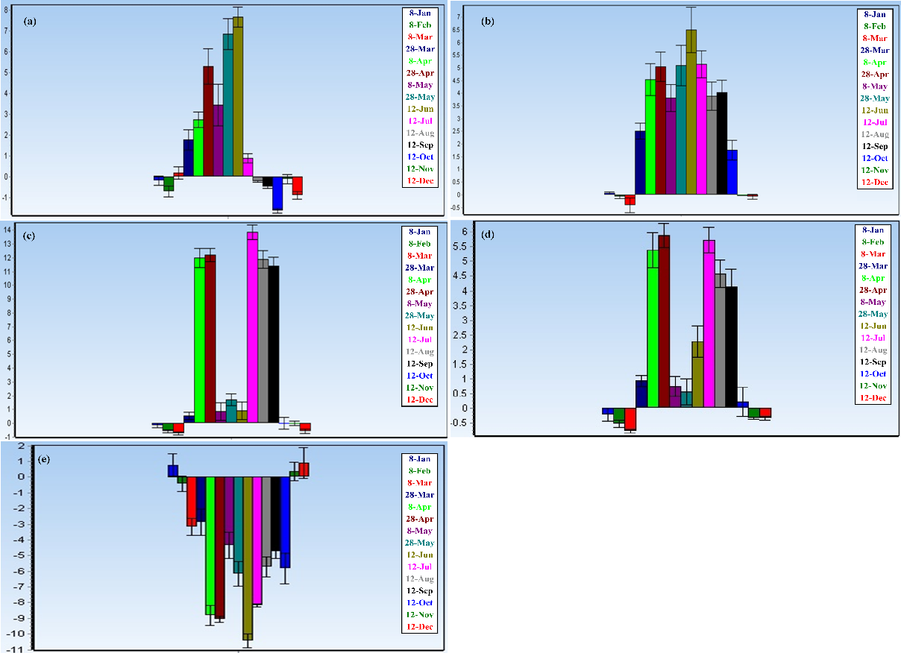

Additional file 3. Fold changes of FT (a), SOC1 (b), CAL (c), LFY (d) and TFL1 (e) gene expression identified by quantitative RT-PCR analysis

