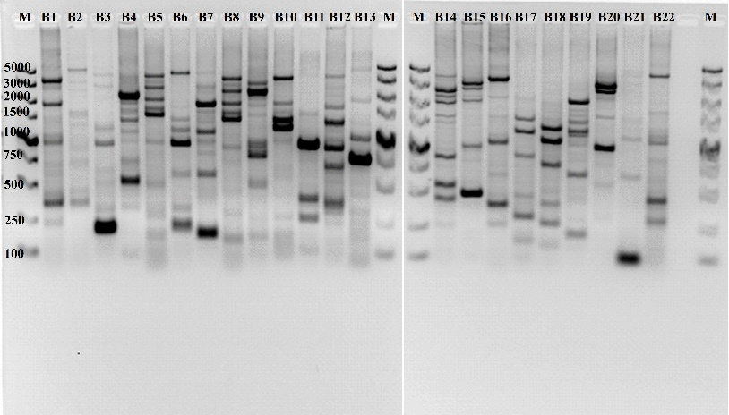
Figure S3. BOX fingerprinting of the screened bacterial isolates from sugarcane.
Strain Codes: B1. CoY3, B2. CoY7, B3. CoY8, B4. CoA1, B5. CoA10, B6. AY6, B7. AY7, B8. AY8, B9. AN8, B10. AN11, B11. AN12, B12. BN5, B13. CY5, B14. CY9, B15. CY10, B16. CY11, B17. CA1, B18. CA6, B19. CA8, B20. CN13, B21. CN14 and B22. N1. M, molecular size marker from 100 bp- 5 kb (Takara).

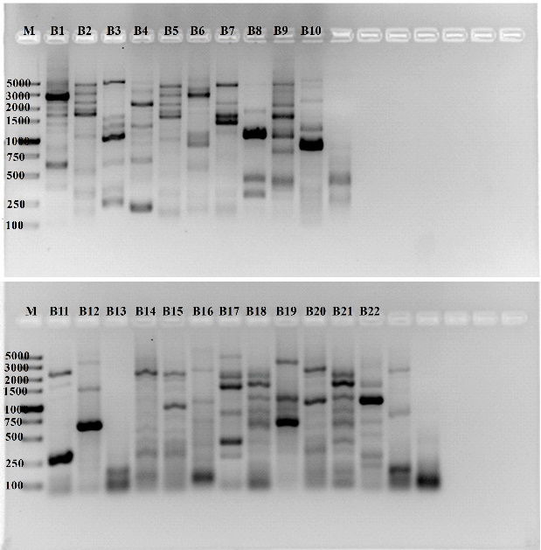
Figure S4. ERIC-PCR fingerprinting of selected bacteria from sugarcane.
Strain Codes: B1. CoY3, B2. CoY7, B3. CoY8, B4. CoA1, B5. CoA10, B6. AY6, B7. AY7, B8. AY8, B9. AN8, B10. AN11, B11. AN12, B12. BN5, B13. CY5, B14. CY9, B15. CY10, B16. CY11, B17. CA1, B18. CA6, B19. CA8, B20. CN13, B21. CN14 and B22. N1. Without labelled gel lanes are not used in this study.

