Supplementary figures
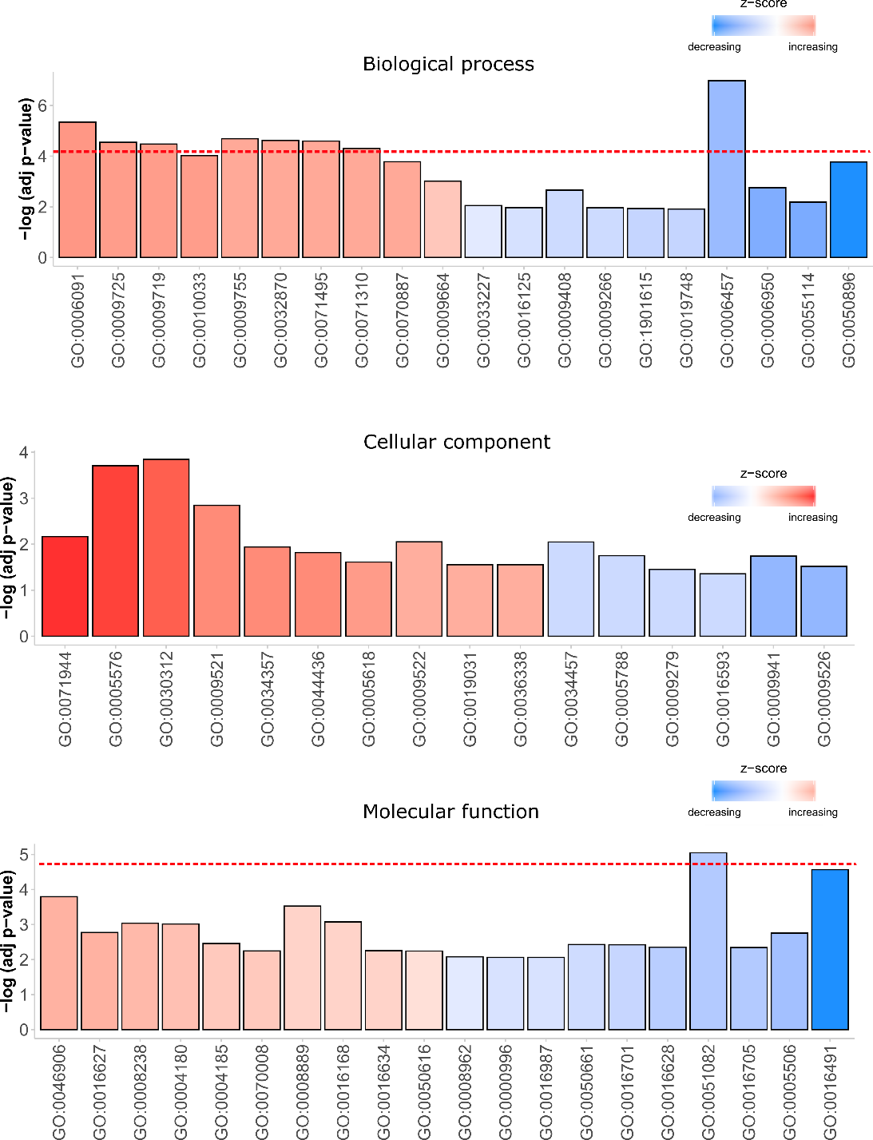
Fig. S1 Gene ontology enrichment of differentially expressed genes identified in leaves under direct sunlight versus under shade. Only up to 10 terms are selected to present. Horizontal redline represents the threshold of significance after false discovery rate correction.

