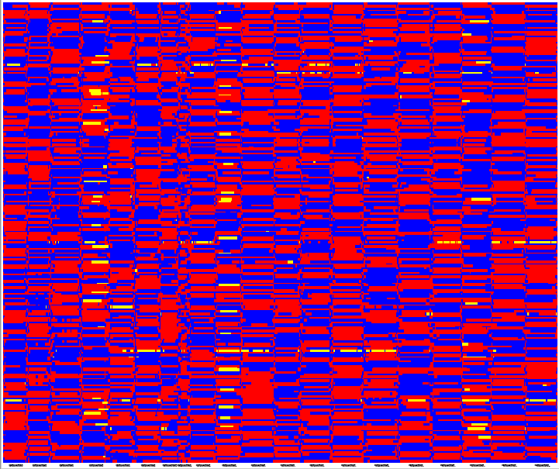
Supplementary Figure 1 The physical recombination map of 212 RILs on 20 chromosomes.
Blue: the genotype of the resistant parent Zheng8903; Red: the genotype of the susceptible parent Yuhua4; Yellow: the heterozygous genotype; RILs were arranged from the top to the bottom and chromosomes were ranked from left to right.

