PRM is quantified using peak area. The fragment ion peak area distribution of the selected peptide in 15 samples is shown below: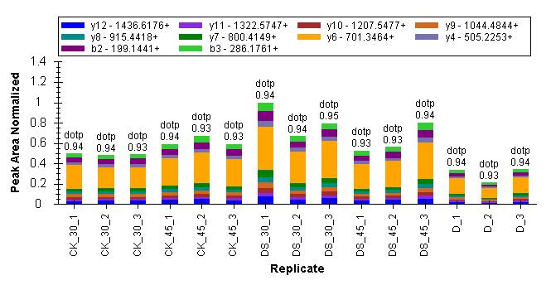
Fig.1 VVSINDYEDVPVNDEK fragment ion peak area distribution map. Fragment ion peak area distribution of peptide VVSINDYEDVPVNDEK (corresponding to protein A0A1U8L2Y6) in 15 samples.

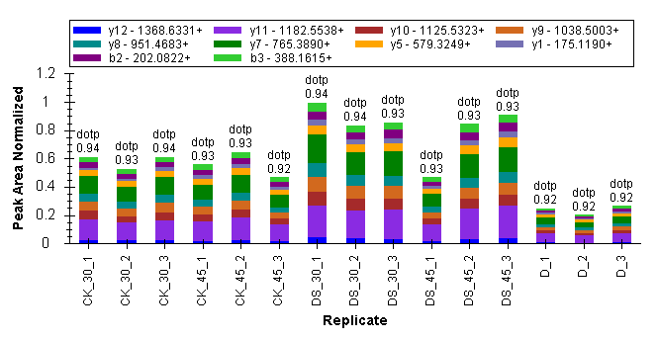
Fig.2 NSWGSSWGEAGYLR fragment ion peak area distribution map. Fragment ion peak area distribution of peptide NSWGSSWGEAGYLR (A0A1U8L2Y6) in 15 samples.

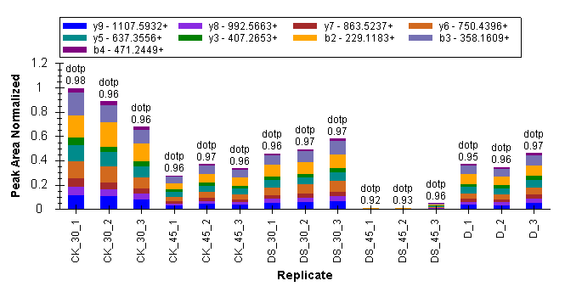
Fig.3 IDELITEFLK fragment ion peak area distribution map. Fragment ion peak area distribution of peptide IDELITEFLK (A0A1U8P5X3) in 15 samples.

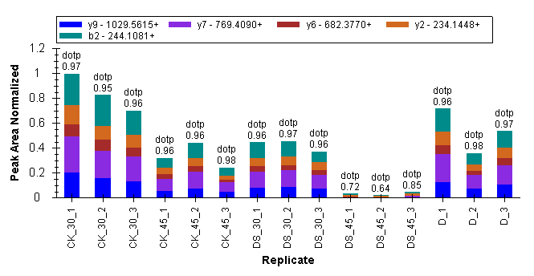
Fig.4 GWPSFLSAYTISK fragment ion peak area distribution map. Fragment ion peak area distribution of peptide GWPSFLSAYTISK (A0A1U8P5X3) in 15 samples.

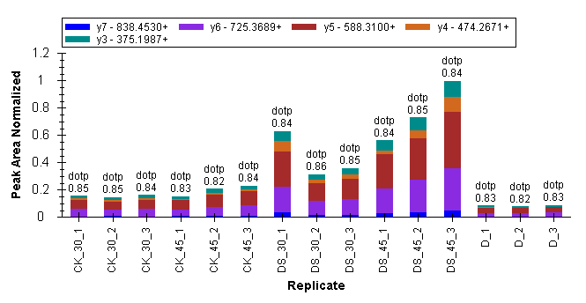
Fig. 5 LLNLHNVAER fragment ion peak area distribution map. Fragment ion peak area distribution of peptide LLNLHNVAER (A0A0U2L631) in 15 samples.

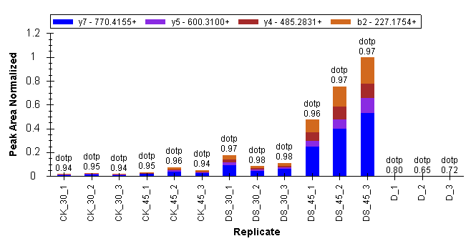
Fig. 6 IIAVDVNPR fragment ion peak area distribution map. Fragment ion peak area distribution of peptide IIAVDVNPR (A4L9H3) in 15 samples.

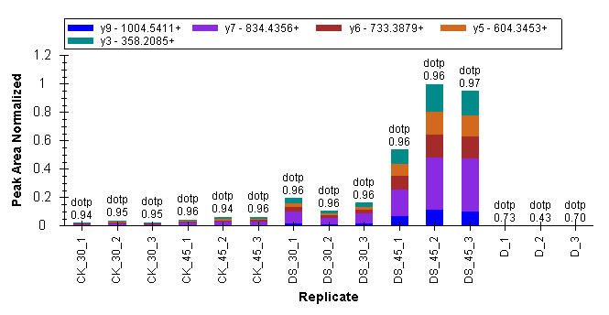
Fig. 7 FGITEFVNPK fragment ion peak area distribution map. Fragment ion peak area distribution of peptide FGITEFVNPK (A4L9H3) in 15 samples.

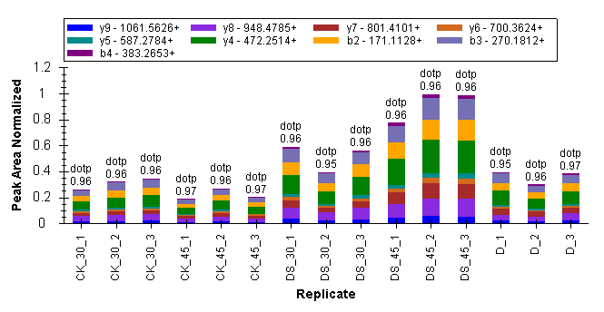
Fig. 8 AVVLFTLDPAER fragment ion peak area distribution map. Fragment ion peak area distribution of peptide AVVLFTLDPAER (A0A1U8IN71) in 15 samples.

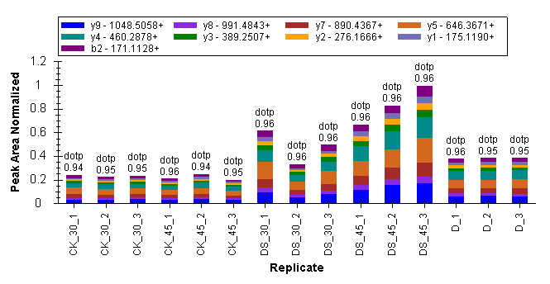
Fig. 9 LGTDEWALTR fragment ion peak area distribution map. Fragment ion peak area distribution of peptide LGTDEWALTR (A0A1U8IN71) in 15 samples.

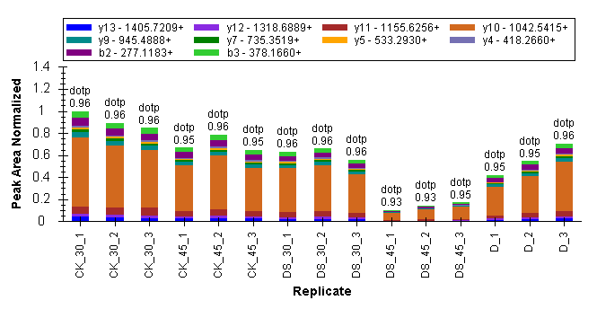
Fig. 10 FETLSYLPPLSDDSIAK fragment ion peak area distribution map. Fragment ion peak area distribution of peptide FETLSYLPPLSDDSIAK (A0A1U8PZJ8) in 15 samples.

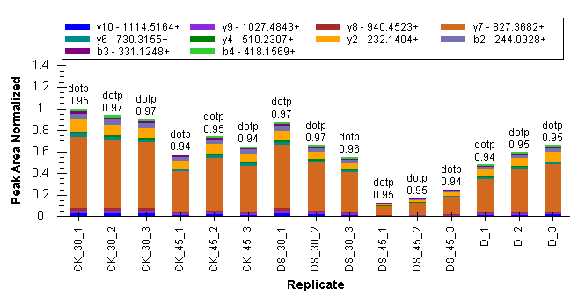
Fig. 11 ENSSIPGYYDGR fragment ion peak area distribution map. Fragment ion peak area distribution of peptide ENSSIPGYYDGR (A0A1U8PZJ8) in 15 samples.

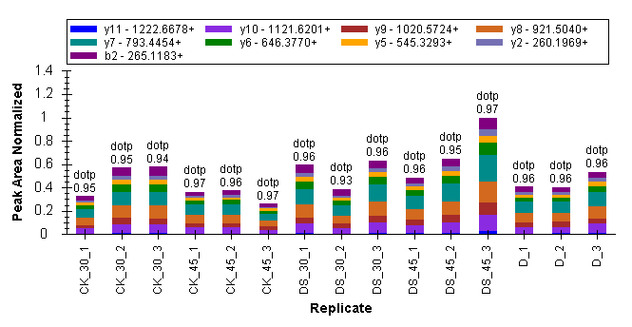
Fig. 12 YTTVQFTGEVLK fragment ion peak area distribution map. Fragment ion peak area distribution of peptide YTTVQFTGEVLK (A0A1U8L4B5) in 15 samples.

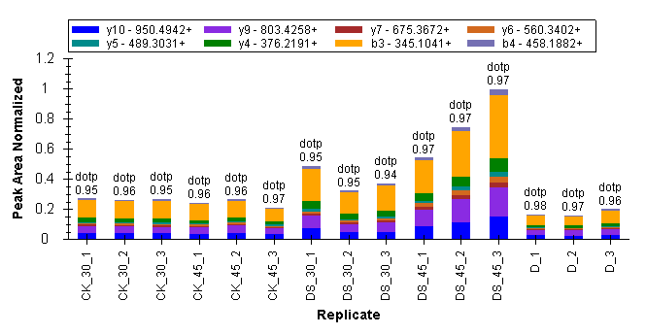
Fig. 13 DNDLFGADAIGTAK fragment ion peak area distribution map. Fragment ion peak area distribution of peptide DNDLFGADAIGTAK (A0A1U8NBT7) in 15 samples.

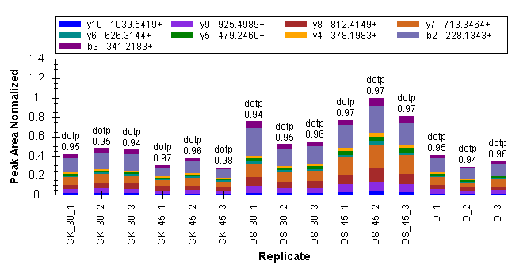
Fig. 14 INLVSFTGSSK fragment ion peak area distribution map. Fragment ion peak area distribution of peptide INLVSFTGSSK (A0A1U8IUK2) in 15 samples.

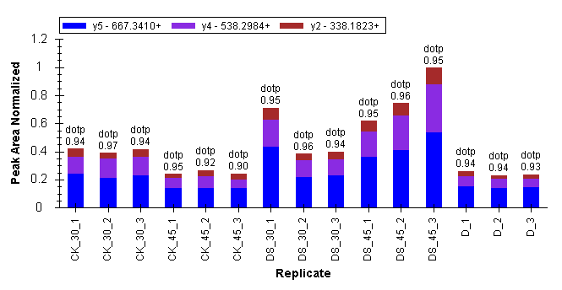
Fig. 15 LLLHESIYR fragment ion peak area distribution map. Fragment ion peak area distribution of peptide LLLHESIYR (A0A1U8IUK2) in 15 samples.

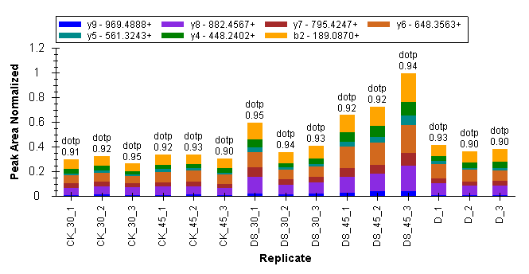
Fig. 16 TSSFSLTEAK fragment ion peak area distribution map. Fragment ion peak area distribution of peptide TSSFSLTEAK (A0A1U8PJA6) in 15 samples.

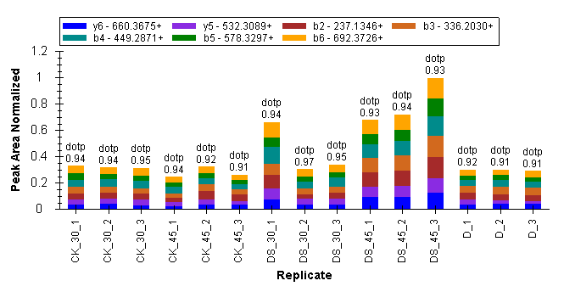
Fig. 17 HVVLENVQNASLK fragment ion peak area distribution map. Fragment ion peak area distribution of peptide HVVLENVQNASLK (A0A1U8PJA6) in 15 samples.

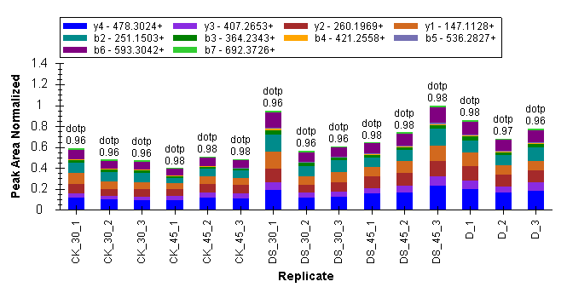
Fig. 18 LHIGDGVAFLK fragment ion peak area distribution map. Fragment ion peak area distribution of peptide LHIGDGVAFLK (A0A1U8JR63) in 15 samples.

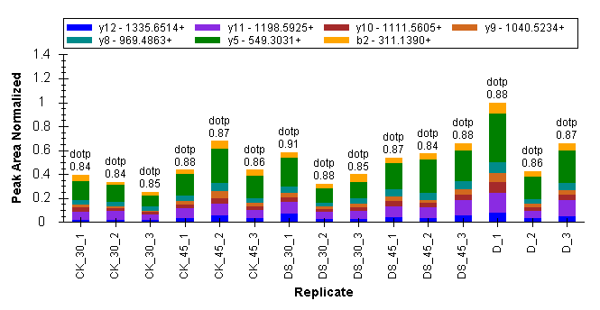
Fig. 19 FYNSEIHSAAFCLPSFAK fragment ion peak area distribution map. Fragment ion peak area distribution of peptide FYNSEIHSAAFCLPSFAK (A0A1U8JR63) in 15 samples.

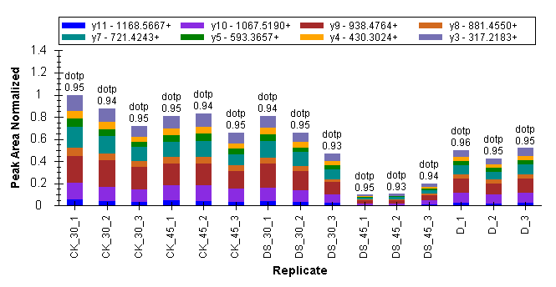
Fig. 20 VTEGCGAYIAVK fragment ion peak area distribution map. Fragment ion peak area distribution of peptide VTEGCGAYIAVK (A0A1U8JXE9) in 15 samples.

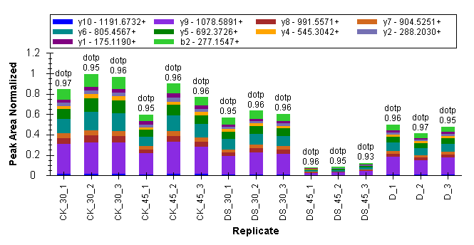
Fig. 21 YLSSVLFQELR fragment ion peak area distribution map. Fragment ion peak area distribution of peptide YLSSVLFQELR (A0A1U8JXE9) in 15 samples.

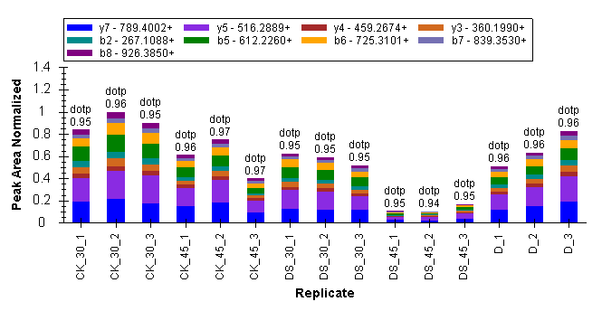
Fig. 22 HETEDINSFSWGVANR fragment ion peak area distribution map. Fragment ion peak area distribution of peptide HETEDINSFSWGVANR (A0A1U8KSQ2) in 15 samples.

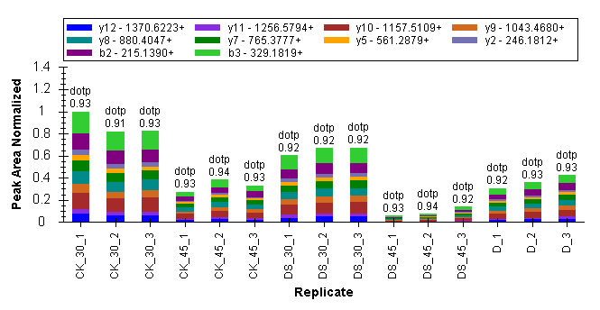
Fig. 23 TINVNYDGFAEDVK fragment ion peak area distribution map. Fragment ion peak area distribution of peptide TINVNYDGFAEDVK (A0A1U8LN42) in 15 samples.

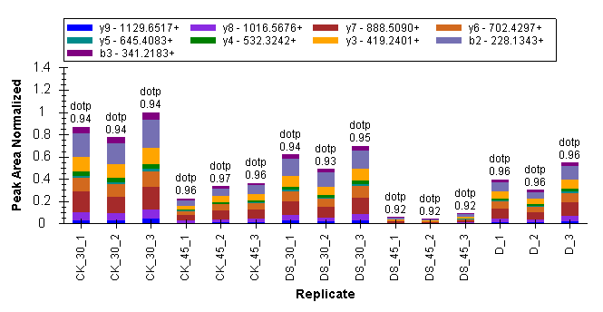
Fig. 24 LNLQWGLIPFR fragment ion peak area distribution map. Fragment ion peak area distribution of peptide LNLQWGLIPFR (A0A1U8LN42) in 15 samples.

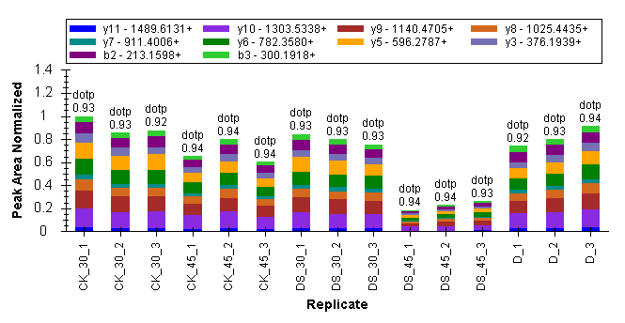
Fig. 25 LVSWYDNEWGYSNR fragment ion peak area distribution map. Fragment ion peak area distribution of peptide LVSWYDNEWGYSNR (A0A1U8PS93) in 15 samples.

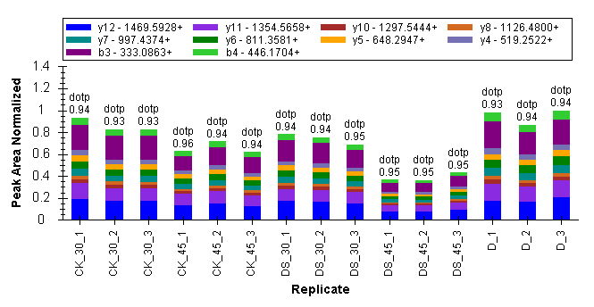
Fig. 26 GDCIIDGGNEWYENTER fragment ion peak area distribution map. Fragment ion peak area distribution of peptide GDCIIDGGNEWYENTER (A0A1U8NRN0) in 15 samples.

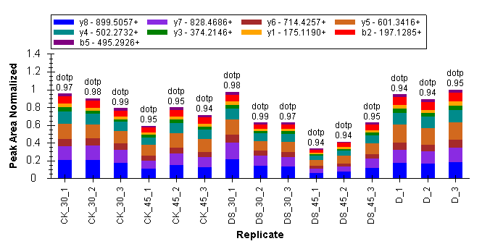
Fig. 27 VPANLVQAQR fragment ion peak area distribution map. Fragment ion peak area distribution of peptide VPANLVQAQR (A0A1U8NRN0) in 15 samples.

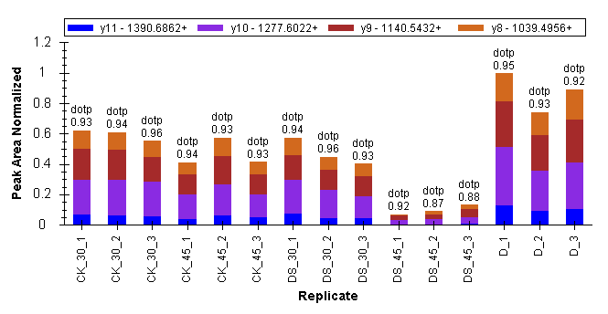
Fig. 28 YANSNIQIHTFNQSQYPR fragment ion peak area distribution map. Fragment ion peak area distribution of peptide YANSNIQIHTFNQSQYPR (D2D2Z0) in 15 samples.

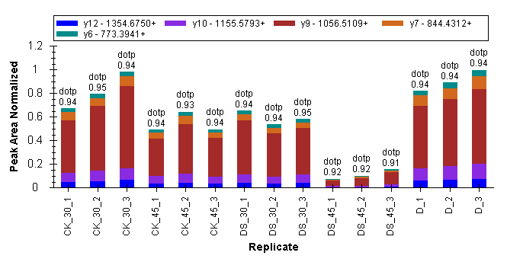
Fig. 29 VQLLEIAQVPDAHVNEFK fragment ion peak area distribution map. Fragment ion peak area distribution of peptide VQLLEIAQVPDAHVNEFK (D2D2Z0) in 15 samples.

